Name Date Period
Lesson 5-7 · Session 2 · Guided Steps · Form B
Surface Area of Triangular Prisms
Learning target — I can find the surface area of a triangular prism using its net. · 6.G.A.4
REMEMBER
• A triangular prism has 2 triangle ends and 3 rectangles: 5 faces.
• Triangle end: ½ × base × height. In a right triangle, the legs are base and height.
• Each rectangle: a triangle side × the prism’s length.
GUIDED PRACTICE fill in each blank — problems 1–4
1. Find each area.
a. 2 ends, base 10 ft, height 6 ft  Step 1 One end: ½ × 10 × 6 =  Step 2 Two ends: 2 × = ft² | b. rectangle 7 ft by 12 ft: ft²

c. 2 ends of 15 cm² each: cm² | d. rectangles 6, 8, 10 cm by 5 cm  Step 1 6 + 8 + 10 =  Step 2 × 5 = cm²

2. Candy Box. Both slanted sides of this candy box are 10 cm.  Step 1 One end: ½ × 16 × 6 =  Step 2 Two ends: 2 × =  a. Area of both triangle ends: cm²  Step 3 16 + 10 + 10 =  Step 4 × 15 =  b. Area of the three rectangles: cm²  Step 5 + =  c. Surface area: cm² | 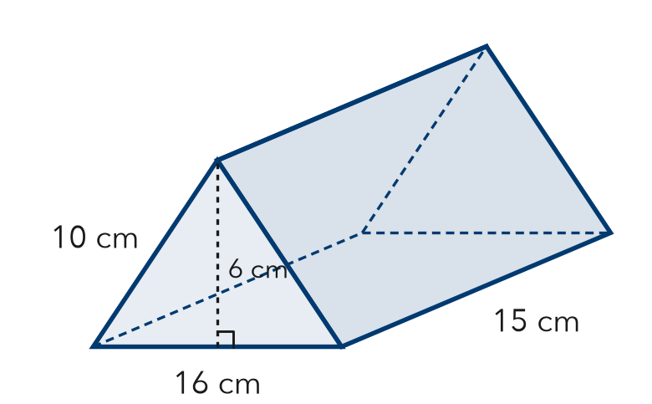

3. Ramp Wedge. A wedge is a triangular prism 10 cm wide. Its ends are right triangles with sides 8, 15, and 17 cm. Find its surface area.  Step 1 One end: ½ × × =  Step 2 Two ends:  Step 3 Sides added: + + =  Step 4 Rectangles: × =  Step 5 SA = + =  Answer cm² | 4. Cheese Wedge. A cheese wedge is a prism 5 cm thick. Its ends are right triangles with sides 6, 8, 10 cm. Find its surface area.  Step 1 One end: ½ × × =  Step 2 Two ends:  Step 3 Sides added: + + =  Step 4 Rectangles: × =  Step 5 SA = + =  Answer cm²

ON YOUR OWN use the open space · show your work · label units
5. Priya’s Ends. A prism is 18 in long. Each end has base 10 in and height 12 in. Priya says both ends cover 60 in². Is she right?  Show your work.  Answer in² | 6. Roof Piece. A roof piece is a prism 20 ft long. Each end: base 24 ft, height 16 ft, two 20 ft sides. Find its SA.  Show your work.  Answer ft²

7. Planter Wedge. Find the surface area of the planter.  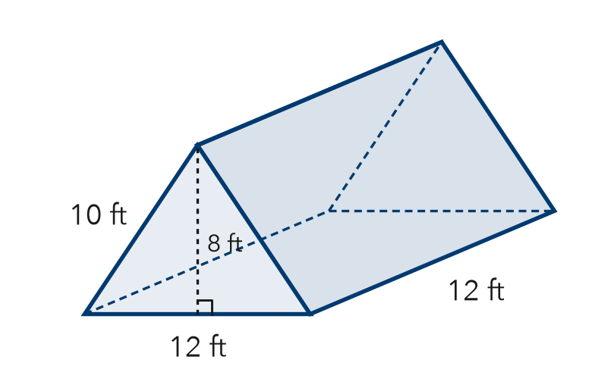  Show your work.  Answer ft² | 8. Camping Tent. A tent is a triangular prism 12 ft long. Each end: base 6 ft, height 4 ft, two 5 ft sides. The floor is 6 ft by 12 ft.  a. Area of the two ends: ft²  b. Total surface area: ft²  c. Fabric needed with no floor: ft²  Show your work.

FIND THE ERROR explain the mistake, then fix it
9. Felix’s Work. A triangular prism is 10 ft long. Each end has a base of 6 ft, a height of 4 ft, and two 5 ft sides. Felix found the rectangles as 6 × 10, 4 × 10, and 4 × 10. Explain the mistake and find the surface area.
Show your work.

TEST PRACTICE choose the best answer
10. How many faces does a triangular prism have in all?
A 3 B 5 C 6 D 9

11. All three rectangles in a triangular prism’s net share one side length: the —
A triangle’s height B prism’s length C triangle’s base D slanted side

CHECK YOURSELF
□ I can do this on my own □ I need a little help □ I have a question about #

