Name Date Period
Lesson 5-8 · Session 1 · Guided Steps · Form A
Surface Area of Pyramids
Learning target — I can find the surface area of a pyramid by adding the base area and the areas of its triangular faces. · 6.G.A.4
REMEMBER
• SA of a pyramid = base area + area of all the triangular faces.
• Each triangle: ½ × base edge × slant height (not the straight-up height).
• A square pyramid has 1 square + 4 matching triangles.
GUIDED PRACTICE fill in each blank — problems 1–3
1. Find the surface area of each square pyramid.
a. base 8 m, slant height 10 m  Step 1 Base: 8 × 8 =  Step 2 One triangle: ½ × 8 × 10 =  Step 3 Four triangles: 4 × =  Step 4 SA = + = m² | b. base 5 ft, slant height 8 ft  Step 1 Base: 5 × 5 =  Step 2 One triangle: ½ × 5 × 8 =  Step 3 Four triangles: 4 × =  Step 4 SA = + = ft²

c. base 2 cm, slant height 3 cm = cm² | d. base 7 in, slant height 10 in = in²

2. Pyramid Model. A class model is a square pyramid. Its net is shown.  Step 1 16 × 16 =  a. Area of the square base: cm²  Step 2 ½ × 16 × 15 =  b. Area of one triangle: cm²  Step 3 Four triangles: 4 × =  Step 4 SA = + =  c. Surface area: cm² | 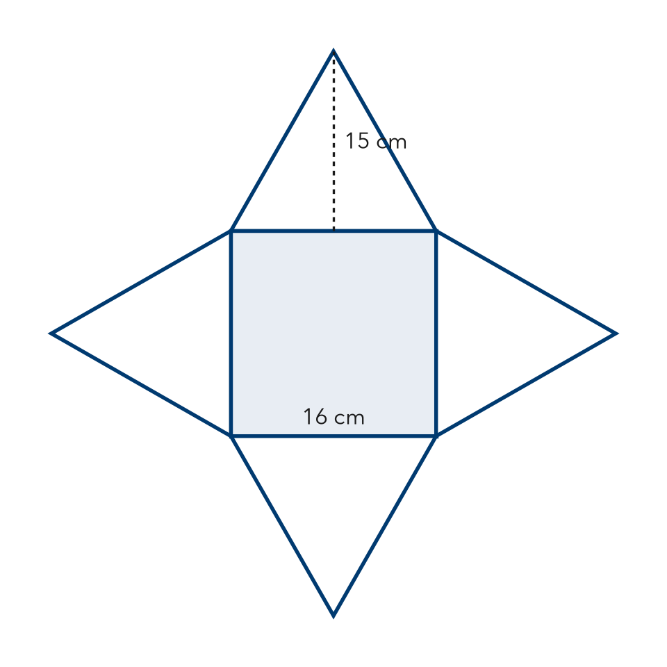

3. Gift Topper. A gift topper is a square pyramid with a base 8 in on each side and a slant height of 11 in. Find its surface area.
Step 1 Base: 8 × 8 =
Step 2 One triangle: ½ × 8 × 11 =
Step 3 Four triangles: 4 × =
Step 4 SA = + =
Answer in²

ON YOUR OWN use the open space · show your work · label units
4. Trophy Top. A trophy top is a square pyramid with a base 12 cm on each side and a slant height of 9 cm. Every face is plated. Find its surface area.  Show your work.  Answer cm² | 5. Roof Cap. Every face of this roof cap, including the bottom, will be shingled. Find its surface area.  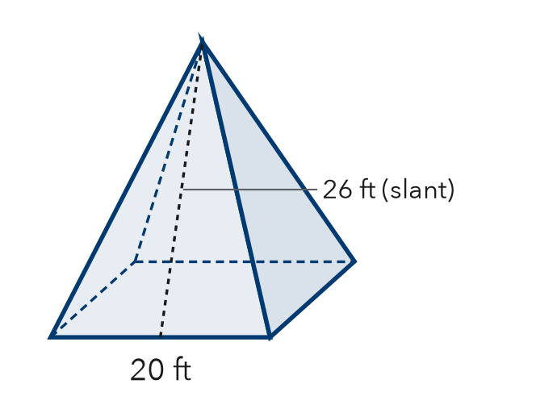  Show your work.  Answer ft²

6. Priya’s Pyramid. A square pyramid has base 18 cm and slant height 13 cm. Priya says its surface area is 117 cm². Is Priya right?  Show your work.  Answer cm² | 7. Sand Mold. A sand mold is a square pyramid: base 16 in, slant height 10 in. Every face counts. Find its surface area.  Show your work.  Answer in²

8. Museum Model. A museum model is a square pyramid: base 14 in, slant height 15 in. Gold foil covers only the four triangles. Foil costs $0.04 per in².
a. Base area and one triangle: in², in²
b. Total surface area: in²
c. Cost of the foil: $
Show your work.

FIND THE ERROR explain the mistake, then fix it
9. Ethan’s Work. A square pyramid has a base 22 in on each side and a slant height of 17 in. Ethan wrote: “SA = 484 + 187 = 671 in².” Explain the mistake and fix it.
Show your work.

TEST PRACTICE choose the best answer
10. How many triangular faces does a square pyramid have?
A 3 B 4 C 5 D 6

11. A base of 25 cm² plus four triangles of 20 cm² each gives a surface area of —
A 45 cm² B 80 cm² C 100 cm² D 105 cm²

CHECK YOURSELF
□ I can do this on my own □ I need a little help □ I have a question about #

