Name Date Period
Lesson 5-8 · Session 1 · Guided Steps · Form B
Surface Area of Pyramids
Learning target — I can find the surface area of a pyramid by adding the base area and the areas of its triangular faces. · 6.G.A.4
REMEMBER
• SA of a pyramid = base area + area of all the triangular faces.
• Each triangle: ½ × base edge × slant height (not the straight-up height).
• A square pyramid has 1 square + 4 matching triangles.
GUIDED PRACTICE fill in each blank — problems 1–3
1. Find the surface area of each square pyramid.
a. base 6 m, slant height 8 m  Step 1 Base: 6 × 6 =  Step 2 One triangle: ½ × 6 × 8 =  Step 3 Four triangles: 4 × =  Step 4 SA = + = m² | b. base 4 ft, slant height 7 ft  Step 1 Base: 4 × 4 =  Step 2 One triangle: ½ × 4 × 7 =  Step 3 Four triangles: 4 × =  Step 4 SA = + = ft²

c. base 3 cm, slant height 5 cm = cm² | d. base 9 in, slant height 10 in = in²

2. Pyramid Model. A class model is a square pyramid. Its net is shown.  Step 1 14 × 14 =  a. Area of the square base: cm²  Step 2 ½ × 14 × 12 =  b. Area of one triangle: cm²  Step 3 Four triangles: 4 × =  Step 4 SA = + =  c. Surface area: cm² | 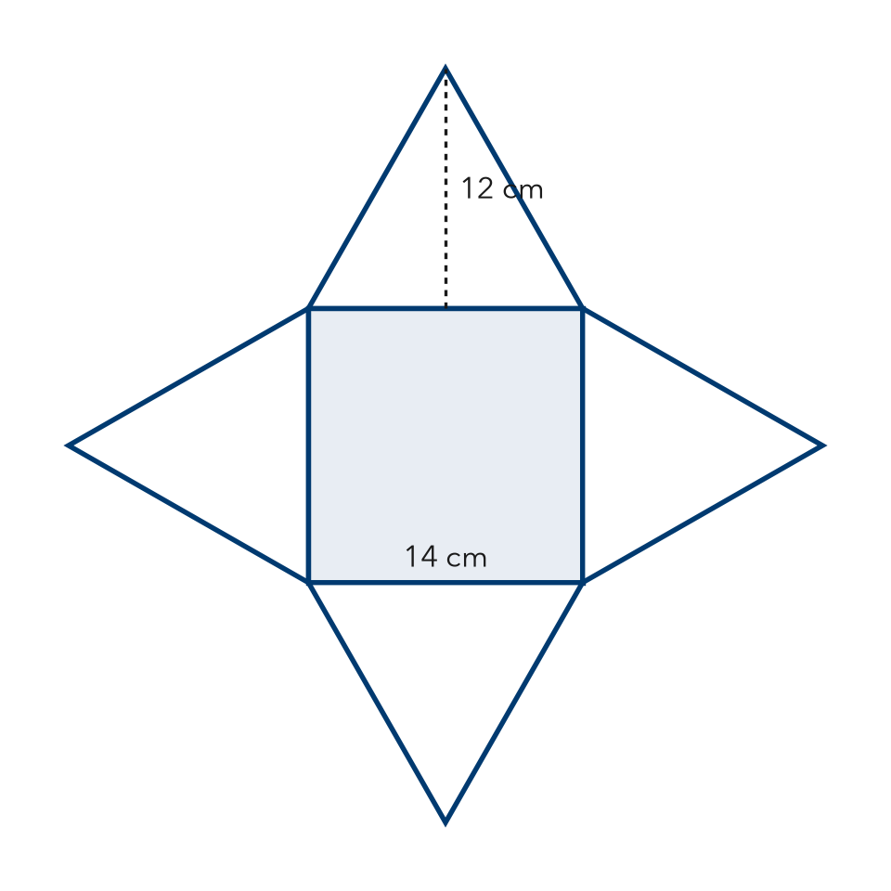

3. Gift Topper. A gift topper is a square pyramid with a base 10 in on each side and a slant height of 13 in. Find its surface area.
Step 1 Base: 10 × 10 =
Step 2 One triangle: ½ × 10 × 13 =
Step 3 Four triangles: 4 × =
Step 4 SA = + =
Answer in²

ON YOUR OWN use the open space · show your work · label units
4. Trophy Top. A trophy top is a square pyramid with a base 8 cm on each side and a slant height of 9 cm. Every face is plated. Find its surface area.  Show your work.  Answer cm² | 5. Roof Cap. Every face of this roof cap, including the bottom, will be shingled. Find its surface area.  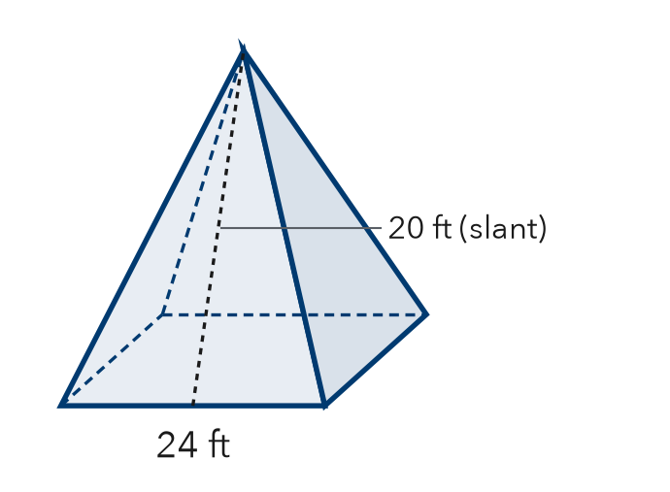  Show your work.  Answer ft²

6. Dante’s Pyramid. A square pyramid has base 16 cm and slant height 11 cm. Dante says its surface area is 88 cm². Is Dante right?  Show your work.  Answer cm² | 7. Sand Mold. A sand mold is a square pyramid: base 12 in, slant height 14 in. Every face counts. Find its surface area.  Show your work.  Answer in²

8. Museum Model. A museum model is a square pyramid: base 10 in, slant height 12 in. Gold foil covers only the four triangles. Foil costs $0.05 per in².
a. Base area and one triangle: in², in²
b. Total surface area: in²
c. Cost of the foil: $
Show your work.

FIND THE ERROR explain the mistake, then fix it
9. Mia’s Work. A square pyramid has a base 20 in on each side and a slant height of 15 in. Mia wrote: “SA = 400 + 150 = 550 in².” Explain the mistake and fix it.
Show your work.

TEST PRACTICE choose the best answer
10. How many faces does a square pyramid have in all?
A 4 B 5 C 6 D 8

11. A base of 36 cm² plus four triangles of 15 cm² each gives a surface area of —
A 51 cm² B 60 cm² C 96 cm² D 540 cm²

CHECK YOURSELF
□ I can do this on my own □ I need a little help □ I have a question about #

