Name Date Period
Lesson 5-8 · Session 2 · Guided Steps · Form A
Lateral Area of Pyramids
Learning target — I can find the lateral area of a pyramid, which covers only its slanted faces. · 6.G.A.4
REMEMBER
• Lateral area = the slanted faces only. Do not include the base.
• Surface area = lateral area + base area.
• A triangle-base pyramid has 3 slanted faces; a square pyramid has 4.
GUIDED PRACTICE fill in each blank — problems 1–3
1. Find each lateral area.
a. 4 faces, each 25 cm²: cm² | b. SA = 150 in², base = 36 in²  Step 1 SA = lateral area +  Step 2 − = in²

c. square base 7 m, slant 9 m  Step 1 One triangle: ½ × 7 × 9 =  Step 2 4 × = m² | d. square base 11 in, slant 10 in  Step 1 One triangle: ½ × 11 × 10 =  Step 2 4 × = in²

2. Canvas Frame. Maria’s frame is a pyramid with a triangle base (24 in sides) and slant height 14 in. Only the slanted faces get canvas.
Step 1 Triangle base: slanted faces
Step 2 One face: ½ × 24 × 14 =
Step 3 × =
a. Faces that get canvas:
b. One slanted face: in²
c. Canvas needed: in²

3. Open-Bottom Tent. This tent is a square pyramid. The floor is open ground.  Step 1 One panel: ½ × 10 × 9 =  a. One panel: ft²  Step 2 Open floor: 4 × =  b. Fabric for the tent: ft²  Step 3 Floor: 10 × 10 =  Step 4 + =  c. Total if the floor were covered: ft² | 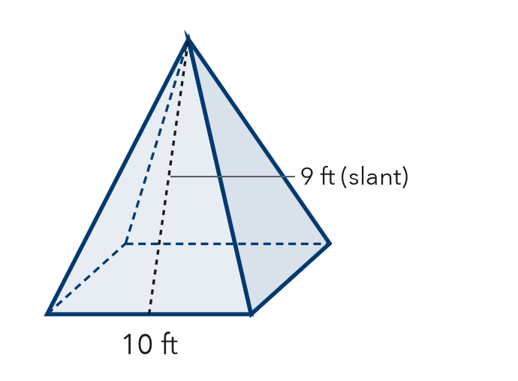

ON YOUR OWN use the open space · show your work · label units
4. Gazebo Roof. A square pyramid roof has base 14 ft and slant height 8 ft. Only its slanted faces get shingles.  Show your work.  Answer ft² | 5. Tower Cap. A square pyramid cap has base 22 m and slant height 17 m. Only its slanted faces are copper.  Show your work.  Answer m²

6. Display Pyramid. A display is a square pyramid: base 26 in, slant height 25 in. Every face is wrapped, base included. How much paper?  Show your work.  Answer in² | 7. Kai’s Canvas. A square pyramid has base 30 cm and slant height 21 cm. Kai says the four slanted faces cover 2,520 cm². Is Kai right?  Show your work.  Answer cm²

8. Tent Cover. A shelter is a square pyramid: base 16 ft, slant height 10 ft, open floor. Canvas costs $3 per ft².
a. Lateral area: ft²
b. Cost of the canvas: $
c. Total SA; why use lateral area here?
Show your work.

FIND THE ERROR explain the mistake, then fix it
9. Rosa’s Work. A square pyramid has base 14 cm and slant height 8 cm. Only the slanted faces are painted. Rosa wrote: “Area = 196 + 224 = 420 cm².” Explain the mistake and fix it.
Show your work.

TEST PRACTICE choose the best answer
10. Lateral area leaves out the —
A base B triangles C slant height D apex

11. How many slanted faces does a pyramid with a triangle base have?
A 3 B 4 C 5 D 6

CHECK YOURSELF
□ I can do this on my own □ I need a little help □ I have a question about #

