Name Date Period
Lesson 6-3 · Session 2 · Guided Steps · Form A
Finding the Value of a Power
Learning target — I can find the value of a power by multiplying the base the number of times the exponent shows. · 6.EE.A.1
REMEMBER
• Write the expanded form, then multiply one factor at a time.
• 4³ = 4 × 4 × 4 = 64, not 4 × 3 = 12.
• Decimals and fractions work the same way: 0.3² = 0.3 × 0.3 = 0.09.
GUIDED PRACTICE fill in each blank — problems 1–4
1. Find the value of each power.
a. 12² =  Step 1 12² = ×  Step 2 × = | b. 3³ =  Step 1 3³ = × ×  Step 2 × =  Step 3 × = | c. 2⁴ =  Step 1 2⁴ = × × ×  Step 2 × =  Step 3 × =  Step 4 × =

d. 11² = | e. 1.2² = | f. (1/3)² =

2. Power Table. A science club makes a table of powers of 2. Complete it. Then tell what each value is multiplied by to get the next one.
Power | Expanded form | Value
2¹
2² | ×
2³ | × ×
2⁴ | × × ×

Multiply by

3. Storage Cube. A storage cube has edges of 4 units, so its volume is 4³ cubic units. Find the volume.  Step 1 4³ = × ×  Step 2 × =  Step 3 × =  Step 4 Volume: cubic units | 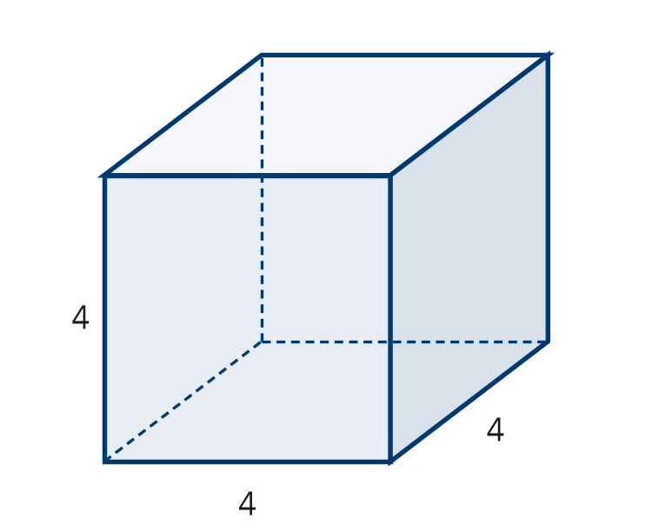

4. Plant Cuttings. A count of plant cuttings is multiplied by 5 each week for 4 weeks, so it is 5⁴. Evaluate it.
Step 1 5⁴ = × × ×
Step 2 × =
Step 3 × =
Step 4 × =
Value

ON YOUR OWN use the open space · show your work · label units
5. Poster Claim. A classroom poster says 7² = 14. Justify or correct the poster.  Show your work.  Value | 6. Which Is Biggest? Evaluate 2⁵, 5² and 3³. Order them from least to greatest.  Show your work.  Order < <

7. Decimal Powers. Evaluate each power.
a. 0.6² =
b. 1.5² =
Show your work.

8. Growing Cells. A culture of cells triples every hour. It starts with 1 cell.
a. Write the number of cells after 4 hours as a power of 3, then evaluate. cells
b. How many cells after 5 hours? cells
c. How many more cells after 5 hours than after 4 hours? cells
Show your work.

FIND THE ERROR explain the mistake, then fix it
9. Teo’s Work. Teo evaluated 10³. He wrote 10 × 3 = 30 and said the value is 30. Explain his mistake. Then find the correct value.
Show your work.

TEST PRACTICE choose the best answer
10. 2⁵ equals —
A 10 B 25 C 32 D 7

11. A number to the 2nd power is said to be —
A squared B cubed C doubled D halved

CHECK YOURSELF
□ I can do this on my own □ I need a little help □ I have a question about #

