Name Date Period
Lesson 6-3 · Session 2 · Guided Steps · Form B
Finding the Value of a Power
Learning target — I can find the value of a power by multiplying the base the number of times the exponent shows. · 6.EE.A.1
REMEMBER
• Write the expanded form, then multiply one factor at a time.
• 4³ = 4 × 4 × 4 = 64, not 4 × 3 = 12.
• Decimals and fractions work the same way: 0.3² = 0.3 × 0.3 = 0.09.
GUIDED PRACTICE fill in each blank — problems 1–4
1. Find the value of each power.
a. 9² =  Step 1 9² = ×  Step 2 × = | b. 2³ =  Step 1 2³ = × ×  Step 2 × =  Step 3 × = | c. 5² =  Step 1 5² = ×  Step 2 × =

d. 13² = | e. 1.3² = | f. (2/5)² =

2. Power Table. A garden club makes a table of powers of 3. Complete it. Then tell what each value is multiplied by to get the next one.
Power | Expanded form | Value
3¹
3² | ×
3³ | × ×
3⁴ | × × ×

Multiply by

3. Storage Cube. A storage cube has edges of 5 units, so its volume is 5³ cubic units. Find the volume.  Step 1 5³ = × ×  Step 2 × =  Step 3 × =  Step 4 Volume: cubic units | 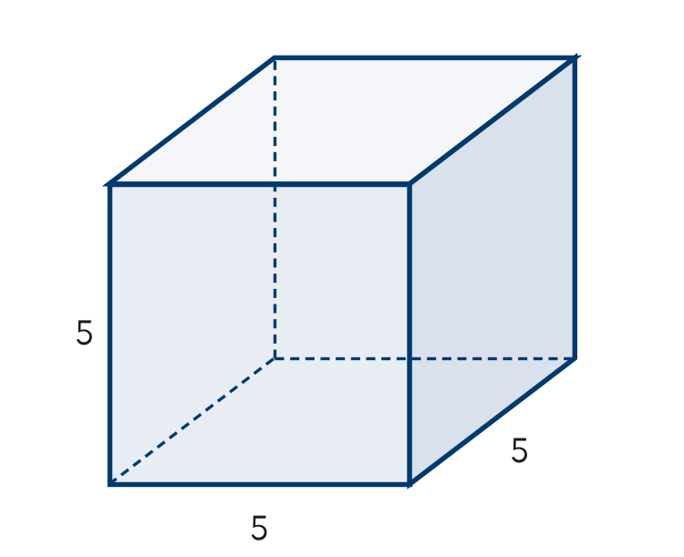

4. Plant Cuttings. A count of plant cuttings is multiplied by 6 each week for 3 weeks, so it is 6³. Evaluate it.
Step 1 6³ = × ×
Step 2 × =
Step 3 × =
Value

ON YOUR OWN use the open space · show your work · label units
5. Poster Claim. A classroom poster says 8² = 16. Justify or correct the poster.  Show your work.  Value | 6. Which Is Biggest? Evaluate 3⁴, 4³ and 2⁷. Order them from least to greatest.  Show your work.  Order < <

7. Decimal Powers. Evaluate each power.
a. 0.4² =
b. 2.5² =
Show your work.

8. Tile Stages. A tile design has 4 times as many tiles at each new stage. It starts with 1 tile.
a. Write the number of tiles after 3 stages as a power of 4, then evaluate. tiles
b. How many tiles after 4 stages? tiles
c. How many more tiles after 4 stages than after 3 stages? tiles
Show your work.

FIND THE ERROR explain the mistake, then fix it
9. Malik’s Work. Malik evaluated 9³. He wrote 9 × 3 = 27 and said the value is 27. Explain his mistake. Then find the correct value.
Show your work.

TEST PRACTICE choose the best answer
10. 10³ equals —
A 30 B 13 C 100 D 1,000

11. 6² equals —
A 12 B 8 C 36 D 66

CHECK YOURSELF
□ I can do this on my own □ I need a little help □ I have a question about #

