Lesson 6.3 Guided Notes

Session 1 · Writing Repeated Factors as Powers
I can write repeated multiplication as a power and name its base and exponent. · 6.EE.A.1
Word / Spanish | Meaning — complete the blank | Example
power / potencia | A short way to write the same ________ multiplied again and again. | 9⁴
base / base | The number that is __________ as a factor. | In 9⁴, the base is 9
exponent / exponente | The raised number that tells how many _______ the base is a factor. | In 9⁴, the exponent is 4

Key idea
The ______ is the repeated factor.
The __________ tells how many times the base is used as a factor.
The exponent counts factors, not ________________ signs.

Worked example
Write 2 × 2 × 2 × 2 as a power. Name the base and the exponent.
The repeated factor is _____. That is the base.
Count the factors: there are _____. That is the exponent.
Write the base with a raised exponent: 2⁴.
Answer: 2⁴, read “2 to the ________ power”

You try
1. Write each product as a power.
a. 6 × 6 × 6 = ______
b. 1/4 × 1/4 = ______
________________________________________________________________
2. Write 10⁴ in expanded form. How many factors does it have?
________________________________________________________________
Sum it up: In 7⁴, the 4 tells me ___ because ___.
________________________________________________________________

Session 2 · Finding the Value of a Power
I can find the value of a power by multiplying the base the number of times the exponent shows. · 6.EE.A.1
Word / Spanish | Meaning — complete the blank | Example
evaluate / evaluar | Find the one ________ an expression equals. | 2³ = 8
squared / al cuadrado | To the 2nd power; use the base as a factor _____ times. | 4² = 4 × 4 = 16
cubed / al cubo | To the 3rd power; use the base as a factor _____ times. | 4³ = 4 × 4 × 4 = 64

Key idea
To evaluate a power, write the __________ form and multiply one factor at a time.
4³ = 4 × 4 × 4 = 64, not 4 × 3 = _____.
Fraction and decimal bases work the ______ way: (1/2)² = 1/4.

Worked example
Find the value of 6³.
Expand: 6³ = 6 × 6 × _____.
Multiply the first two: 6 × 6 = _____.
Multiply by the last 6: 36 × 6 = _____.
Answer: 6³ = _____, not 6 × 3 = 18

You try
1. Find the value of each power.
a. 9² = ______
b. 0.5² = ______
________________________________________________________________
2. A cube has edges of 3 cm. Its volume is 3³ cm³. Find the volume.
________________________________________________________________
Sum it up: 2⁴ is not the same as 2 × 4 because ___.
________________________________________________________________

Session 1 · Model, reason, and explain
Writing Repeated Factors as Powers · 6.EE.A.1
Success: represent the quantities, justify the relationship, and check the result with the correct units.
Compare 3 × 3 × 3 × 3, 3 × 4, and 3 + 3 + 3 + 3. Write the repeated-factor expression as a power and explain the others.
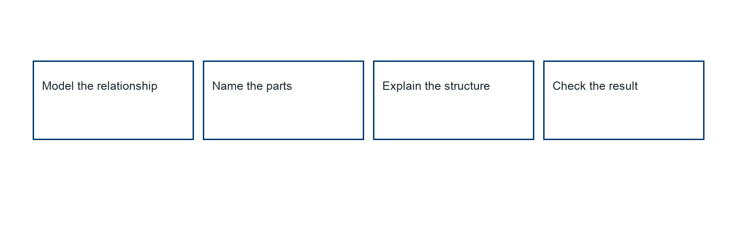
________________________________________________________________
________________________________________________________________
________________________________________________________________

Extend your reasoning
Create a contrasting example that exposes the misconception: multiplies base by exponent.. Explain what changes and what stays true.
________________________________________________________________
________________________________________________________________
Self-check: Did my model, calculation, explanation, and units agree?

Session 2 · Model, reason, and explain
Finding the Value of a Power · 6.EE.A.1
Success: represent the quantities, justify the relationship, and check the result with the correct units.
Compare 2⁵ and 5² by expanding both. Does reversing base and exponent preserve value?
________________________________________________________________
________________________________________________________________
________________________________________________________________

Extend your reasoning
Create a contrasting example that exposes the misconception: treats exponentiation as commutative multiplication.. Explain what changes and what stays true.
________________________________________________________________
________________________________________________________________
Self-check: Did my model, calculation, explanation, and units agree?

