Name Date Period
Lesson 6-4 · Session 1 · Guided Steps · Form A
Writing Numerical Expressions
Learning target — I can write a numerical expression that matches a situation. · 6.EE.A.2
REMEMBER
• A numerical expression has numbers and operations but no equal sign.
• “Each” or “per” means equal groups, so multiply. Totals of groups are added. “5 less than 12” is 12 − 5.
• Use parentheses for a part done first: the sum of 4 and 6, tripled, is 3 × (4 + 6).
GUIDED PRACTICE fill in each blank — problems 1–4
1. Write a numerical expression for each phrase. Do not evaluate.
a. 4 more than the product of 6 and 3  Step 1 Product: ×  Step 2 Then add: +  Step 3 Write: | b. 20 less than 75  Step 1 Start with  Step 2 Take away  Step 3 Write: −

c. the sum of 5 and 9, tripled  Step 1 Sum: ( + )  Step 2 Multiply by  Step 3 Write: × ( ) | d. the quotient of 48 and 8, plus 7  Step 1 Quotient: ÷  Step 2 Then (+ or −):  Step 3 Write:

2. School Store Order. A school store orders 5 boxes of pens at $12 a box and 4 packs of paper at $3 a pack. It also stacks notebooks in 10 rows of 10.
a. Total cost of the order
Step 1 First item: × $
Step 2 Second item: × $
Step 3 Add: + =
Step 4 Expression:
a. Total cost: dollars
b. The power
Step 5 Same number twice: ×
Step 6 As a power: base , exponent
Step 7 Evaluate: × =
b. notebooks

3. Field Trip. A field trip costs $13 for each of 20 students, plus one $25 bus fee. Write one expression for the total cost. Evaluate it.  Step 1 Students: × $  Step 2 Add the fee: + $  Step 3 Expression:  Step 4 Evaluate: + =  Answer dollars | 4. Square Garden. A square garden has 15 plants along each side, filling the whole square. Write the number of plants as a power. Evaluate it.  Step 1 Plants on one side:  Step 2 Same number twice: ×  Step 3 As a power: base , exponent  Step 4 Evaluate: × =  Answer plants

ON YOUR OWN use the open space · show your work · label units
5. Cracker Bags. Leo fills 3 bags with 16 crackers each, then eats 5 crackers. He wrote 3 + 16 − 5 for the crackers left. Justify or correct his expression.  Show your work.  Answer crackers | 6. Cube Bin. A cube-shaped bin is 12 inches on every edge. Write the number of 1-inch cubes that fill it as a power. Evaluate it.  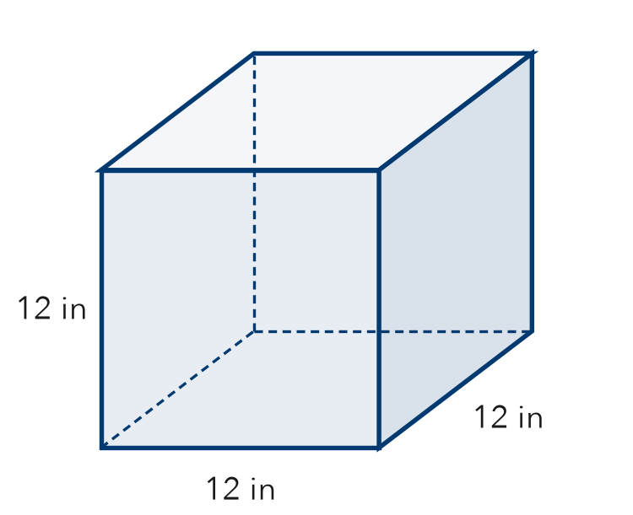  Show your work.  Answer cubes

7. Supply Change. A class buys 12 notebooks at $3 each and 20 pens at $2 each. It pays with $100.
a. Write an expression for the total cost.

b. Write an expression for the change. Evaluate it.
Show your work.

dollars
c. Why do parentheses help in part b?

8. Tickets and Programs. A group buys 4 tickets at $9 each and 3 programs at $6 each. Write one expression for the total cost. Evaluate it.
Show your work.

Answer dollars

FIND THE ERROR explain the mistake, then fix it
9. Ines’s Work. Snacks cost $3 each. Ines buys 4 snacks and one $10 poster. She wrote 3 + 4 × 10 for the total. Explain her mistake. Then write and evaluate a correct expression.
Show your work.

TEST PRACTICE choose the best answer
10. “3 more than the product of 5 and 4” is written —
A 5 × 4 + 3 B 3 × 5 + 4 C (3 + 5) × 4 D 5 + 4 × 3

11. “15 less than 40” is written —
A 15 − 40 B 40 − 15 C 40 + 15 D 15 × 40

CHECK YOURSELF
□ I can do this on my own □ I need a little help □ I have a question about #

