Name Date Period
Lesson 6-4 · Session 1 · Guided Steps · Form B
Writing Numerical Expressions
Learning target — I can write a numerical expression that matches a situation. · 6.EE.A.2
REMEMBER
• A numerical expression has numbers and operations but no equal sign.
• “Each” or “per” means equal groups, so multiply. Totals of groups are added. “5 less than 12” is 12 − 5.
• Use parentheses for a part done first: the sum of 4 and 6, tripled, is 3 × (4 + 6).
GUIDED PRACTICE fill in each blank — problems 1–4
1. Write a numerical expression for each phrase. Do not evaluate.
a. 6 more than the product of 7 and 2  Step 1 Product: ×  Step 2 Then add: +  Step 3 Write: | b. 18 less than 60  Step 1 Start with  Step 2 Take away  Step 3 Write: −

c. the sum of 3 and 7, doubled  Step 1 Sum: ( + )  Step 2 Multiply by  Step 3 Write: × ( ) | d. the quotient of 56 and 7, minus 3  Step 1 Quotient: ÷  Step 2 Then (+ or −):  Step 3 Write:

2. Art Club Order. An art club buys 6 sets of brushes at $11 a set and 3 packs of canvas at $8 a pack. It also lays out mosaic tiles in 9 rows of 9.
a. Total cost of the order
Step 1 First item: × $
Step 2 Second item: × $
Step 3 Add: + =
Step 4 Expression:
a. Total cost: dollars
b. The power
Step 5 Same number twice: ×
Step 6 As a power: base , exponent
Step 7 Evaluate: × =
b. tiles

3. Field Trip. A field trip costs $12 for each of 25 students, plus one $30 bus fee. Write one expression for the total cost. Evaluate it.  Step 1 Students: × $  Step 2 Add the fee: + $  Step 3 Expression:  Step 4 Evaluate: + =  Answer dollars | 4. Square Garden. A square garden has 14 plants along each side, filling the whole square. Write the number of plants as a power. Evaluate it.  Step 1 Plants on one side:  Step 2 Same number twice: ×  Step 3 As a power: base , exponent  Step 4 Evaluate: × =  Answer plants

ON YOUR OWN use the open space · show your work · label units
5. Pretzel Bags. Mia fills 4 bags with 15 pretzels each, then eats 6 pretzels. She wrote 4 + 15 − 6 for the pretzels left. Justify or correct her expression.  Show your work.  Answer pretzels | 6. Cube Bin. A cube-shaped bin is 10 inches on every edge. Write the number of 1-inch cubes that fill it as a power. Evaluate it.  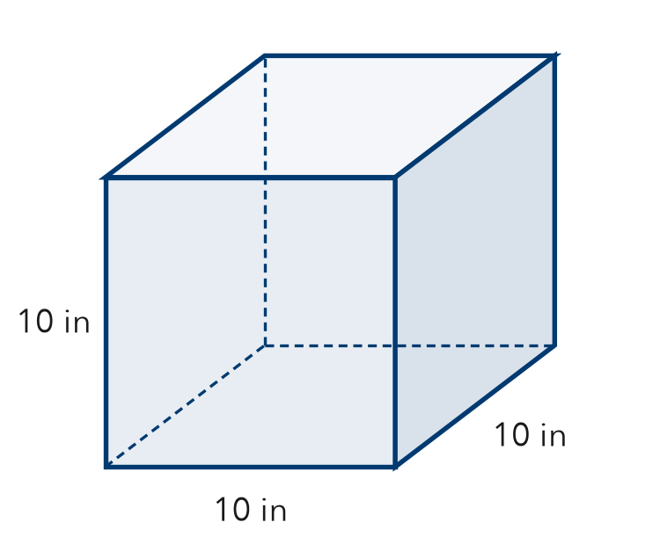  Show your work.  Answer cubes

7. Supply Change. A class buys 10 notebooks at $4 each and 15 pens at $3 each. It pays with $100.
a. Write an expression for the total cost.

b. Write an expression for the change. Evaluate it.
Show your work.

dollars
c. Why do parentheses help in part b?

8. Tickets and Programs. A group buys 5 tickets at $8 each and 4 programs at $5 each. Write one expression for the total cost. Evaluate it.
Show your work.

Answer dollars

FIND THE ERROR explain the mistake, then fix it
9. Jaden’s Work. Jaden counts seedlings in 6 trays of 8 seedlings each, plus 9 extra seedlings. He wrote 6 + 8 + 9 = 23. Explain his mistake. Then write and evaluate a correct expression.
Show your work.

TEST PRACTICE choose the best answer
10. “The sum of 8 and 2, doubled” is written —
A 8 + 2 × 2 B 2 × (8 + 2) C 8 × 2 + 2 D 2 + 8 × 2

11. Parentheses tell you which part to —
A do first B skip C do last D always multiply

CHECK YOURSELF
□ I can do this on my own □ I need a little help □ I have a question about #

