Lesson 6.4 Guided Notes

Session 1 · Writing Numerical Expressions
I can write a numerical expression that matches a situation. · 6.EE.A.2
Word / Spanish | Meaning — complete the blank | Example
numerical expression / expresión numérica | Numbers and operations with no _______ sign. | 4 × 9 + 3
evaluate / evaluar | Find the one ________ an expression equals. | 4 × 9 + 3 = 39
product / producto | The answer when you __________. | the product of 6 and 7 is 6 × 7

Key idea
Equal groups (“each,” “per”) in a story usually mean __________.
A total of different groups means _____ the products.
“Less than” flips the order: 5 less than 12 is _____ − 5.

Worked example
A team buys 6 shirts at $7 each and 1 hat for $5. Write an expression for the total cost. Evaluate it.
Shirts are equal groups: 6 × _____.
Add the one hat: 6 × 7 + _____.
Evaluate: 42 + 5 = _____.
Answer: 6 × 7 + 5 = $_____

You try
1. Write a numerical expression.
a. the product of 6 and 4, plus 2 ______
b. 10 less than 35 ______
________________________________________________________________
2. Jo buys 3 books at $5 each and a $4 bookmark. Write an expression for the total cost. Evaluate it.
________________________________________________________________
Sum it up: To write an expression for a story, I look for ___ because ___.
________________________________________________________________

Session 2 · Order of Operations with Powers
I can evaluate an expression that contains grouping symbols and powers using the order of operations. · 6.EE.A.2c
Word / Spanish | Meaning — complete the blank | Example
order of operations / orden de las operaciones | The rules for which ______ to do first, next and last. | ( ), powers, × ÷, + −
grouping symbols / símbolos de agrupación | Parentheses or brackets; do the work ________ them first. | (9 − 7)
left to right / de izquierda a derecha | Do partner steps (× and ÷, or + and −) in the order they ________. | 24 ÷ 4 × 2 = 6 × 2 = 12

Key idea
First do work inside __________ symbols, then evaluate ________.
Next multiply and divide from ______ to right.
Last, add and subtract from left to _______.

Worked example
Evaluate 40 − (2 + 3)² ÷ 5.
Parentheses: 2 + 3 = _____, so 40 − 5² ÷ 5.
Power: 5² = _____, so 40 − 25 ÷ 5.
Divide, then subtract: 40 − _____.
Answer: 40 − (2 + 3)² ÷ 5 = _____

You try
1. Evaluate.
a. 12 − 2 × 5 = ______
b. (3 + 1)² = ______
________________________________________________________________
2. Evaluate 6 + 2³ × 3.
________________________________________________________________
Sum it up: In 2 + 3 × 4², I start with ___ because ___.
________________________________________________________________

Session 1 · Model, reason, and explain
Writing Numerical Expressions · 6.EE.A.2
Success: represent the quantities, justify the relationship, and check the result with the correct units.
A club buys 4 boxes with 6 markers each and 3 single markers. Match the story to 4 × 6 + 3 or 4 × (6 + 3). Explain the difference.
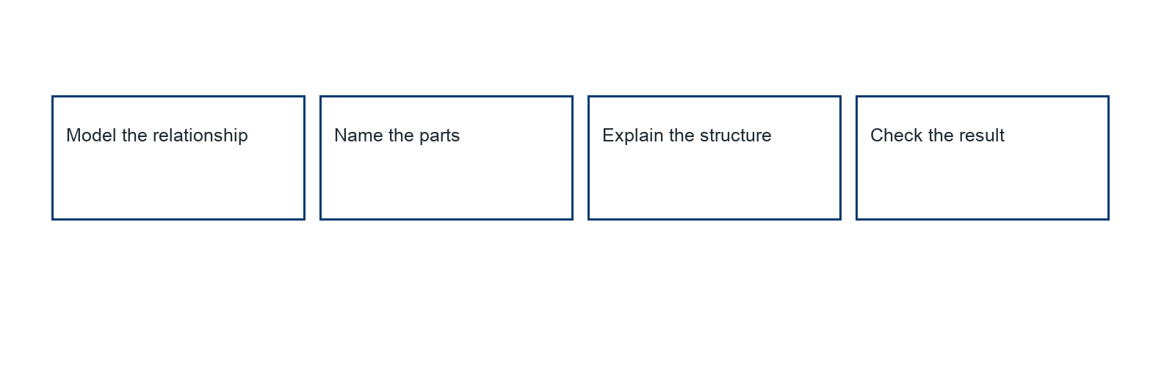
________________________________________________________________
________________________________________________________________
________________________________________________________________

Extend your reasoning
Create a contrasting example that exposes the misconception: groups a one-time amount with a repeated amount.. Explain what changes and what stays true.
________________________________________________________________
________________________________________________________________
Self-check: Did my model, calculation, explanation, and units agree?

Session 2 · Model, reason, and explain
Order of Operations with Powers · 6.EE.A.2c
Success: represent the quantities, justify the relationship, and check the result with the correct units.
Compare 2 × 3² and (2 × 3)². Then evaluate 24 ÷ 4 × 2. Explain the relevant base and equal-precedence rule.
________________________________________________________________
________________________________________________________________
________________________________________________________________

Extend your reasoning
Create a contrasting example that exposes the misconception: applies the power to the wrong base or performs all multiplication before division.. Explain what changes and what stays true.
________________________________________________________________
________________________________________________________________
Self-check: Did my model, calculation, explanation, and units agree?

