Lesson 6.5 Guided Notes

Session 1 · Writing Algebraic Expressions
I can write an algebraic expression that uses a variable for an unknown amount. · 6.EE.A.2a
Word / Spanish | Meaning — complete the blank | Example
variable / variable | A ________ that stands for an unknown number. | the m in 14m + 35
coefficient / coeficiente | The number ____________ by the variable. | In 14m, the coefficient is 14
constant / constante | A number by itself that does not ________. | the 35 in 14m + 35
algebraic expression / expresión algebraica | An expression with at least one __________. | 14m + 35

Key idea
An amount that repeats “each” time goes with the __________.
A one-time amount is the __________.
Order matters: “4 less than x” is x _____ 4.

Worked example
A bike shop charges $9 per hour plus a $3 helmet fee. Write an expression for the cost of h hours.
The $9 repeats each hour: 9 × h = _____.
The one-time fee is the constant: _____.
Join the terms with a plus sign.
Answer: The cost is ________ dollars.

You try
1. Write an algebraic expression.
a. 6 more than n ______
b. the product of 4 and k ______
________________________________________________________________
2. Concert tickets cost $10 each plus one $4 fee. Write an expression for the cost of t tickets.
________________________________________________________________
Sum it up: In 9h + 3, the 9 goes with h because ___.
________________________________________________________________

Session 2 · Evaluating Algebraic Expressions
I can evaluate an algebraic expression by substituting a value for the variable. · 6.EE.A.2c
Word / Spanish | Meaning — complete the blank | Example
substitute / sustituir | _________ a variable with a given number. | If b = 7: 6b = 6 × 7
evaluate / evaluar | Find the _______ after you substitute. | 6 × 7 − 9 = 33
variable / variable | A letter that stands for a ________. | the b in 6b − 9

Key idea
To evaluate, ____________ the value for the variable.
Then use the _______ of operations: powers, then × and ÷, then + and −.
4x means 4 × x. When x = 3, 4x = _____, not 43.

Worked example
Evaluate 7p − 2 when p = 4.
Substitute: 7 × _____ − 2.
Multiply first: 7 × 4 = _____.
Subtract: 28 − 2 = _____.
Answer: 7p − 2 = _____ when p = 4

You try
1. Evaluate when a = 3.
a. 5a + 1 = ______
b. a² − 4 = ______
________________________________________________________________
2. A garage charges 3h + 6 dollars for h hours. Find the cost for 5 hours.
________________________________________________________________
Sum it up: When I evaluate 4 + 2p, I multiply first because ___.
________________________________________________________________

Session 1 · Model, reason, and explain
Writing Algebraic Expressions · 6.EE.A.2a
Success: represent the quantities, justify the relationship, and check the result with the correct units.
A rental charges $7 per hour and a one-time $4 fee. Write an expression for h hours. Explain which term repeats and whether this is already an equation.
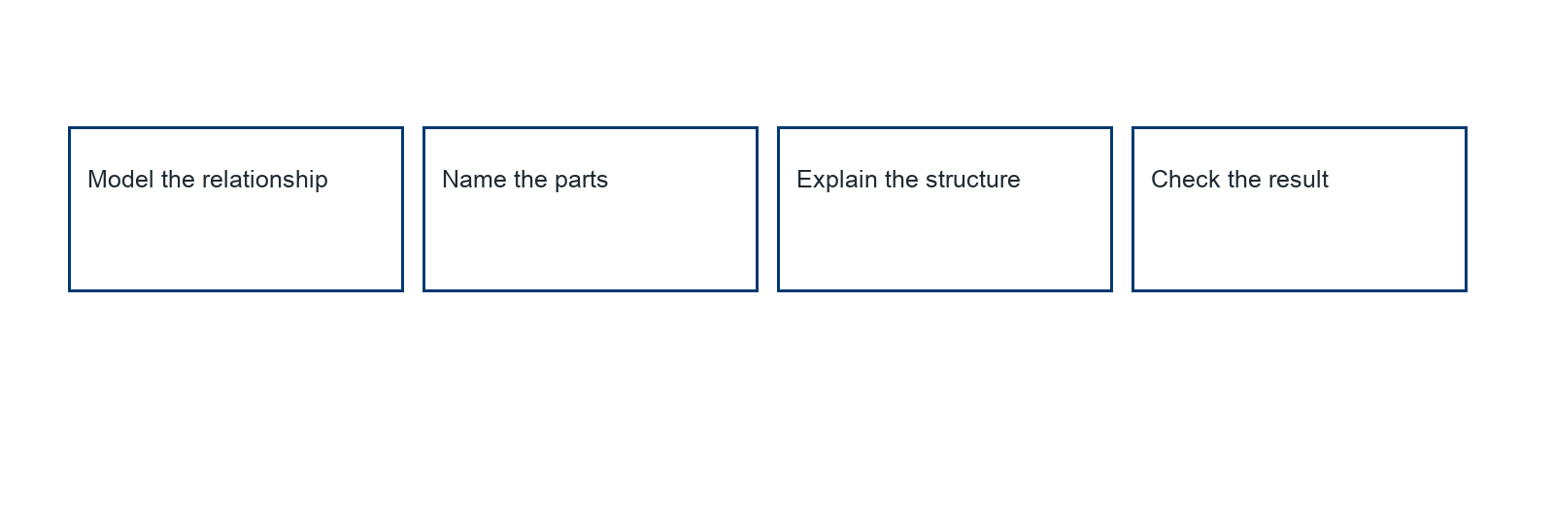
________________________________________________________________
________________________________________________________________
________________________________________________________________

Extend your reasoning
Create a contrasting example that exposes the misconception: repeats the fixed fee or writes an equation without an equality relationship.. Explain what changes and what stays true.
________________________________________________________________
________________________________________________________________
Self-check: Did my model, calculation, explanation, and units agree?

Session 2 · Model, reason, and explain
Evaluating Algebraic Expressions · 6.EE.A.2c
Success: represent the quantities, justify the relationship, and check the result with the correct units.
Evaluate 6p + 4 when p = 3. Show substitution, evaluate, and connect the terms to a cost story.
________________________________________________________________
________________________________________________________________
________________________________________________________________

Extend your reasoning
Create a contrasting example that exposes the misconception: adds before multiplying or treats 6p as 6+p.. Explain what changes and what stays true.
________________________________________________________________
________________________________________________________________
Self-check: Did my model, calculation, explanation, and units agree?

