Lesson 6.6 Guided Notes

Session 1 · Simplifying to Show Equivalence
I can simplify an expression by combining like terms to test whether two expressions are equivalent. · 6.EE.A.3
Word / Spanish | Meaning — complete the blank | Example
like terms / términos semejantes | Terms with the same __________ part. | 7c and 6c
combine / combinar | Add or subtract like terms into _____ term. | 7c + 6c = 13c
equivalent expressions / expresiones equivalentes | Expressions that have the same _______ for every number. | 7c + 9 + 6c and 13c + 9

Key idea
Like terms have the same __________ part; 4x and 4 are not like terms.
Combine like terms by adding their ______________: 4x + 9x = 13x.
Two expressions are equivalent if they simplify to the ______ expression.

Worked example
Simplify 9b + 4 + 3b + 1.
The like terms with b are 9b and _____.
Combine them: 9b + 3b = _____.
Combine the constants: 4 + 1 = _____.
Answer: 9b + 4 + 3b + 1 = _________

You try
1. Simplify.
a. 6a + 2a = ______
b. x + 4x + 3 = ______
________________________________________________________________
2. Are 2n + 7 + 3n and 5n + 7 equivalent? Simplify to decide.
________________________________________________________________
Sum it up: I can combine 3x and 5x but not 3x and 5 because ___.
________________________________________________________________

Session 2 · Testing and Justifying Equivalence
I can test whether two expressions are equivalent by substituting values and by reasoning. · 6.EE.A.4
Word / Spanish | Meaning — complete the blank | Example
equivalent expressions / expresiones equivalentes | Expressions with the same value for _______ value of the variable. | 2(y + 7) and 2y + 14
counterexample / contraejemplo | One test value that shows a claim is _______. | x = 1: 2x + 8 = 10, 4x = 4
Distributive Property / propiedad distributiva | Multiply the number outside by ______ term inside the parentheses. | 4(n + 3) = 4n + 12
Commutative Property / propiedad conmutativa | You can change the _______ when you add or multiply. | a + b = b + a

Key idea
To test, substitute the ______ value into both expressions.
One value that gives different results proves they are _____ equivalent.
Matching values do not prove it; _________ with properties.

Worked example
Are 2x + 8 and 4x equivalent?
Try x = 4: 2 × 4 + 8 = 16 and 4 × 4 = _____. One match is not proof.
Try x = 1: 2 × 1 + 8 = _____ and 4 × 1 = 4.
10 ≠ 4, so x = 1 is a ________________.
Answer: They are _____ equivalent.

You try
1. Evaluate when a = 3.
a. 2(a + 1) = ______
b. 2a + 1 = ______
________________________________________________________________
2. Are 5m and m + 4 equivalent? Test m = 1 and m = 2.
________________________________________________________________
Sum it up: One matching test value does not prove two expressions are equivalent because ___.
________________________________________________________________

Session 1 · Model, reason, and explain
Simplifying to Show Equivalence · 6.EE.A.3
Success: represent the quantities, justify the relationship, and check the result with the correct units.
Use a grouping or tile model to simplify 4x + 3 + 2x + 5. Explain why 4x and 2x combine but 4x and 3 do not.
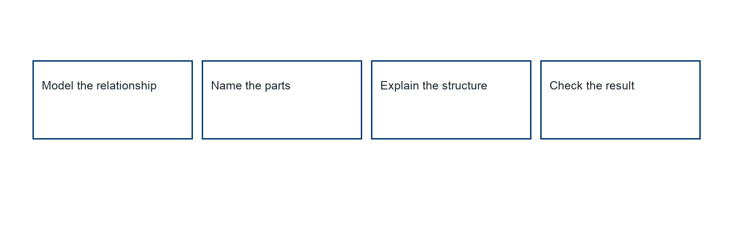
________________________________________________________________
________________________________________________________________
________________________________________________________________

Extend your reasoning
Create a contrasting example that exposes the misconception: combines variable terms and constants into one coefficient.. Explain what changes and what stays true.
________________________________________________________________
________________________________________________________________
Self-check: Did my model, calculation, explanation, and units agree?

Session 2 · Model, reason, and explain
Testing and Justifying Equivalence · 6.EE.A.4
Success: represent the quantities, justify the relationship, and check the result with the correct units.
Are 3(x+2) and 3x+6 equivalent? Are 3x+6 and 6x equivalent? Give a property argument for one and a counterexample for the other.
________________________________________________________________
________________________________________________________________
________________________________________________________________

Extend your reasoning
Create a contrasting example that exposes the misconception: treats one matching substitution as proof of equivalence.. Explain what changes and what stays true.
________________________________________________________________
________________________________________________________________
Self-check: Did my model, calculation, explanation, and units agree?

