Lesson 6.7 Guided Notes

Session 1 · Factors and Greatest Common Factor
I can list the factors of two numbers and find their greatest common factor. · 6.NS.B.4
Word / Spanish | Meaning — complete the blank | Example
factor / factor | A whole number that divides another number with _____ remainder. | 1, 2, 4, 8, 16 all divide 16
common factor / factor común | A factor that two numbers _______. | 4 is a factor of 16 and of 24
greatest common factor (GCF) / máximo común divisor | The __________ factor that two numbers share. | GCF of 16 and 24 is 8
prime factorization / factorización prima | A number written as a product of _______ numbers. | 24 = 2 × 2 × 2 × 3

Key idea
List the factors of each number, then circle the factors that appear in ______ lists.
The GCF tells the greatest number of ___________ groups you can make with nothing left over.

Worked example
A teacher has 20 pencils and 30 markers. She makes identical kits with nothing left over. What is the greatest number of kits?
Factors of 20: 1, 2, 4, 5, _____, 20.
Factors of 30: 1, 2, 3, 5, 6, 10, 15, 30. Shared: 1, 2, 5, 10.
The GCF is _____, so she can make 10 kits.
Answer: Each kit has 20 ÷ 10 = _____ pencils and 30 ÷ 10 = _____ markers.

You try
1. Find the GCF of each pair.
a. 12 and 30 ______
b. 27 and 36 ______
________________________________________________________________
2. A coach has 24 balls and 32 cones. She sets up identical stations with nothing left over. What is the greatest number of stations?
________________________________________________________________
Sum it up: To find the GCF of two numbers, I ___ because ___.
________________________________________________________________

Session 2 · Multiples and Least Common Multiple
I can list multiples of two numbers and find their least common multiple. · 6.NS.B.4
Word / Spanish | Meaning — complete the blank | Example
multiple / múltiplo | A number you land on when you ____________ by another number. | 6, 12, 18, 24
common multiple / múltiplo común | A number that is a multiple of ______ numbers. | 18 is a multiple of 6 and of 9
least common multiple (LCM) / mínimo común múltiplo | The __________ number above 0 that is a multiple of both. | LCM of 6 and 9 is 18

Key idea
List multiples of each number and find the _______ number on both lists.
The product of two numbers is always a common multiple, but not always the _______ one.

Worked example
A library van visits every 8 days. An art cart visits every 10 days. Both visit today. In how many days will both visit again?
Multiples of 8: 8, 16, 24, 32, _____.
Multiples of 10: 10, 20, 30, 40.
The first shared multiple is the LCM: _____.
Answer: Both visit again in _____ days.

You try
1. Find the LCM of each pair.
a. 4 and 6 ______
b. 5 and 10 ______
________________________________________________________________
2. Plates come in packs of 12. Cups come in packs of 9. What is the fewest of each you can buy to have the same number?
________________________________________________________________
Sum it up: To find the LCM of two numbers, I ___ because ___.
________________________________________________________________

Session 1 · Model, reason, and explain
Factors and Greatest Common Factor · 6.NS.B.4
Success: represent the quantities, justify the relationship, and check the result with the correct units.
Make the greatest possible number of identical kits using 24 pencils and 36 markers with nothing left. Find number of kits and contents per kit.
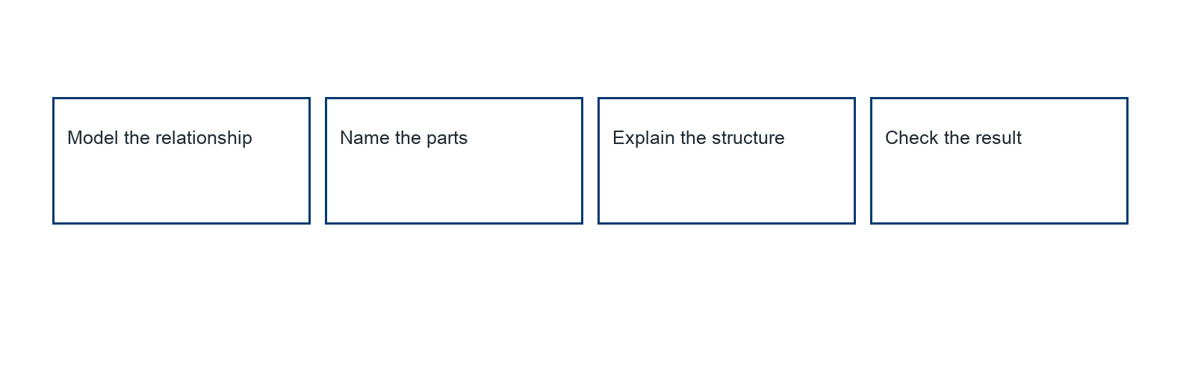
________________________________________________________________
________________________________________________________________
________________________________________________________________

Extend your reasoning
Create a contrasting example that exposes the misconception: reports the number of items per kit as the GCF.. Explain what changes and what stays true.
________________________________________________________________
________________________________________________________________
Self-check: Did my model, calculation, explanation, and units agree?

Session 2 · Model, reason, and explain
Multiples and Least Common Multiple · 6.NS.B.4
Success: represent the quantities, justify the relationship, and check the result with the correct units.
Two visits occur every 6 days and every 8 days. Both happen today. Draw event timelines and find the next shared day.
________________________________________________________________
________________________________________________________________
________________________________________________________________

Extend your reasoning
Create a contrasting example that exposes the misconception: uses GCF for recurrence or reports today as the next meeting.. Explain what changes and what stays true.
________________________________________________________________
________________________________________________________________
Self-check: Did my model, calculation, explanation, and units agree?

