Lesson 6.8 Guided Notes

Session 1 · Using Properties to Rewrite Expressions
I can use the distributive property and like terms to rewrite an expression in simplest form. · 6.EE.A.3
Word / Spanish | Meaning — complete the blank | Example
Distributive Property / propiedad distributiva | Multiply the outside number by ______ term inside the parentheses. | a(b + c) = ab + ac
Commutative Property / propiedad conmutativa | Changing the _______ when adding or multiplying does not change the answer. | a + b = b + a
Associative Property / propiedad asociativa | Changing the __________ when adding or multiplying does not change the answer. | (a + b) + c = a + (b + c)
like terms / términos semejantes | Terms with the same __________ part. | 4m and 3m

Key idea
Expressions are ____________ when they give the same value for every value of the variable.
To simplify: distribute, put like terms together, then _________ them.

Worked example
Simplify 4(m + 2) + 3m.
Distribute: 4(m + 2) = 4m + _____.
Reorder: 4m + 3m + 8 (Commutative Property).
Combine like terms: 4m + 3m = _____.
Answer: 4(m + 2) + 3m = ________

You try
1. Write each expression in simplest form.
a. 2(x + 5) = ______
b. 3(y + 1) + 2y = ______
________________________________________________________________
2. Simplify 6(c + 2) + c + 4. Check your answer with c = 1.
________________________________________________________________
Sum it up: Two expressions are equivalent when ___, so I can check by ___.
________________________________________________________________

Session 2 · Expanding and Factoring Expressions
I can expand an expression and factor one using the greatest common factor. · 6.EE.A.3
Word / Spanish | Meaning — complete the blank | Example
expand / desarrollar | Multiply to ________ the parentheses. | 6(3x + 4) = 18x + 24
factor an expression / factorizar una expresión | Write it as a _________: a shared factor times a sum. | 18x + 24 = 6(3x + 4)
term / término | One ______ of an expression, separated by + or − signs. | 18x and 24 are terms
greatest common factor / máximo común divisor | The _________ number that divides both numbers evenly. | GCF of 18 and 24 is 6

Key idea
Factoring ________ expanding, so you can check a factored form by expanding it.
Factor out the _____ so the terms inside share no other common factor.

Worked example
Factor 18x + 27 using the GCF.
The GCF of 18 and 27 is _____.
Divide each term: 18x ÷ 9 = _____ and 27 ÷ 9 = 3.
Check: 9 × 2x + 9 × 3 = 18x + 27.
Answer: 18x + 27 = ___________

You try
1. Expand or factor.
a. Expand 4(2x + 3) ______
b. Factor 15y + 20 ______
________________________________________________________________
2. Factor 16n + 24 using the GCF. Then expand to check.
________________________________________________________________
Sum it up: To factor an expression, I ___, and I check by ___.
________________________________________________________________

Session 1 · Model, reason, and explain
Using Properties to Rewrite Expressions · 6.EE.A.3
Success: represent the quantities, justify the relationship, and check the result with the correct units.
Use a partitioned rectangle to expand 3(x+4), then simplify 3(x+4)+2x. Explain which property justifies each change.
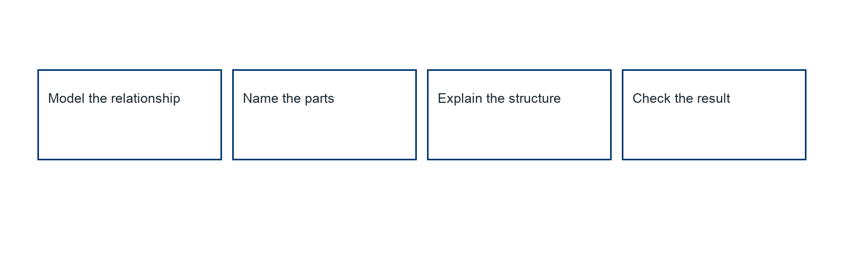
________________________________________________________________
________________________________________________________________
________________________________________________________________

Extend your reasoning
Create a contrasting example that exposes the misconception: distributes to only the variable term.. Explain what changes and what stays true.
________________________________________________________________
________________________________________________________________
Self-check: Did my model, calculation, explanation, and units agree?

Session 2 · Model, reason, and explain
Expanding and Factoring Expressions · 6.EE.A.3
Success: represent the quantities, justify the relationship, and check the result with the correct units.
Factor 12x+18 using the greatest common factor. Expand to verify. Is 2(6x+9) also equivalent, and why is it not factored by the GCF?
________________________________________________________________
________________________________________________________________
________________________________________________________________

Extend your reasoning
Create a contrasting example that exposes the misconception: accepts any common factor as the greatest or fails to divide every term.. Explain what changes and what stays true.
________________________________________________________________
________________________________________________________________
Self-check: Did my model, calculation, explanation, and units agree?

