Name Date Period
Lesson 7-1 · Session 1 · Guided Steps · Form A
Integers and Opposites
Learning target — I can write an integer for a real situation and name its opposite. · 6.NS.C.5
REMEMBER
• Positive and negative numbers show opposite directions from 0. First decide what 0 means.
• Above, gain, and deposit are positive. Below, loss, and debt are negative.
• Opposites are the same distance from 0 on different sides. Zero is its own opposite.
GUIDED PRACTICE fill in each blank — problems 1–4
1. Write an integer for each situation.
a. a gain of 12 yards  Step 1 Positive or negative?  Step 2 The integer is | b. a debt of 25 dollars  Step 1 Positive or negative?  Step 2 The integer is

c. 8 degrees below zero  Step 1 Positive or negative?  Step 2 The integer is | d. 3 floors below the street  Step 1 Positive or negative?  Step 2 The integer is

2. Write the opposite of each number.
a. −19  Step 1 Side of 0?  Step 2 Opposite: | b. 6  Step 1 Side of 0?  Step 2 Opposite: | c. 0  Step 1 Side of 0?  Step 2 Opposite:

3. Hiking Trail. A trail map lists four spots: Ridge Point 35 m above sea level, Salt Flat 20 m below, Camp 15 m above, and Cave Floor 35 m below.
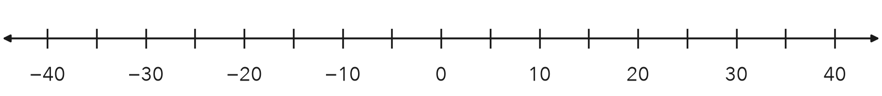
Step 1 Ridge Point: 35 m above →
Step 2 Salt Flat: 20 m below →
Step 3 Camp: 15 m above →
Step 4 Cave Floor: 35 m below →
a. Write the integers: Ridge Salt Flat Camp Cave
b. Plot and label all four. Which two spots are opposites?

4. Sunrise Temperature. At sunrise it was 12 degrees below zero. Write the integer. Then write its opposite.
Step 1 Below zero means (+ or −)
Step 2 The integer is
Step 3 The opposite is the same distance from 0, on the other side
Step 4 The opposite is
Integer, opposite ,

ON YOUR OWN use the open space · show your work · label units
5. Marco’s Claim. Marco says the opposite of −18 is −18, because it already has a negative sign. Is he right?  Show your work.  Opposite | 6. Golf Scores. Three golfers finished at 7 under par, 7 over par, and even par. Write an integer for each. Plot them. Name the opposite pair.  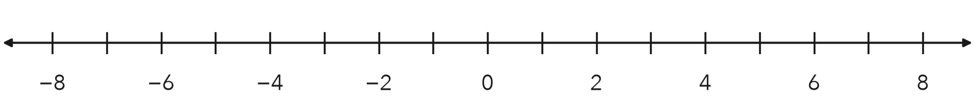  Show your work.  Opposite pair

7. Windmill and Well. A windmill blade tops out 31 feet above the ground. A well bottom sits at the opposite elevation.  a. Integer for the well bottom: ft  b. What does 0 represent here?  Show your work. | 8. Elevator Trip. An elevator starts at the lobby, marked 0. It goes down 3 floors, then up 7 floors.  a. Write an integer for each move.  b. Integer for the floor where it ends:  c. What would the opposite of that floor mean?  Show your work.

FIND THE ERROR explain the mistake, then fix it
9. Tessa’s Work. A canyon floor sits 24 meters below sea level. Tessa wrote the elevation as 24 and said its opposite is also 24. Explain her two mistakes. Then give the correct elevation and its opposite.
Show your work.

TEST PRACTICE choose the best answer
10. A debt of 30 dollars is written as —
A 30 B −30 C 0 D −(−30)

11. The opposite of 0 is —
A 1 B −1 C 0 D There is none.

CHECK YOURSELF
□ I can do this on my own □ I need a little help □ I have a question about #

