Name Date Period
Lesson 7-1 · Session 1 · Guided Steps · Form B
Integers and Opposites
Learning target — I can write an integer for a real situation and name its opposite. · 6.NS.C.5
REMEMBER
• Positive and negative numbers show opposite directions from 0. First decide what 0 means.
• Above, gain, and deposit are positive. Below, loss, and debt are negative.
• Opposites are the same distance from 0 on different sides. Zero is its own opposite.
GUIDED PRACTICE fill in each blank — problems 1–4
1. Write an integer for each situation.
a. a rocket rises 17 meters  Step 1 Positive or negative?  Step 2 The integer is | b. an unpaid bill of 32 dollars  Step 1 Positive or negative?  Step 2 The integer is

c. 6 degrees below zero  Step 1 Positive or negative?  Step 2 The integer is | d. 4 floors below the street  Step 1 Positive or negative?  Step 2 The integer is

2. Write the opposite of each number.
a. −23  Step 1 Side of 0?  Step 2 Opposite: | b. 9  Step 1 Side of 0?  Step 2 Opposite: | c. 0  Step 1 Side of 0?  Step 2 Opposite:

3. Ocean Research Map. A map lists four spots: Lookout 28 m above sea level, Reef 16 m below, Dock 12 m above, and Dive Station 28 m below.
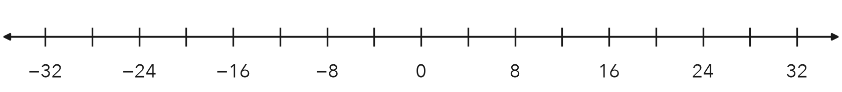
Step 1 Lookout: 28 m above →
Step 2 Reef: 16 m below →
Step 3 Dock: 12 m above →
Step 4 Dive Station: 28 m below →
a. Write the integers: Lookout Reef Dock Dive Station
b. Plot and label all four. Which two spots are opposites?

4. Freezer Temperature. A freezer is 15 degrees below zero. Write the integer. Then write its opposite.
Step 1 Below zero means (+ or −)
Step 2 The integer is
Step 3 The opposite is the same distance from 0, on the other side
Step 4 The opposite is
Integer, opposite ,

ON YOUR OWN use the open space · show your work · label units
5. Lena’s Claim. Lena says the opposite of −21 is −21, because it already has a negative sign. Is she right?  Show your work.  Opposite | 6. Golf Scores. Three golfers finished at 5 under par, 5 over par, and even par. Write an integer for each. Plot them. Name the opposite pair.  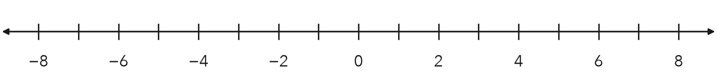  Show your work.  Opposite pair

7. Tower and Tunnel. A water tower top is 44 feet above the ground. A tunnel bottom sits at the opposite elevation.  a. Integer for the tunnel bottom: ft  b. What does 0 represent here?  Show your work. | 8. Elevator Trip. An elevator starts at the lobby, marked 0. It goes down 5 floors, then up 8 floors.  a. Write an integer for each move.  b. Integer for the floor where it ends:  c. What would the opposite of that floor mean?  Show your work.

FIND THE ERROR explain the mistake, then fix it
9. Darius’s Work. A cave floor sits 26 meters below sea level. Darius wrote the elevation as 26 and said its opposite is also 26. Explain his two mistakes. Then give the correct elevation and its opposite.
Show your work.

TEST PRACTICE choose the best answer
10. A rise of 9 degrees is written as —
A −9 B 9 C 0 D −(9)

11. The opposite of −15 is —
A −15 B 0 C 15 D 1/15

CHECK YOURSELF
□ I can do this on my own □ I need a little help □ I have a question about #

