Name Date Period
Lesson 7-2 · Session 1 · Guided Steps · Form A
Rational Numbers on a Number Line
Learning target — I can plot a rational number and its opposite on a number line. · 6.NS.C.6c
REMEMBER
• A rational number can be written as a fraction of two integers: 3/4, −2.5 = −5/2, 7 = 7/1.
• To plot one, mark the integers, then split each gap into equal parts (halves, fourths, tenths).
• Negative numbers sit left of 0, or below 0 on a vertical number line.
GUIDED PRACTICE fill in each blank
1. Name the two integers each number is between.
a. −9/2  Step 1 9 ÷ 2 = r  Step 2 Between − and − | b. 0.75  Step 1 0.75 is more than  Step 2 and less than

c. −11/4  Step 1 11 ÷ 4 = r  Step 2 Between − and − | d. −2.4  Step 1 2.4 is between and  Step 2 So between − and −

2. Garden Log. A garden log measures from the soil surface (0): sunflower 3.5 m up, carrot root 0.75 m down, bean sprout 0.5 m up, tulip bulb 0.2 m down.
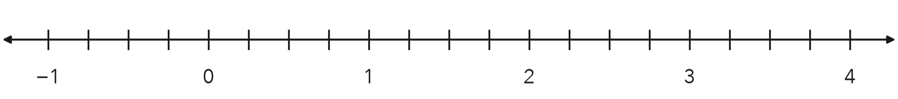
a. Write a rational number for each:
 | Sunflower | Carrot | Bean | Tulip
Up or down? | 3.5 m up | 0.75 m down | 0.5 m up | 0.2 m down
Sign (+ or −)
Number

b. Plot and label all four on the number line.

3. Lab Thermometer. A lab thermometer read −2.5 degrees at 6 a.m. and 2.5 degrees at noon. Plot both readings. How far is each reading from 0?
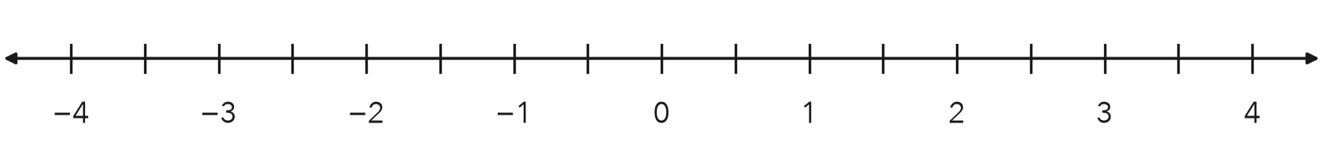
Step 1 Each tick is degree.
Step 2 2.5 is ticks from 0.
Step 3 −2.5 is ticks from 0.
Answer degrees

4. Mixing Bowl. A cook added 5/4 cups of broth to a bowl, then removed 5/4 cups. Write the removal as a rational number in decimal form.
Step 1 5 ÷ 4 = r
Step 2 5/4 = 1 and /4
Step 3 1/4 = 0. so 5/4 =
Step 4 Removing makes it (+ or −)
Answer cups

ON YOUR OWN use the open space · show your work · label units
5. Rational Claim. Lena says 7 is not a rational number because it is not written as a fraction. Write 7 as a fraction with a denominator of 1. Is Lena right?  Show your work.  Fraction | 6. Three Marks. A number strip shows the marks −11/4, 1.3 and −0.45. Plot all three. Which mark is closest to 0?  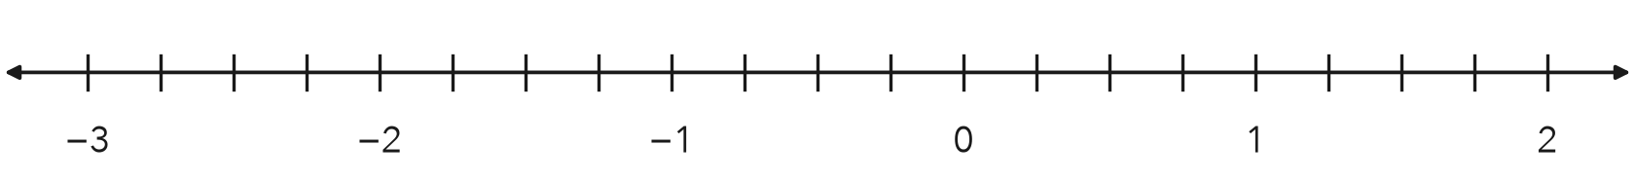  Show your work.  Closest to 0

7. Pool Depths. A pool’s surface is 0. A float sits 0.4 m above the surface and a drain sits at −1.6 m. How many meters farther from the surface is the drain than the float?  Show your work.  Answer m | 8. Ledge and Cave. A rock ledge is 12.5 meters above the sea surface. A cave floor sits at the opposite value.  a. Write the number for the cave floor. m  b. Between which two integers is the cave floor?  Show your work.  Answer and

FIND THE ERROR explain the mistake, then fix it
9. Rafael’s Work. To plot −3.4, Rafael counted four tenths to the RIGHT of −3 and put his point between −3 and −2. Explain his mistake. Then name the two integers −3.4 is between.
Show your work.

TEST PRACTICE choose the best answer
10. On a number line, −2.5 sits between —
A −2 and −1 B −3 and −2 C 2 and 3 D −2.5 and −2

11. Which number is farthest left on a number line?
A −4.5 B −1.5 C 0 D 2.5

CHECK YOURSELF
□ I can do this on my own □ I need a little help □ I have a question about #

