Name Date Period
Lesson 7-2 · Session 1 · Guided Steps · Form B
Rational Numbers on a Number Line
Learning target — I can plot a rational number and its opposite on a number line. · 6.NS.C.6c
REMEMBER
• A rational number can be written as a fraction of two integers: 3/4, −2.5 = −5/2, 7 = 7/1.
• To plot one, mark the integers, then split each gap into equal parts (halves, fourths, tenths).
• Negative numbers sit left of 0, or below 0 on a vertical number line.
GUIDED PRACTICE fill in each blank
1. Name the two integers each number is between.
a. −7/2  Step 1 7 ÷ 2 = r  Step 2 Between − and − | b. 0.4  Step 1 0.4 is more than  Step 2 and less than

c. −9/4  Step 1 9 ÷ 4 = r  Step 2 Between − and − | d. −3.7  Step 1 3.7 is between and  Step 2 So between − and −

2. Garden Log. Ms. Patel’s class measures from the soil surface (0): sunflower 2.5 m up, carrot root 0.5 m down, bean sprout 1.25 m up, tulip bulb 0.3 m down.
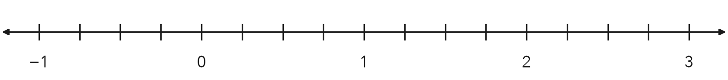
a. Write a rational number for each:
 | Sunflower | Carrot | Bean | Tulip
Up or down? | 2.5 m up | 0.5 m down | 1.25 m up | 0.3 m down
Sign (+ or −)
Number

b. Plot and label all four on the number line.

3. Lab Thermometer. A lab thermometer read −3.5 degrees at 6 a.m. and 3.5 degrees at noon. Plot both readings. How far is each reading from 0?
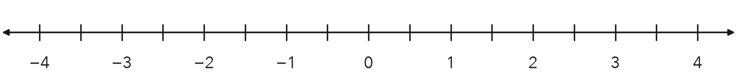
Step 1 Each tick is degree.
Step 2 3.5 is ticks from 0.
Step 3 −3.5 is ticks from 0.
Answer degrees

4. Mixing Bowl. A cook added 7/4 cups of broth to a bowl, then removed 7/4 cups. Write the removal as a rational number in decimal form.
Step 1 7 ÷ 4 = r
Step 2 7/4 = 1 and /4
Step 3 3/4 = 0. so 7/4 =
Step 4 Removing makes it (+ or −)
Answer cups

ON YOUR OWN use the open space · show your work · label units
5. Rational Claim. Jalen says −4 is not a rational number because it is not written as a fraction. Write −4 as a fraction with a denominator of 1. Is Jalen right?  Show your work.  Fraction | 6. Three Marks. A number strip shows the marks −9/4, 1.6 and −0.35. Plot all three. Which mark is closest to 0?  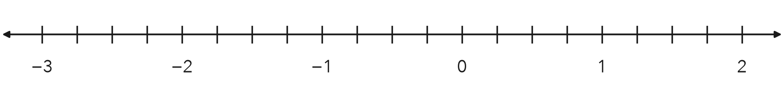  Show your work.  Closest to 0

7. Pool Depths. A pool’s surface is 0. A float sits 0.6 m above the surface and a drain sits at −2.1 m. How many meters farther from the surface is the drain than the float?  Show your work.  Answer m | 8. Ledge and Cave. A rock ledge is 8.5 meters above the sea surface. A cave floor sits at the opposite value.  a. Write the number for the cave floor. m  b. Between which two integers is the cave floor?  Show your work.  Answer and

FIND THE ERROR explain the mistake, then fix it
9. Jalen’s Work. To plot −3.6, Jalen counted six tenths to the RIGHT of −3 and put his point between −3 and −2. Explain his mistake. Then name the two integers −3.6 is between.
Show your work.

TEST PRACTICE choose the best answer
10. On a number line, −1.5 sits between —
A −1 and 0 B 1 and 2 C −2 and −1 D −1.5 and −1

11. Which number is farthest right on a number line?
A −0.5 B −3 C 0.25 D −0.75

CHECK YOURSELF
□ I can do this on my own □ I need a little help □ I have a question about #

