Name Date Period
Lesson 7-4 · Session 2 · Guided Steps · Form A
Ordering Integers and Rational Numbers
Learning target — I can order integers and rational numbers from least to greatest. · 6.NS.C.7b
REMEMBER
• Least to greatest means left to right on a number line. Greatest to least means right to left.
• The number farthest from 0 may be the least. Deepest or coldest means least.
• Change every number to a decimal first: −2 1/2 = −2.5 and 3/4 = 0.75.
GUIDED PRACTICE fill in each blank
1. Order each set from least to greatest.
a. −2, −14, −9  Step 1 All are negative. Farthest from 0:  Step 2 Closest to 0:  Step 3 Least to greatest:  , , | b. −3, 2.5, −0.5, 0  Step 1 Negatives: <  Step 2 Then 0 and positives: <  Step 3 Least to greatest:  , , ,

2. Golf Leaderboard. Scores: Sofia −3, Lena 2, Mark −7, Owen 0, Dev 5. In golf, the least score leads.
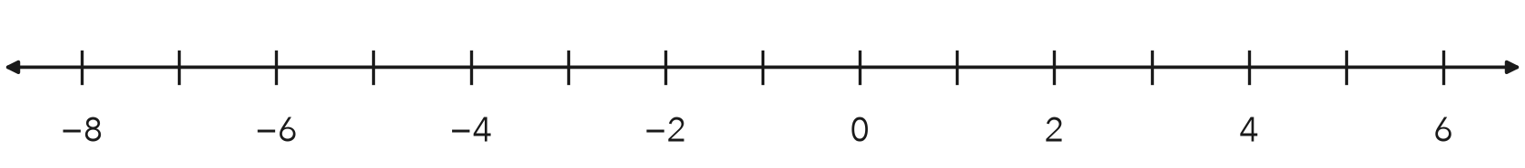
a. Plot the scores. Order them from least to greatest.
Step 1 Negatives, least first: ,
Step 2 Zero and positives: , ,
a.
b. Which score is farther from 0, −7 or 5?
Step 3 ∣−7∣ = and ∣5∣ =
b. Farther from 0:
c. Who is leading?
Step 4 The least score is
c. Leader:

3. Lake Floors. Three lake floors sit at −188 ft, −640 ft, and −1,105 ft. Which floor is deepest?
Step 1 Distances below 0: 188, 640,
Step 2 The deepest is the distance
Step 3 Deepest floor: ft
Deepest ft

4. Mixed Forms. Order −1/2, −0.75, and −1.25 from least to greatest. Which is greatest?
Step 1 −1/2 = −0.
Step 2 All three are negative. Farthest from 0:
Step 3 Least to greatest:
, ,
Greatest

ON YOUR OWN use the open space · show your work · label units
5. Week of Lows. Low temperatures: −11, 4, −19, 0, and −2 degrees. Plot and order them from least to greatest. Name the coldest reading.  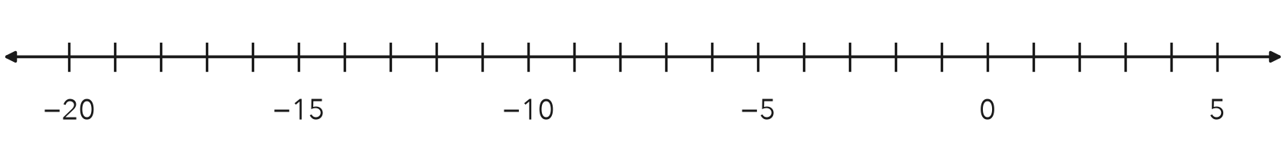  Show your work.  Coldest | 6. Number Strip. A strip shows −2.5, −2.05, 1/2, and −3.4. Order them from greatest to least. Which has the greatest absolute value?  Show your work.  Greatest |n|

7. Harbor Depths. A harbor chart lists −16 ft, −4 1/2 ft, 0 ft, and −16.5 ft. Order them from least to greatest. Name the deepest spot.  Show your work.  Deepest | 8. Five Readings. Sensors read 1.5, −2, −1/4, 0.75, and −2.5 degrees.  a. Write every reading as a decimal.  b. Order the readings from least to greatest.  Show your work.  c. Which reading is closest to 0? How do you know?  Show your work.

FIND THE ERROR explain the mistake, then fix it
9. Isaiah’s Work. Isaiah ordered −2, −14, and −9 from least to greatest as −2, −9, −14, because 2 is smaller than 9 and 14. Explain his mistake. Then write the correct order.
Show your work.

TEST PRACTICE choose the best answer
10. The least of −8, −15, and −2 is —
A −8 B −15 C −2 D 0

11. The greatest of −4.5, −4.05, and −4.55 is —
A −4.5 B −4.05 C −4.55 D They are equal.

CHECK YOURSELF
□ I can do this on my own □ I need a little help □ I have a question about #

