Name Date Period
Lesson 7-5 · Session 1 · Guided Steps · Form B
Plotting Points on the Coordinate Plane
Learning target — I can plot a point with rational coordinates and name the quadrant it lies in. · 6.NS.C.6c
REMEMBER
• An ordered pair (x, y) names a point. Start at the origin (0, 0): x says right or left, then y says up or down.
• Signs name the quadrant: (+, +) I, (−, +) II, (−, −) III, (+, −) IV.
• A point with a 0 coordinate is on an axis, not in a quadrant.
GUIDED PRACTICE fill in each blank — problems 1–4
1. Name the quadrant or axis for each point.
a. (−3, 8)  Step 1 x is + or − ?  Step 2 y is + or − ?  Step 3 Quadrant: | c. (−6, −1)  Step 1 x is + or − ?  Step 2 y is + or − ?  Step 3 Quadrant: | e. (0, 3)  Step 1 Which one is 0?  Step 2 On the -axis

b. (5, 2) | d. (7, −4) | f. (−6, 0)

2. Park Map. Ms. Rivera’s class map puts the fountain at the origin. Gate (3, 6), Pond (−8, 4), Bench (−2, −7), Swing Set (6, −5).  Step 1 Start at the origin, (0, 0).  Step 2 Move along x first, then y.  Step 3 Mark each spot and label it.  a. Plot and label all four spots.  c. Ordered pair for the fountain: ( , ) | 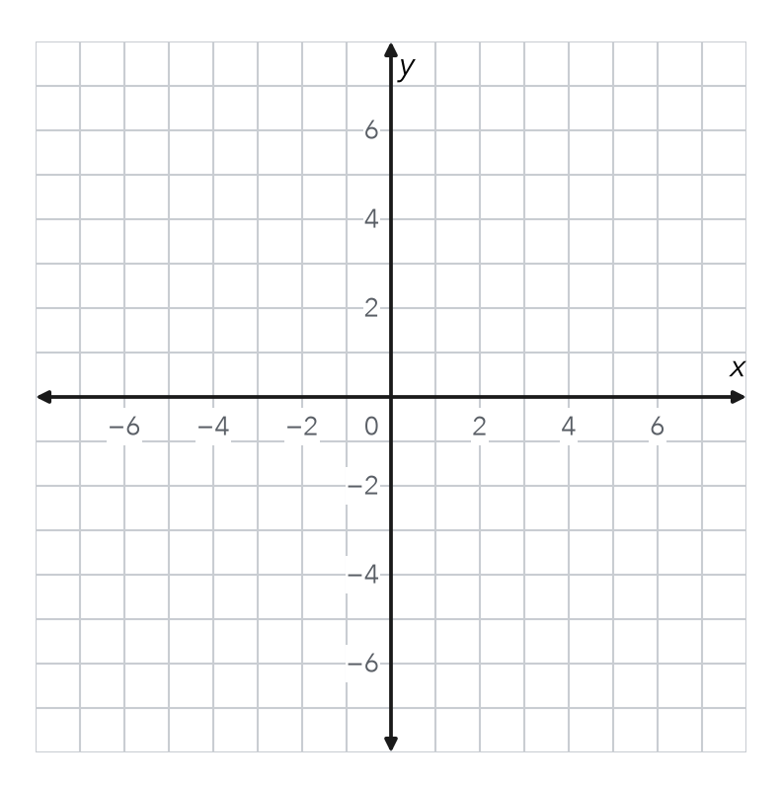
   | Gate | Pond | Bench | Swing Set
  x is + or −
  y is + or −
  Quadrant

3. Build the Pair. A point is 9 units left of the y-axis and 5 units below the x-axis. Write its ordered pair and quadrant.
Step 1 9 units left of y-axis so x =
Step 2 5 units below x-axis so y =
Step 3 Ordered pair: ( , )
Step 4 Quadrant:

4. Order Matters. Name the quadrant of (−4, 2) and of (2, −4). Are they the same point?
1st: (−4, 2)  Step 1 x is + or − ?  Step 2 y is + or − ?  Step 3 Quadrant: | 2nd: (2, −4)  Step 4 x is + or − ?  Step 5 y is + or − ?  Step 6 Quadrant:

Step 7 Same point? (yes or no)

ON YOUR OWN use the open space · show your work · label units
5. Same Digits. Theo says (3, −7) and (−7, 3) name the same point because they use the same two numbers. Explain why he is wrong.
Show your work.

6. Rational Coordinates. Plot (−2.5, −4.5) and (3.5, 1.5). Name each quadrant.  Quadrants and  Show your work. | 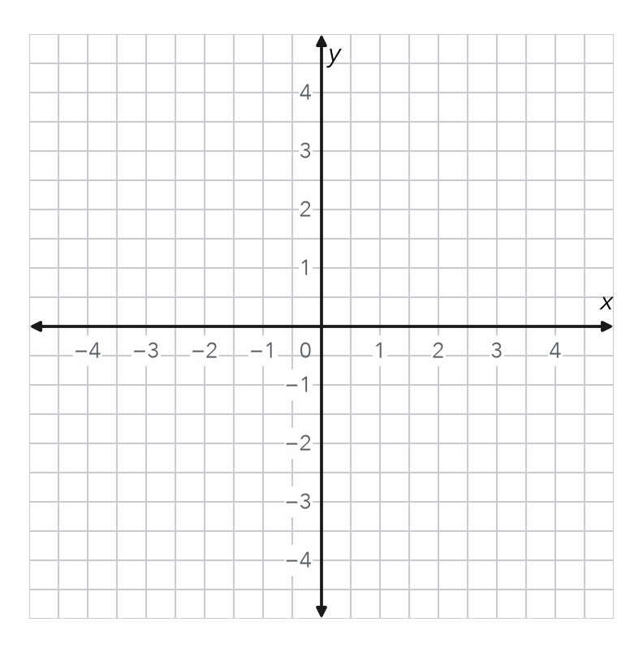

7. City Map. The library is at the origin. The museum is at (6, −3). The stadium is at (−8, 2).  a. Quadrant: museum stadium  b. Ordered pair for the library: ( , )  Show your work. | 8. Map Points. A map shows a school at (3.5, −2), a park at (−3.5, −2), and a pool at (−3.5, 4).  a. Quadrant of each place:  b. Shared y-coordinate:  c. How many units straight up is the pool from the park?  Show your work.

FIND THE ERROR explain the mistake, then fix it
9. Jalen’s Work. Jalen plotted (−3, 6) by moving down 3 units and then right 6 units. His point landed in Quadrant IV. Explain his mistake. Then describe the correct moves and quadrant.
Show your work.

TEST PRACTICE choose the best answer
10. The point (5, −2) lies in —
A Quadrant I B Quadrant II C Quadrant III D Quadrant IV

11. A point with both coordinates negative lies in —
A Quadrant I B Quadrant II C Quadrant III D Quadrant IV

CHECK YOURSELF
□ I can do this on my own □ I need a little help □ I have a question about #

