Name Date Period
Lesson 7-5 · Session 2 · Guided Steps · Form B
Reflecting Points Across Axes
Learning target — I can reflect a point across the x-axis or the y-axis and name the new coordinates. · 6.NS.C.6b
REMEMBER
• A reflection flips a point like a mirror image. Only one coordinate changes sign.
• Across the x-axis, y changes sign: (4, 1) becomes (4, −1). Across the y-axis, x changes sign: (4, 1) becomes (−4, 1).
• A point and its image are the same distance from the mirror: (−5, 2) and (5, 2) are 5 + 5 = 10 units apart.
GUIDED PRACTICE fill in each blank — problems 1–4
1. Write the image after each reflection.
a. (6, 2) across the x-axis  Step 1 x stays: x =  Step 2 Change y = 2 to  Step 3 Image: ( , ) | b. (−5, 7) across the y-axis  Step 1 y stays: y =  Step 2 Change x = −5 to  Step 3 Image: ( , )

c. (8, −3) across the x-axis → ( , ) | d. (−10, −5) across the y-axis → ( , )

2. Mirror Room. Ms. Rivera’s floor plan puts lamp L at (−5, 6). One mirror lies along each axis.  a. Across the x-axis  Step 1 x stays: x =  Step 2 Change y = 6 to  Step 3 Image: ( , ) Quadrant  b. Across the y-axis  Step 4 y stays: y =  Step 5 Change x = −5 to  Step 6 Image: ( , ) Quadrant | 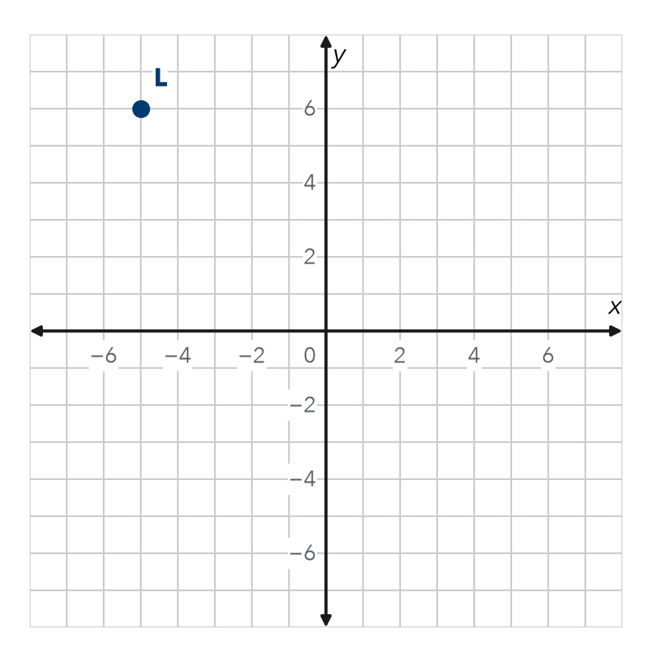

3. Two Kites. Maya’s kite flies over (−7, 2). Omar’s kite is its reflection across the y-axis. Where is Omar’s kite? How far apart are the kites?
Step 1 Across the y-axis, y stays: y =
Step 2 Change x = −7 to
Step 3 The 2nd kite is at ( , )
Step 4 Distance to the mirror: units
Step 5 Apart: + = units

4. Stage Lights. A light hangs over (−6, 9). A second light is its reflection across the x-axis. Where is it? How far apart are the lights?
Step 1 Across the x-axis, x stays: x =
Step 2 Change y = 9 to
Step 3 Light 2 is at ( , )
Step 4 Distance to the mirror: units
Step 5 Apart: + = units

ON YOUR OWN use the open space · show your work · label units
5. Which Mirror? Point P is at (−4, 7) and point Q is at (4, 7). Across which axis are they reflections? How do the coordinates show it?  Show your work. | 6. Ana’s Image. Ana says reflecting (4, −5) across the y-axis gives (4, 5). What did she mix up? Write the correct image.  Show your work.  Image ( , )

7. Double Flip. Theo’s marker at (−6, −3) reflects across the x-axis. Then that image reflects across the y-axis.  a. First image: ( , )  b. Final image: ( , )  c. Quadrant of the final image:  Show your work. | 8. Design Symmetry. A designer puts a corner at A(5, 2) and wants matching corners in the other three quadrants.  a. Reflect A across the y-axis: ( , )  b. Reflect A across the x-axis: ( , )  c. Name the fourth corner. How did you find it?  Show your work.

FIND THE ERROR explain the mistake, then fix it
9. Mateo’s Work. To reflect (−7, 2) across the x-axis, Mateo flipped both signs and wrote (7, −2). Explain his mistake. Then write the correct image.
Show your work.

TEST PRACTICE choose the best answer
10. Reflecting (5, 3) across the x-axis gives —
A (−5, 3) B (5, −3) C (−5, −3) D (3, 5)

11. Reflecting (−2, 8) across the y-axis gives —
A (2, 8) B (−2, −8) C (2, −8) D (8, −2)

CHECK YOURSELF
□ I can do this on my own □ I need a little help □ I have a question about #

