Name Date Period
Lesson 7-6 · Session 1 · Guided Steps · Form A
Distance Between Points on a Grid
Learning target — I can find the distance between two points that share a coordinate. · 6.NS.C.8
REMEMBER
• Same y-coordinate: the points are side to side. Use the x-coordinates.
• Same x-coordinate: the points are up and down. Use the y-coordinates.
• Opposite signs: add the absolute values. Same sign: subtract them. (5, −2) to (5, −9) is 9 − 2 = 7.
GUIDED PRACTICE fill in each blank — problems 1–4
1. Find the distance between each pair of points.
a. (3, 14) and (3, 4)  Step 1 Same x or same y?  Step 2 14 and 4: same or opposite?  Step 3 14 4 = units | b. (−11, 2) and (6, 2)  Step 1 Same x or same y?  Step 2 −11 and 6: same or opposite?  Step 3 11 6 = units

c. (−13, 9) and (−13, −6) = units | d. (−6, 4) and (5, 4) = units

2. Town Map Walk. Each unit is 1 kilometer. Library (−8, 5), Pool (7, 5), Clinic (−8, −6).  a. Plot and label the three places. | 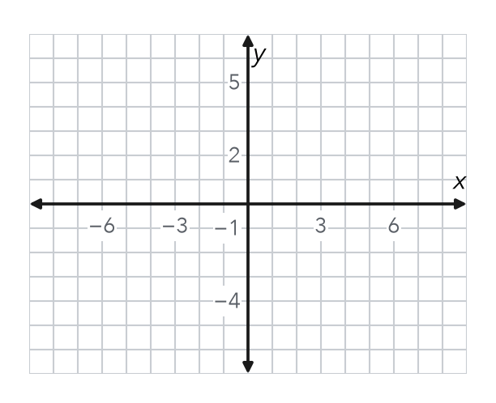
  b. Library to Pool  Step 1 Same x or same y?  Step 2 −8 and 7: same or opposite?  Step 3 8 7 = km | c. Library to Clinic  Step 4 Same x or same y?  Step 5 5 and −6: same or opposite?  Step 6 6 5 = km

3. Drone Flight. A drone flies straight from (−5, 13) to (−5, −4). Each unit is 1 meter. How far does it fly?
Step 1 Same x or same y?
Step 2 13 and −4: same or opposite?
Step 3 13 4 = meters

4. One Quadrant. Find the distance from (−16, −7) to (−16, −20).
Step 1 Same x or same y?
Step 2 −7 and −20: same or opposite?
Step 3 20 7 = units

ON YOUR OWN use the open space · show your work · label units
5. Missing Point. Point G is at (10, −3). Point H is 15 units directly to the left of G. Name point H.  Show your work.  Point H ( , ) | 6. Window Washer. A window washer moves from (21, 18) to (21, 7). Each unit is 1 foot. How far does the washer move?  Show your work.  Answer feet

7. Bus Route. A bus runs straight from (−17, −4) to (12, −4). Each unit is 1 block. How far does the bus go?
Show your work.

Answer blocks

8. City Grid. Each unit is 1 block. A library is at (−4, 6), a school at (5, 6) and a park at (5, −3). Plot the walk on the grid.  a. Library to school blocks  b. School to park blocks  c. Total walk blocks  Show your work. | 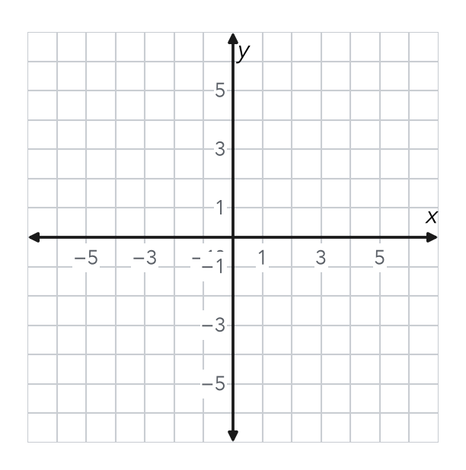

FIND THE ERROR explain the mistake, then fix it
9. Malik’s Work. To find the distance from (2, −9) to (2, 6), Malik wrote 9 − 6 = 3 units. Explain his mistake. Then find the correct distance.
Show your work.

TEST PRACTICE choose the best answer
10. The distance from (4, 2) to (4, 9) is —
A 2 units B 7 units C 11 units D 13 units

11. The distance from (−3, 5) to (6, 5) is —
A 3 units B 9 units C 11 units D −9 units

CHECK YOURSELF
□ I can do this on my own □ I need a little help □ I have a question about #

