Name Date Period
Lesson 7-6 · Session 1 · Guided Steps · Form B
Distance Between Points on a Grid
Learning target — I can find the distance between two points that share a coordinate. · 6.NS.C.8
REMEMBER
• Same y-coordinate: the points are side to side. Use the x-coordinates.
• Same x-coordinate: the points are up and down. Use the y-coordinates.
• Opposite signs: add the absolute values. Same sign: subtract them. (5, −2) to (5, −9) is 9 − 2 = 7.
GUIDED PRACTICE fill in each blank — problems 1–4
1. Find the distance between each pair of points.
a. (2, 12) and (2, 5)  Step 1 Same x or same y?  Step 2 12 and 5: same or opposite?  Step 3 12 5 = units | b. (−9, 3) and (7, 3)  Step 1 Same x or same y?  Step 2 −9 and 7: same or opposite?  Step 3 9 7 = units

c. (−12, 8) and (−12, −5) = units | d. (−5, 1) and (9, 1) = units

2. Town Map Walk. Each unit is 1 kilometer. Market (−6, 4), Museum (8, 4), Station (−6, −7).  a. Plot and label the three places. | 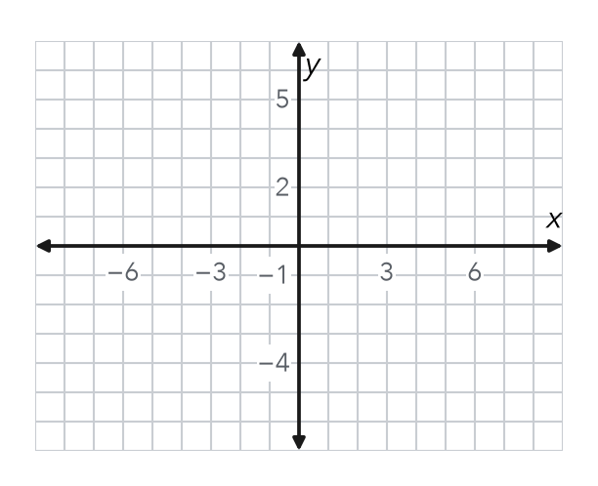
  b. Market to Museum  Step 1 Same x or same y?  Step 2 −6 and 8: same or opposite?  Step 3 8 6 = km | c. Market to Station  Step 4 Same x or same y?  Step 5 4 and −7: same or opposite?  Step 6 7 4 = km

3. Drone Flight. A drone flies straight from (−6, 11) to (−6, −5). Each unit is 1 meter. How far does it fly?
Step 1 Same x or same y?
Step 2 11 and −5: same or opposite?
Step 3 11 5 = meters

4. One Quadrant. Find the distance from (−15, −8) to (−15, −20).
Step 1 Same x or same y?
Step 2 −8 and −20: same or opposite?
Step 3 20 8 = units

ON YOUR OWN use the open space · show your work · label units
5. Missing Point. Point G is at (9, −2). Point H is 14 units directly to the left of G. Name point H.  Show your work.  Point H ( , ) | 6. Window Washer. A window washer moves from (19, 17) to (19, 8). Each unit is 1 foot. How far does the washer move?  Show your work.  Answer feet

7. Bus Route. Omar rides a bus straight from (−15, −3) to (13, −3). Each unit is 1 block. How far does he ride?
Show your work.

Answer blocks

8. City Grid. Each unit is 1 block. Daniel walks from a library at (−5, 4) to a school at (6, 4), then to a park at (6, −2). Plot the walk on the grid.  a. Library to school blocks  b. School to park blocks  c. Total walk blocks  Show your work. | 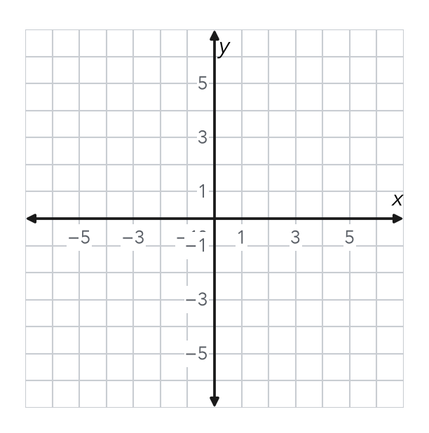

FIND THE ERROR explain the mistake, then fix it
9. Amina’s Work. To find the distance from (3, −8) to (3, 5), Amina wrote 8 − 5 = 3 units. Explain her mistake. Then find the correct distance.
Show your work.

TEST PRACTICE choose the best answer
10. The distance from (6, 1) to (6, 10) is —
A 4 units B 9 units C 11 units D −9 units

11. Two points with the same x-coordinate lie on a —
A horizontal line B vertical line C diagonal line D circle

CHECK YOURSELF
□ I can do this on my own □ I need a little help □ I have a question about #

