Name Date Period
Lesson 7-6 · Session 2 · Guided Steps · Form A
Comparing Distances on the Plane
Learning target — I can decide whether to add or subtract to find a distance, then compare two distances. · 6.NS.C.8
REMEMBER
• Find each distance first. Then compare the two numbers.
• Changing coordinates with opposite signs: add. Same sign: subtract.
• With a scale, change both distances to real units before you compare. A distance is never negative.
GUIDED PRACTICE fill in each blank — problems 1–4
1. Add or subtract? Find each distance.
a. (5, −3) to (5, −15)  Step 1 Same x or same y?  Step 2 −3 and −15: same or opposite?  Step 3 15 3 = units | b. (5, −3) to (5, 10)  Step 1 Same x or same y?  Step 2 −3 and 10: same or opposite?  Step 3 10 3 = units

c. (−4, 1) to (6, 1) = units | d. (3, −8) to (3, −2) = units

2. Campus Map. The map shows a gym (G), a field (F) and an office (O). Each grid unit stands for 10 meters.  c. Which trip is longer? By how many meters? | 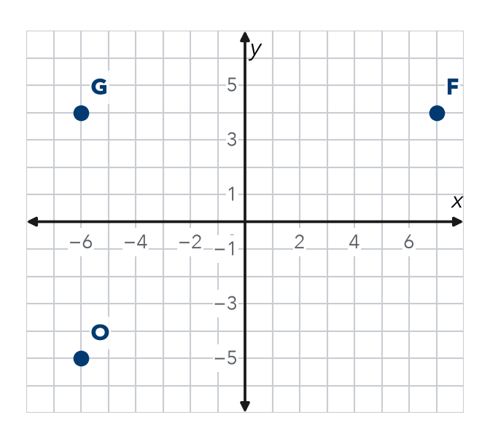
  a. Gym to Field  Step 1 G ( , ) F ( , )  Step 2 Units apart:  Step 3 units × 10 = m | b. Gym to Office  Step 4 G ( , ) O ( , )  Step 5 Units apart:  Step 6 units × 10 = m

3. Two Riders. From (−9, 5), Tariq rides to (−9, −8) and Jada rides to (6, 5). Each unit is 1 block. Who rides farther, and by how much?
Step 1 Tariq keeps x. Use y: 5 and −8.
Step 2 Same or opposite signs?
Step 3 Tariq: = blocks
Step 4 Jada keeps y. Use x: −9 and 6.
Step 5 Jada: = blocks
Step 6 Farther: by − = blocks

4. Partner Point. Point T is at (−4, 16). Point U is 22 units directly below T. Name point U.
Step 1 Moving down changes x or y?
Step 2 New y: 16 22 =
Step 3 Point U: ( , )

ON YOUR OWN use the open space · show your work · label units
5. Place the Stop. Point N is at (13, −5). Point M is 20 units directly to the left of N. Name point M.  Show your work.  Point M ( , ) | 6. Two Hikes. Kendra hikes from (−11, 12) to (−11, 3). Owen hikes from (−2, −15) to (10, −15). Each unit is 1 km. Who hikes farther, and by how much?  Show your work.  Who By km

7. Two Walks. From (4.25, 5.75), Ana walks to (4.25, −3.25) and Ben walks to (4.25, 9.75). Who walks farther, and by how much?  Show your work.  Who By units | 8. Delivery Routes. A depot is at (0, 0). Stop 1 is at (0, 12), Stop 2 is at (0, −9) and Stop 3 is at (0, 4).  a. Distance to each stop:  b. Order, closest to farthest:  c. Stop 1 to Stop 2 units  Show your work.

FIND THE ERROR explain the mistake, then fix it
9. Ines’s Work. To find the distance from (−8, 3) to (4, 3), Ines wrote 8 − 4 = 4 units. Explain her mistake. Then find the correct distance.
Show your work.

TEST PRACTICE choose the best answer
10. Two coordinates on the same side of zero call for —
A addition B subtraction C multiplication D division

11. A distance can never be —
A zero B a decimal C negative D greater than 10

CHECK YOURSELF
□ I can do this on my own □ I need a little help □ I have a question about #

