Name Date Period
Lesson 7-6 · Session 2 · Guided Steps · Form B
Comparing Distances on the Plane
Learning target — I can decide whether to add or subtract to find a distance, then compare two distances. · 6.NS.C.8
REMEMBER
• Find each distance first. Then compare the two numbers.
• Changing coordinates with opposite signs: add. Same sign: subtract.
• With a scale, change both distances to real units before you compare. A distance is never negative.
GUIDED PRACTICE fill in each blank — problems 1–4
1. Add or subtract? Find each distance.
a. (4, −2) to (4, −13)  Step 1 Same x or same y?  Step 2 −2 and −13: same or opposite?  Step 3 13 2 = units | b. (4, −2) to (4, 8)  Step 1 Same x or same y?  Step 2 −2 and 8: same or opposite?  Step 3 8 2 = units

c. (−3, 2) to (6, 2) = units | d. (7, −9) to (7, −1) = units

2. Nature Center Map. The map shows a pond (P), a meadow (M) and a cabin (C). Each grid unit stands for 10 meters.  c. Which trip is longer? By how many meters? | 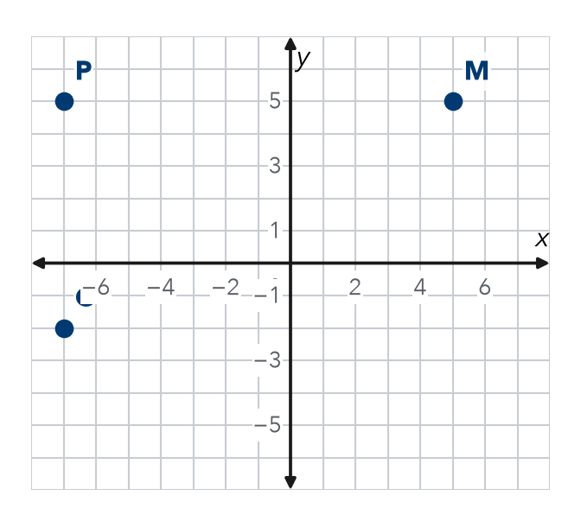
  a. Pond to Meadow  Step 1 P ( , ) M ( , )  Step 2 Units apart:  Step 3 units × 10 = m | b. Pond to Cabin  Step 4 P ( , ) C ( , )  Step 5 Units apart:  Step 6 units × 10 = m

3. Two Riders. From (−8, 4), Rosa rides to (−8, −7) and Kofi rides to (6, 4). Each unit is 1 block. Who rides farther, and by how much?
Step 1 Rosa keeps x. Use y: 4 and −7.
Step 2 Same or opposite signs?
Step 3 Rosa: = blocks
Step 4 Kofi keeps y. Use x: −8 and 6.
Step 5 Kofi: = blocks
Step 6 Farther: by − = blocks

4. Partner Point. Point T is at (−3, 14). Point U is 20 units directly below T. Name point U.
Step 1 Moving down changes x or y?
Step 2 New y: 14 20 =
Step 3 Point U: ( , )

ON YOUR OWN use the open space · show your work · label units
5. Place the Stop. Point N is at (12, −4). Point M is 18 units directly to the left of N. Name point M.  Show your work.  Point M ( , ) | 6. Two Hikes. Mei hikes from (−10, 13) to (−10, 4). Andre hikes from (−3, −14) to (11, −14). Each unit is 1 km. Who hikes farther, and by how much?  Show your work.  Who By km

7. Two Walks. From (3.25, 4.75), Ana walks to (3.25, −2.25) and Ben walks to (3.25, 9.75). Who walks farther, and by how much?  Show your work.  Who By units | 8. Delivery Routes. A depot is at (0, 0). Stop 1 is at (0, 11), Stop 2 is at (0, −8) and Stop 3 is at (0, 5).  a. Distance to each stop:  b. Order, closest to farthest:  c. Stop 1 to Stop 2 units  Show your work.

FIND THE ERROR explain the mistake, then fix it
9. Diego’s Work. To find the distance from (−6, 2) to (9, 2), Diego wrote 9 − 6 = 3 units. Explain his mistake. Then find the correct distance.
Show your work.

TEST PRACTICE choose the best answer
10. Two coordinates on opposite sides of zero call for —
A subtraction B addition C division D doubling

11. The distance from (−7, 0) to (7, 0) is —
A 0 units B 7 units C 14 units D 49 units

CHECK YOURSELF
□ I can do this on my own □ I need a little help □ I have a question about #

