Lesson 7.6 Guided Notes

Session 1 · Distance Between Points on a Grid
I can find the distance between two points that share a coordinate. · 6.NS.C.8
Word / Spanish | Meaning — complete the blank | Example
distance / distancia | How far apart two points are. It is never __________. | (2, 1) to (2, 5) is 4 units
absolute value / valor absoluto | How far a number is from _____, ignoring its sign. | |−7| = 7
horizontal distance / distancia horizontal | Distance side to side. Use the _____-coordinates. | (−3, 2) to (4, 2)
vertical distance / distancia vertical | Distance up and down. Use the _____-coordinates. | (5, −1) to (5, 6)

Key idea
If two points share a y-coordinate, find the distance with the _____-coordinates.
If the changing coordinates have opposite signs, _____ their absolute values. If they have the same sign, __________ them.

Worked example
Find the distance from (−4, 3) to (5, 3).
The points share the y-coordinate _____, so use the x-coordinates.
−4 and 5 have __________ signs, so the trip crosses the y-axis.
Add the absolute values: 4 + 5 = _____.
Answer: The distance is _____ units.

You try
1. Find the distance between each pair of points.
a. (1, 6) and (1, −3) ______
b. (−7, −2) and (−2, −2) ______
________________________________________________________________
2. Point A is at (3, −1). Point B is 5 units directly above A. Name point B.
________________________________________________________________
Sum it up: To find the distance between two points that share a coordinate, I ___ because ___.
________________________________________________________________

Session 2 · Comparing Distances on the Plane
I can decide whether to add or subtract to find a distance, then compare two distances. · 6.NS.C.8
Word / Spanish | Meaning — complete the blank | Example
quadrant / cuadrante | One of the four __________ of the coordinate plane. | (−3, −5) is in Quadrant III
compare / comparar | Decide which amount is _________ or less. | 12 units > 9 units
scale / escala | How much real length one grid ______ stands for. | 1 unit = 5 meters

Key idea
Find ______ distance first. Then compare the two numbers.
With a scale, change ______ distances to real units before you compare.

Worked example
A = (1, 2), B = (1, 9), C = (−8, 2). Each unit is 5 meters. Is B or C farther from A?
A to B: same x, so 9 − 2 = _____ units = 35 m.
A to C: same y, opposite signs, so 1 + 8 = _____ units = _____ m.
Answer: _____ is farther, by 10 m.

You try
1. Add or subtract? Find each distance.
a. (−2, 3) to (7, 3) ______
b. (5, 3) to (12, 3) ______
________________________________________________________________
2. From (4, −3), Ana walks to (4, 6) and Ben walks to (−6, −3). Who walks farther?
________________________________________________________________
Sum it up: To compare two distances on the plane, I ___ because ___.
________________________________________________________________

Session 1 · Model, reason, and explain
Distance Between Points on a Grid · 6.NS.C.8
Success: represent the quantities, justify the relationship, and check the result with the correct units.
Find distance from (−3,2) to (4,2), and from (−3,2) to (−1,2). Explain the shared coordinate and why the distances differ.
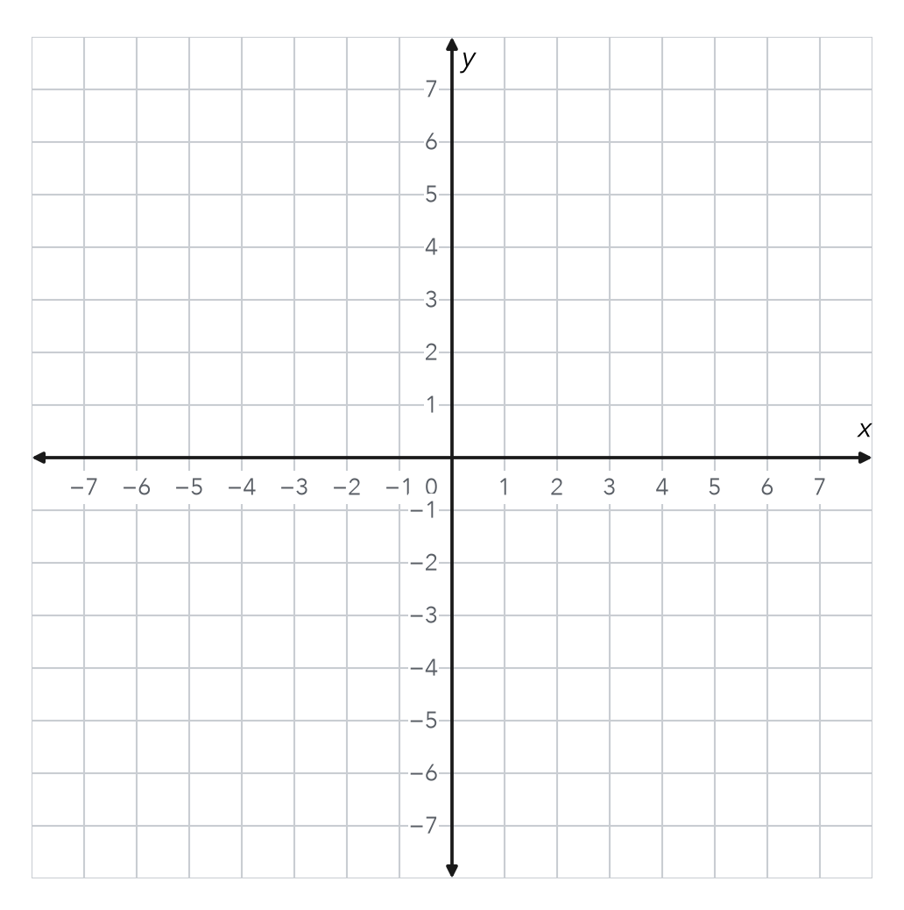
________________________________________________________________
________________________________________________________________
________________________________________________________________

Extend your reasoning
Create a contrasting example that exposes the misconception: uses the unchanged coordinate or returns a signed distance.. Explain what changes and what stays true.
________________________________________________________________
________________________________________________________________
Self-check: Did my model, calculation, explanation, and units agree?

Session 2 · Model, reason, and explain
Comparing Distances on the Plane · 6.NS.C.8
Success: represent the quantities, justify the relationship, and check the result with the correct units.
A=(1,2), B=(1,8), C=(−7,2). Each grid unit is 3 m. Compare AB and AC in meters and state which is longer.
________________________________________________________________
________________________________________________________________
________________________________________________________________

Extend your reasoning
Create a contrasting example that exposes the misconception: compares grid units with meters without conversion.. Explain what changes and what stays true.
________________________________________________________________
________________________________________________________________
Self-check: Did my model, calculation, explanation, and units agree?

