Name Date Period
Lesson 7-7 · Session 1 · Guided Steps · Form A
Polygons and Perimeter on the Plane
Learning target — I can find the perimeter and area of a polygon drawn on the coordinate plane. · 6.G.A.3
REMEMBER
• A polygon is a closed shape with straight sides. Its corners are vertices.
• Find each side from matching coordinates: opposite signs add, same sign subtract.
• Perimeter = add all the sides. Area of a rectangle = length × width.
GUIDED PRACTICE fill in each blank — problems 1–4
1. A rectangle has vertices (−3, 4), (6, 4), (6, −2) and (−3, −2). Find each measure.
a. side (−3, 4) to (6, 4)  Step 1 Same x or same y?  Step 2 −3 and 6: same or opposite?  Step 3 6 3 = units | b. side (6, 4) to (6, −2)  Step 1 Same x or same y?  Step 2 4 and −2: same or opposite?  Step 3 4 2 = units

c. Perimeter  Step 4 Add all four sides:  + + + = | d. Area  Step 5 Length × width:  × = sq. units

2. Garden Plot. A garden plot has corners at (−4, 6), (9, 6), (9, −3) and (−4, −3). Each unit is 1 meter.  a. Plot the corners and connect them.  d. Perimeter  Step 7 Add all four sides: + + + = m | 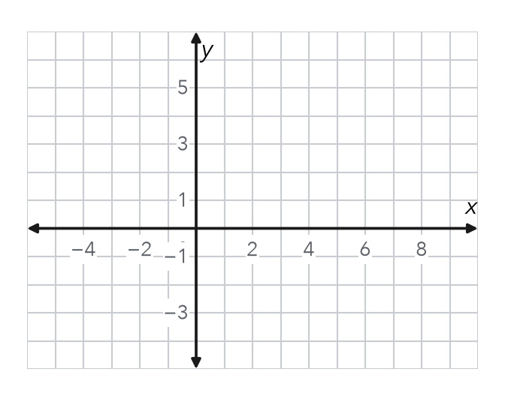
  b. Top side  Step 1 Same x or same y?  Step 2 −4 and 9: same or opposite?  Step 3 9 4 = m | c. Left side  Step 4 Same x or same y?  Step 5 6 and −3: same or opposite?  Step 6 6 3 = m

3. Dog Run. Dog run vertices: (−7, 10), (11, 10), (11, −1) and (−7, −1). Each unit is 1 meter. Find the perimeter.
Across  Step 1 Same x or same y?  Step 2 −7 and 11: same or opposite?  Step 3 11 7 = m | Up and down  Step 4 Same x or same y?  Step 5 10 and −1: same or opposite?  Step 6 10 1 = m

Step 7 Perimeter: 2 × ( + ) = m

4. Missing Vertex. Three corners of a rectangle are (−2, 9), (8, 9) and (8, 1). Name the fourth corner.
Step 1 Missing corner lines up with (−2, 9) in x: x =
Step 2 It lines up with (8, 1) in y: y =
Step 3 Fourth corner: ( , )

ON YOUR OWN use the open space · show your work · label units
5. Right Triangle. A right triangle has vertices (−5, 2), (7, 2) and (7, −5). Find its area.  Show your work.  Answer sq. units | 6. Deck Area. Deck vertices: (−6, −2), (7, −2), (7, −9) and (−6, −9). Each unit is 1 yard. Find its area.  Show your work.  Answer sq. yd

7. Mural Outline. The mural outline has vertices (−6, 5), (6, 5), (6, −1), (1, −1), (1, −7) and (−6, −7). Each unit is 1 foot. Find the perimeter.  Show your work.  Answer ft | 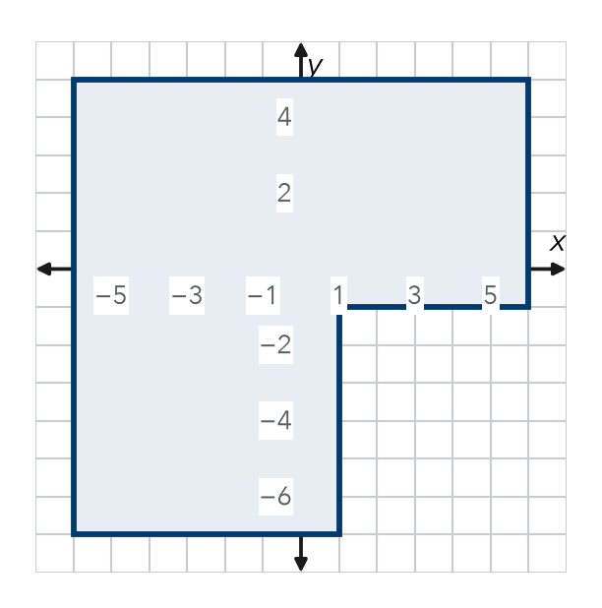

8. Fence and Sod. A plot has vertices (−6, 5), (9, 5), (9, −4) and (−6, −4). Fencing costs $7 per unit. Sod costs $2 per square unit.
a. Length units Width units
b. Perimeter units Cost of fencing $
c. Area sq. units Cost of sod $
Show your work.

FIND THE ERROR explain the mistake, then fix it
9. Jorge’s Work. For a side from (−5, 4) to (3, 4), Jorge wrote the length as 5 − 3 = 2 units. Explain his mistake. Then find the correct length.
Show your work.

TEST PRACTICE choose the best answer
10. A rectangle with sides 8 units and 5 units has a perimeter of —
A 13 units B 26 units C 40 units D 80 units

11. A rectangle with sides 8 units and 5 units has an area of —
A 13 square units B 26 square units C 40 square units D 80 square units

CHECK YOURSELF
□ I can do this on my own □ I need a little help □ I have a question about #

