Name Date Period
Lesson 7-7 · Session 1 · Guided Steps · Form B
Polygons and Perimeter on the Plane
Learning target — I can find the perimeter and area of a polygon drawn on the coordinate plane. · 6.G.A.3
REMEMBER
• A polygon is a closed shape with straight sides. Its corners are vertices.
• Find each side from matching coordinates: opposite signs add, same sign subtract.
• Perimeter = add all the sides. Area of a rectangle = length × width.
GUIDED PRACTICE fill in each blank — problems 1–4
1. A rectangle has vertices (−5, 3), (5, 3), (5, −4) and (−5, −4). Find each measure.
a. side (−5, 3) to (5, 3)  Step 1 Same x or same y?  Step 2 −5 and 5: same or opposite?  Step 3 5 5 = units | b. side (5, 3) to (5, −4)  Step 1 Same x or same y?  Step 2 3 and −4: same or opposite?  Step 3 4 3 = units

c. Perimeter  Step 4 Add all four sides:  + + + = | d. Area  Step 5 Length × width:  × = sq. units

2. Garden Plot. A garden plot has corners at (−5, 5), (7, 5), (7, −4) and (−5, −4). Each unit is 1 meter.  a. Plot the corners and connect them.  d. Perimeter  Step 7 Add all four sides: + + + = m | 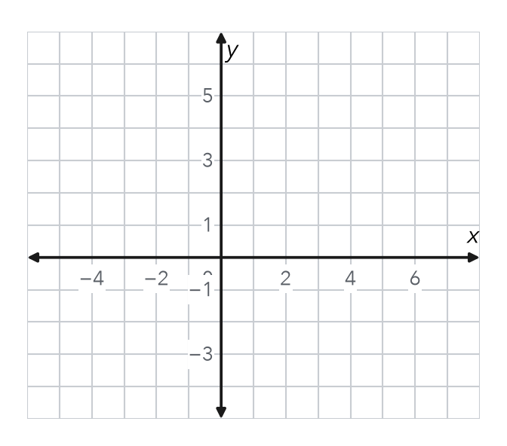
  b. Top side  Step 1 Same x or same y?  Step 2 −5 and 7: same or opposite?  Step 3 7 5 = m | c. Left side  Step 4 Same x or same y?  Step 5 5 and −4: same or opposite?  Step 6 5 4 = m

3. Dog Run. Dog run vertices: (−6, 9), (10, 9), (10, −3) and (−6, −3). Each unit is 1 meter. Find the perimeter.
Across  Step 1 Same x or same y?  Step 2 −6 and 10: same or opposite?  Step 3 10 6 = m | Up and down  Step 4 Same x or same y?  Step 5 9 and −3: same or opposite?  Step 6 9 3 = m

Step 7 Perimeter: 2 × ( + ) = m

4. Missing Vertex. Three corners of a rectangle are (−3, 8), (7, 8) and (7, 2). Name the fourth corner.
Step 1 Missing corner lines up with (−3, 8) in x: x =
Step 2 It lines up with (7, 2) in y: y =
Step 3 Fourth corner: ( , )

ON YOUR OWN use the open space · show your work · label units
5. Right Triangle. A right triangle has vertices (−4, 3), (6, 3) and (6, −5). Find its area.  Show your work.  Answer sq. units | 6. Deck Area. Deck vertices: (−5, −1), (8, −1), (8, −7) and (−5, −7). Each unit is 1 yard. Find its area.  Show your work.  Answer sq. yd

7. Mural Outline. The mural outline has vertices (−5, 6), (6, 6), (6, 0), (2, 0), (2, −6) and (−5, −6). Each unit is 1 foot. Find the perimeter.  Show your work.  Answer ft | 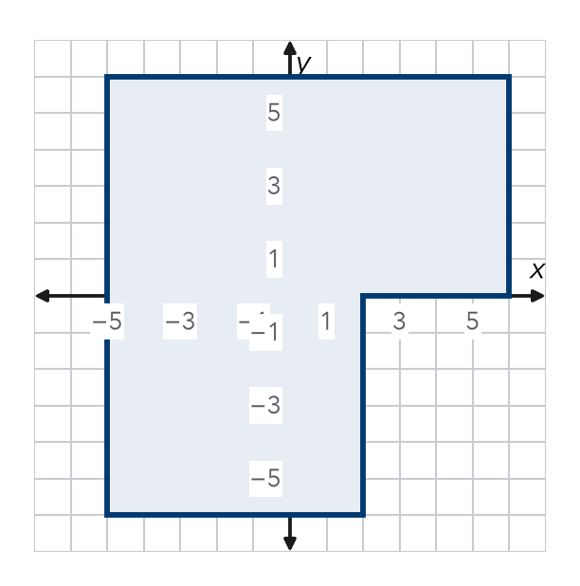

8. Fence and Sod. A plot has vertices (−5, 6), (9, 6), (9, −3) and (−5, −3). Fencing costs $6 per unit. Sod costs $3 per square unit.
a. Length units Width units
b. Perimeter units Cost of fencing $
c. Area sq. units Cost of sod $
Show your work.

FIND THE ERROR explain the mistake, then fix it
9. Bri’s Work. For a side from (−9, 2) to (6, 2), Bri wrote the length as 9 − 6 = 3 units. Explain her mistake. Then find the correct length.
Show your work.

TEST PRACTICE choose the best answer
10. A rectangle with sides 9 units and 4 units has a perimeter of —
A 13 units B 26 units C 36 units D 18 units

11. A rectangle with sides 9 units and 4 units has an area of —
A 13 square units B 26 square units C 36 square units D 72 square units

CHECK YOURSELF
□ I can do this on my own □ I need a little help □ I have a question about #

