Lesson 7.7 Guided Notes

Session 1 · Polygons and Perimeter on the Plane
I can find the perimeter and area of a polygon drawn on the coordinate plane. · 6.G.A.3
Word / Spanish | Meaning — complete the blank | Example
polygon / polígono | A closed shape with __________ sides. | triangle, rectangle, square
vertex / vértice | A ________ point of a polygon. | (−2, 3)
perimeter / perímetro | The distance all the way ________ a shape. | add every side length
area / área | The number of ________ units inside a shape. | rectangle: length × width

Key idea
Two vertices that share a coordinate make a ____________ or vertical side.
Perimeter is the _____ of all the sides. Area of a rectangle is length _____ width.

Worked example
A rectangle has vertices (−1, 4), (5, 4), (5, −3) and (−1, −3). Find its perimeter and area.
Top side: same y, opposite signs, so 1 + 5 = _____ units.
Right side: same x, opposite signs, so 4 + 3 = _____ units.
Perimeter: 6 + 7 + 6 + 7 = _____ units.
Answer: Area = 6 × 7 = _____ square units

You try
1. A square has vertices (−3, 2), (1, 2), (1, −2) and (−3, −2). Find its perimeter.
________________________________________________________________
2. Three corners of a rectangle are (−4, 1), (3, 1) and (3, −5). Name the fourth corner.
________________________________________________________________
Sum it up: To find the perimeter of a polygon on the coordinate plane, I ___ because ___.
________________________________________________________________

Session 2 · Designing Polygons with Scale
I can use a scale to find a missing dimension of a figure on the coordinate plane. · 6.G.A.3
Word / Spanish | Meaning — complete the blank | Example
scale / escala | How much real length one grid ______ stands for. | 1 unit = 4 meters
area / área | The flat space ________ a shape, in square units. | 20 m × 12 m = 240 m²
dimensions / dimensiones | The ________ and width of a shape. | 24 ft by 16 ft

Key idea
Multiply grid units by the _______ to get real length.
To find a missing side, ________ the area by the known side.

Worked example
A rectangle is 5 units by 3 units on a grid. Each unit is 4 meters. Find its real area.
Real width: 5 × 4 = _____ m.
Real height: 3 × 4 = _____ m.
Answer: Area = 20 × 12 = _____ m²

You try
1. On a plan, 1 unit = 5 ft.
a. 8 units = ______ ft
b. 35 ft = ______ units
________________________________________________________________
2. A rectangle has an area of 600 ft². One side is 20 ft. Find the other side.
________________________________________________________________
Sum it up: To find a missing dimension with a scale, I ___ because ___.
________________________________________________________________

Session 1 · Model, reason, and explain
Polygons and Perimeter on the Plane · 6.G.A.3
Success: represent the quantities, justify the relationship, and check the result with the correct units.
Draw the rectangle (−2,3),(4,3),(4,−1),(−2,−1). Find perimeter and area, then explain a missing corner if only the first three vertices were supplied.
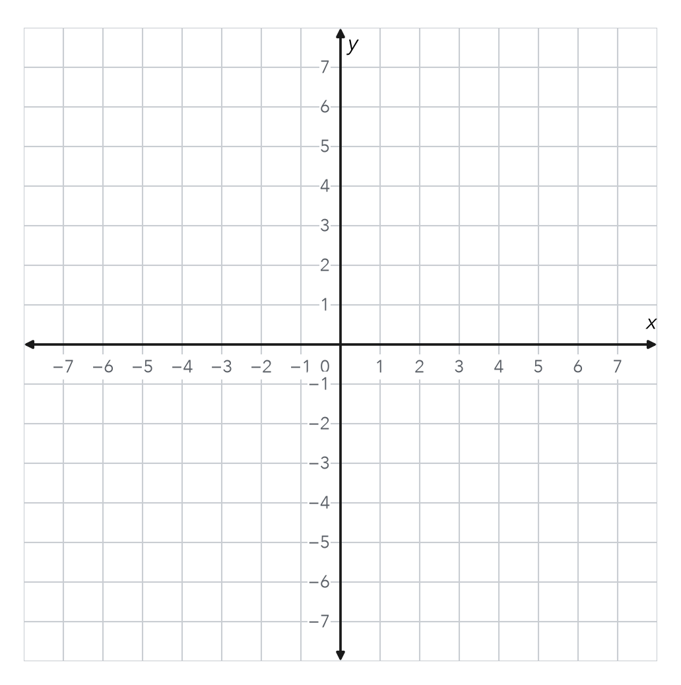
________________________________________________________________
________________________________________________________________
________________________________________________________________

Extend your reasoning
Create a contrasting example that exposes the misconception: confuses coordinate values with side lengths.. Explain what changes and what stays true.
________________________________________________________________
________________________________________________________________
Self-check: Did my model, calculation, explanation, and units agree?

Session 2 · Model, reason, and explain
Designing Polygons with Scale · 6.G.A.3
Success: represent the quantities, justify the relationship, and check the result with the correct units.
A grid rectangle is 5 units by 3 units. Each unit is 4 m. Find real perimeter and area. Explain why area does not simply multiply by 4.
________________________________________________________________
________________________________________________________________
________________________________________________________________

Extend your reasoning
Create a contrasting example that exposes the misconception: applies a length scale only once to area.. Explain what changes and what stays true.
________________________________________________________________
________________________________________________________________
Self-check: Did my model, calculation, explanation, and units agree?

