Lesson 8.1 Guided Notes

Session 1 · Equations and Solutions
I can check whether a value is a solution of an equation by substituting it. · 6.EE.B.5
Word / Spanish | Meaning — complete the blank | Example
equation / ecuación | A math sentence that says two amounts are _______. | x + 3 = 10
variable / variable | A letter that stands for an _________ number. | the x in x + 3 = 10
solution / solución | A value that makes the equation ______. | x = 7
substitute / sustituir | _________ the variable with a number. | put 7 in place of x

Key idea
To test a value, ____________ it for the variable and do the math.
If both sides are _______, the value is a solution. If not, it is not a solution.

Worked example
Is k = 7 a solution of k − 4 = 2? Is k = 6?
k = 7: 7 − 4 = _____. 3 ≠ 2, so the equation is _______.
k = 6: 6 − 4 = _____. 2 = 2, so the equation is true.
Answer: k = _____ is the solution.

You try
1. Substitute the value. Write T for true or F for false.
a. 4k = 20 (k = 5) ______
b. n − 2 = 6 (n = 4) ______
________________________________________________________________
2. Which of 6, 8 or 9 is the solution of 7m = 56?
________________________________________________________________
Sum it up: A number is a solution of an equation when ___ because ___.
________________________________________________________________

Session 2 · Writing Equations
I can write an equation for a situation and test a proposed answer. · 6.EE.B.6
Word / Spanish | Meaning — complete the blank | Example
variable / variable | A letter that stands for the _________ number. | let m = marbles lost
equation / ecuación | A math sentence with an _______ sign. | 30 − m = 11
increased by / aumentado en | Means _____. | n + 9
decreased by / disminuido en | Means __________. | n − 9

Key idea
Name the unknown with a ________ and say what it means.
Write the story as a math sentence, like start _____ lost = left, or groups × size = _______.

Worked example
A jar had 30 marbles. Some rolled away and 11 are left. How many rolled away?
Let m = the marbles that _____________.
Start − lost = left: 30 − m = _____.
Test m = 19: 30 − 19 = _____. True.
Answer: _____ marbles rolled away.

You try
1. Write an equation for each sentence. Use n.
a. A number plus 8 is 15. ______
b. 3 times a number is 21. ______
________________________________________________________________
2. A crate had 46 milk cartons. Some were taken, and 13 are left. Write an equation. Find the number taken.
________________________________________________________________
Sum it up: To write an equation for a story, I ___ because ___.
________________________________________________________________

Session 1 · Model, reason, and explain
Equations and Solutions · 6.EE.B.5
Success: represent the quantities, justify the relationship, and check the result with the correct units.
Test x=6 and x=7 in x−3=4. Write both substituted statements and explain why only one is a solution.
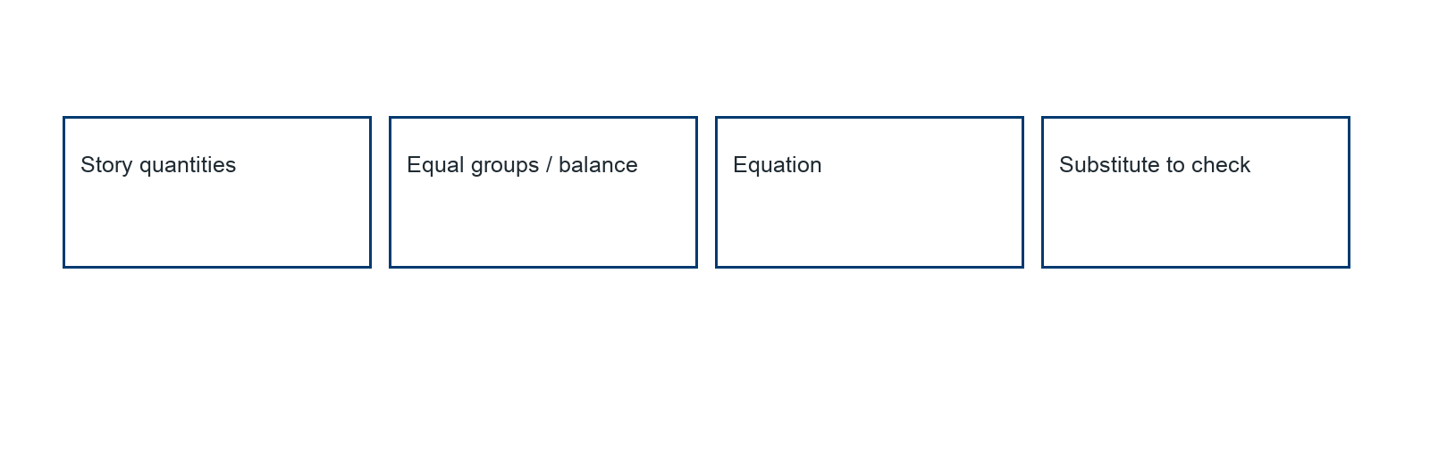
________________________________________________________________
________________________________________________________________
________________________________________________________________

Extend your reasoning
Create a contrasting example that exposes the misconception: accepts a proposed value without testing the original equality.. Explain what changes and what stays true.
________________________________________________________________
________________________________________________________________
Self-check: Did my model, calculation, explanation, and units agree?

Session 2 · Model, reason, and explain
Writing Equations · 6.EE.B.6
Success: represent the quantities, justify the relationship, and check the result with the correct units.
A jar begins with 28 counters. Some are removed and 9 remain. Define r, write an equation, solve, and check the story.
________________________________________________________________
________________________________________________________________
________________________________________________________________

Extend your reasoning
Create a contrasting example that exposes the misconception: models the unknown as the remaining amount instead of the removed amount.. Explain what changes and what stays true.
________________________________________________________________
________________________________________________________________
Self-check: Did my model, calculation, explanation, and units agree?

