Lesson 8.2 Guided Notes

Session 1 · Addition Equations
I can solve an addition equation by subtracting the same amount from both sides. · 6.EE.B.7
Word / Spanish | Meaning — complete the blank | Example
inverse operations / operaciones inversas | Two operations that ______ each other. | + and −
isolate / aislar | Get the variable _______ on one side. | y = 26
Subtraction Property of Equality / propiedad de sustracción de la igualdad | Subtract the same number from ______ sides. They stay equal. | both sides − 14

Key idea
Subtraction ________ addition.
To solve x + 14 = 40, subtract _____ from both sides so the equation stays __________.

Worked example
Solve 21 + p = 50.
Subtract _____ from both sides.
p = 50 − 21 = _____.
Check: 21 + 29 = _____.
Answer: p = _____

You try
1. Solve each equation.
a. x + 9 = 25 ______
b. 12 + m = 30 ______
________________________________________________________________
2. Solve k + 4.5 = 10. Check your answer.
________________________________________________________________
Sum it up: To solve an addition equation, I ___ because ___.
________________________________________________________________

Session 2 · Subtraction Equations
I can solve a subtraction equation by adding the same amount to both sides. · 6.EE.B.7
Word / Spanish | Meaning — complete the blank | Example
Addition Property of Equality / propiedad de suma de la igualdad | Add the same number to ______ sides. They stay equal. | both sides + 9
difference / diferencia | The answer when you __________. | in m − 9 = 14, it is 14
isolate / aislar | Get the variable _______ on one side. | m = 23

Key idea
Addition ________ subtraction.
To solve p − 7 = 12, add _____ to both sides.

Worked example
Solve m − 9 = 14.
Add _____ to both sides.
m = 14 + 9 = _____.
Check: 23 − 9 = _____.
Answer: m = _____

You try
1. Solve each equation.
a. x − 7 = 19 ______
b. n − 15 = 40 ______
________________________________________________________________
2. Solve p − 2.5 = 4. Check your answer.
________________________________________________________________
Sum it up: To solve a subtraction equation, I ___ because ___.
________________________________________________________________

Session 1 · Model, reason, and explain
Addition Equations · 6.EE.B.7
Success: represent the quantities, justify the relationship, and check the result with the correct units.
Use a balance model to solve x+8=23. Explain why subtracting 8 from only one side would not preserve the equality.
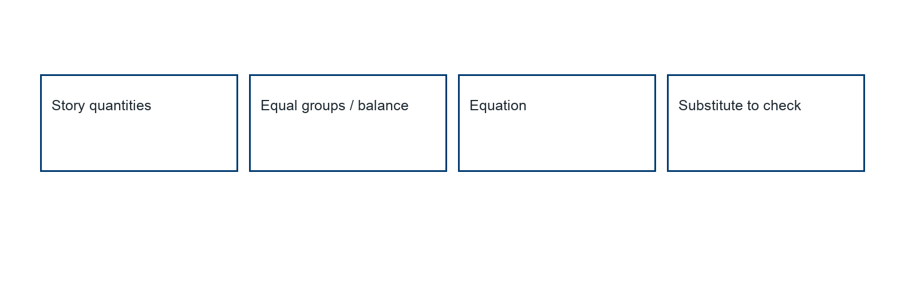
________________________________________________________________
________________________________________________________________
________________________________________________________________

Extend your reasoning
Create a contrasting example that exposes the misconception: uses an unexplained move-across rule or changes one side only.. Explain what changes and what stays true.
________________________________________________________________
________________________________________________________________
Self-check: Did my model, calculation, explanation, and units agree?

Session 2 · Model, reason, and explain
Subtraction Equations · 6.EE.B.7
Success: represent the quantities, justify the relationship, and check the result with the correct units.
Solve n−7=18 using a balance explanation. Compare its inverse step with that for n+7=18.
________________________________________________________________
________________________________________________________________
________________________________________________________________

Extend your reasoning
Create a contrasting example that exposes the misconception: subtracts again to solve a subtraction equation.. Explain what changes and what stays true.
________________________________________________________________
________________________________________________________________
Self-check: Did my model, calculation, explanation, and units agree?

