Lesson 8.3 Guided Notes

Session 1 · Multiplication Equations
I can solve a multiplication equation by dividing both sides by the same number. · 6.EE.B.7
Word / Spanish | Meaning — complete the blank | Example
coefficient / coeficiente | The number that ____________ the variable. | the 3 in 3x
inverse operations / operaciones inversas | × and ÷ ______ each other. | 5 × 9 = 45, so 45 ÷ 5 = 9
Division Property of Equality / propiedad de división de la igualdad | Divide both sides by the same number (not ______). They stay equal. | both sides ÷ 3

Key idea
Division ________ multiplication.
To solve 5b = 45, divide both sides by the _____________, 5.

Worked example
A room holds 84 chairs in 6 equal stacks. Solve 6c = 84.
The coefficient is _____.
Divide both sides by 6: c = 84 ÷ 6 = _____.
Check: 6 × 14 = _____.
Answer: c = _____ chairs in each stack

You try
1. Solve each equation.
a. 7x = 63 ______
b. 4n = 52 ______
________________________________________________________________
2. Solve 4w = 3.2. Check your answer.
________________________________________________________________
Sum it up: To solve a multiplication equation, I ___ because ___.
________________________________________________________________

Session 2 · Division Equations
I can solve a division equation by multiplying both sides by the same number. · 6.EE.B.7
Word / Spanish | Meaning — complete the blank | Example
divisor / divisor | The number you ________ by. | the 4 in n ÷ 4
Multiplication Property of Equality / propiedad de multiplicación de la igualdad | Multiply ______ sides by the same number. They stay equal. | both sides × 4
equal groups / grupos iguales | Groups that each have the ______ amount. | 24 is 4 groups of 6

Key idea
Multiplication ________ division.
To solve n ÷ 4 = 7, multiply both sides by _____.

Worked example
Nine hikers share a bag of trail mix equally. Each gets 7 ounces. Solve t ÷ 9 = 7.
Multiply both sides by _____.
t = 7 × 9 = _____.
Check: 63 ÷ 9 = _____.
Answer: The bag holds _____ ounces.

You try
1. Solve each equation.
a. x ÷ 3 = 12 ______
b. n ÷ 7 = 8 ______
________________________________________________________________
2. Solve n ÷ 2 = 1.5. Check your answer.
________________________________________________________________
Sum it up: To solve a division equation, I ___ because ___.
________________________________________________________________

Session 1 · Model, reason, and explain
Multiplication Equations · 6.EE.B.7
Success: represent the quantities, justify the relationship, and check the result with the correct units.
Six equal groups contain 42 objects. Let g be objects per group. Write, solve, and check a multiplication equation with a tape model.
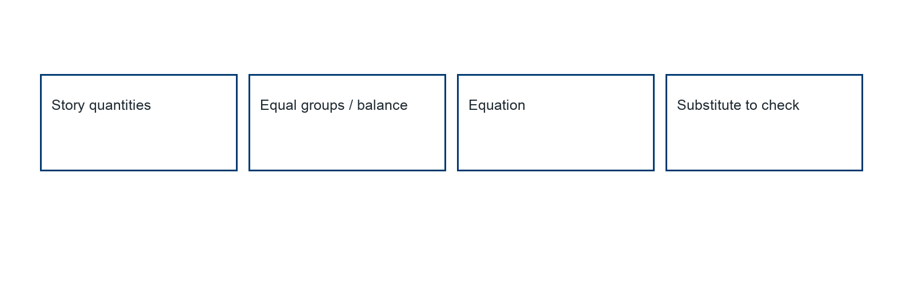
________________________________________________________________
________________________________________________________________
________________________________________________________________

Extend your reasoning
Create a contrasting example that exposes the misconception: multiplies by the coefficient instead of dividing or expects only whole-number solutions.. Explain what changes and what stays true.
________________________________________________________________
________________________________________________________________
Self-check: Did my model, calculation, explanation, and units agree?

Session 2 · Model, reason, and explain
Division Equations · 6.EE.B.7
Success: represent the quantities, justify the relationship, and check the result with the correct units.
A total t is shared among 5 groups, each receiving 9 items. Write and solve a division equation. State why the total exceeds one share in this context.
________________________________________________________________
________________________________________________________________
________________________________________________________________

Extend your reasoning
Create a contrasting example that exposes the misconception: divides again or makes an unconditional total/share comparison.. Explain what changes and what stays true.
________________________________________________________________
________________________________________________________________
Self-check: Did my model, calculation, explanation, and units agree?

