Name Date Period
Lesson 8-4 · Session 2 · Guided Steps · Form A
Representing Inequalities
Learning target — I can represent an inequality with a set of solutions and describe them. · 6.EE.B.8
REMEMBER
• Closed (filled) circle: the boundary counts (≤, ≥). Open circle: it does not (<, >).
• Arrow left for less than. Arrow right for greater than.
• Check the story: people and tickets come only in whole numbers.
GUIDED PRACTICE fill in each blank — problems 1–4
1. Write the inequality for each graph. Use x.
a. open circle at 4, arrow right  Step 1 Does 4 count?  Step 2 Arrow left or right?  Step 3 x | b. closed circle at −1, arrow left  Step 1 Does −1 count?  Step 2 Arrow left or right?  Step 3 x

c. closed circle at 6, arrow right  Step 1 Does 6 count?  Step 2 Arrow left or right?  Step 3 x | d. open circle at 0, arrow left  Step 1 Does 0 count?  Step 2 Arrow left or right?  Step 3 x

2. Meeting Room. A meeting room may hold at most 120 people at one time.
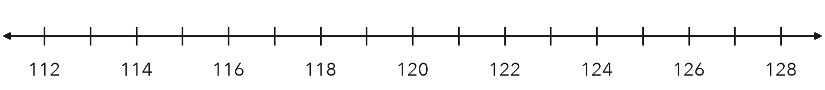
a. Write an inequality for n, the number of people.
Step 1 “At most”: is 120 allowed?
Step 2 Symbol:
Step 3 n
b. Graph it on the number line.
Step 4 Circle at 120: open or closed?
Step 5 Arrow points:
Step 6 Draw the graph on the number line.

3. Fish Tank. The graph shows the safe water temperatures, t, for a fish tank. Write the inequality. Is 78 degrees a solution?
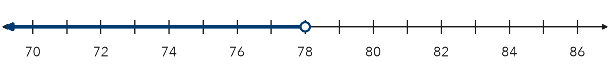
Step 1 Circle at 78: open or closed?
Step 2 Arrow points:
Step 3 Inequality: t
Step 4 Substitute 78: 78 78 is
Step 5 Is 78 a solution?

4. Locker Bag. A bag must be shorter than 22 inches to fit in a locker. Write an inequality for h. Name two solutions and one non-solution.
Step 1 “Shorter than”: is 22 allowed?
Step 2 Symbol:
Step 3 Inequality: h
Step 4 Two solutions: and
Step 5 One non-solution:

ON YOUR OWN use the open space · show your work · label units
5. Lab Station. A lab station may hold at most 5 students. Write an inequality for s. Is 5 a solution?
Show your work.

Inequality Is 5 a solution?

6. Parade Float. A float must be shorter than 14 feet to pass under a bridge.
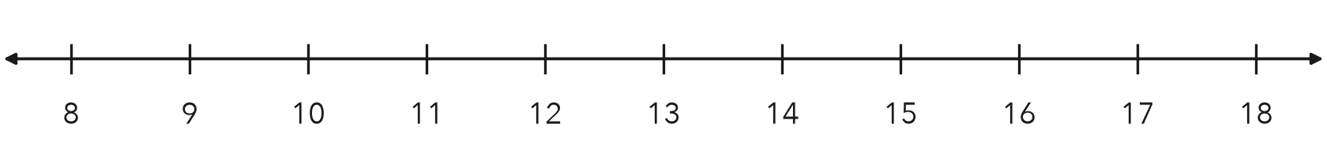
a. Write an inequality for h.

b. Graph it on the number line above.

7. Name Solutions. For n > 7, name three solutions and one number that is not a solution.  Show your work.  Solutions , , Not a solution | 8. Delivery Limit. A van’s load, w, must be at least 50 pounds and at most 900 pounds.  a. Write both inequalities.  b. Name three loads that fit both rules.  c. Why is 900 pounds allowed but 901 pounds is not?

FIND THE ERROR explain the mistake, then fix it
9. Zuri’s Work. A sign says: “Carry no more than 6 items into the fitting room.” Zuri wrote i < 6. Explain her mistake. Write the correct inequality.
Show your work.

Correct inequality

TEST PRACTICE choose the best answer
10. Which value is a solution of n > 5?
A 3 B 5 C 4.9 D 6

11. Which value is NOT a solution of x ≥ 4?
A 4 B 3.5 C 7 D 10

CHECK YOURSELF
□ I can do this on my own □ I need a little help □ I have a question about #

