Name Date Period
Lesson 8-5 · Session 1 · Guided Steps · Form A
Graphing Inequalities
Learning target — I can graph an inequality on a number line using an open or a closed dot. · 6.EE.B.8
REMEMBER
• An open dot means the boundary is NOT a solution (< or >). A closed dot means it is (≤ or ≥).
• Point the arrow toward the numbers that work: > and ≥ point right; < and ≤ point left.
• At least means ≥. At most means ≤. Under means <.
GUIDED PRACTICE fill in each blank — problems 1–4
1. Describe each graph: open or closed dot, and the arrow direction.
a. n > 6  Step 1 Boundary number:  Step 2 Dot (open/closed):  Step 3 Arrow (left/right): | b. k ≤ 2  Step 1 Boundary number:  Step 2 Dot (open/closed):  Step 3 Arrow (left/right):

c. x ≥ −3  Step 1 Boundary number:  Step 2 Dot (open/closed):  Step 3 Arrow (left/right): | d. p < 8  Step 1 Boundary number:  Step 2 Dot (open/closed):  Step 3 Arrow (left/right):

2. Donation Box. A food pantry accepts a donation box only when it weighs at least 15 pounds. Let w be the weight in pounds.
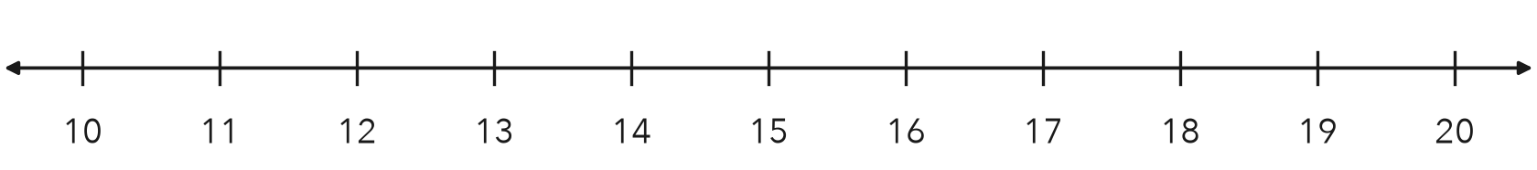
a. Write the inequality.
Step 1 “At least”: is 15 allowed?
Step 2 Symbol:
Step 3 w
b. Graph it on the number line.
Step 4 Dot at 15:
Step 5 Arrow points:
c. Name one value that works and one that does not.
Step 6 A value that works:
Step 7 A value that does not:

3. Freezer Setting. A freezer keeps food frozen when the temperature stays at most 8 degrees Fahrenheit. Write an inequality using t. Then graph it.
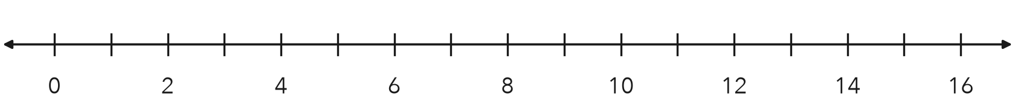
Step 1 “At most”: is 8 allowed?
Step 2 Symbol:
Step 3 t
Step 4 Dot at 8:
Step 5 Arrow points:
Inequality

4. Practice Cancelled. The county cancels outdoor practice when the temperature drops to 20 degrees or lower. Write an inequality using t and describe its graph.
Step 1 “Or lower”: does 20 count?
Step 2 Symbol:
Step 3 t
Step 4 Dot at 20:
Step 5 Arrow points:
Inequality

ON YOUR OWN use the open space · show your work · label units
5. Reading Goal. Students meet the reading goal by finishing at least 18 books. Write an inequality using b and describe its graph.
Show your work.

Inequality Graph dot, arrow

6. Read a Graph. Use the graph below.
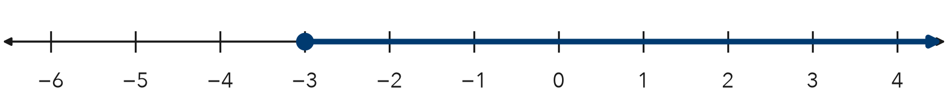
a. Write the inequality, using x.

b. Is −3 a solution? Explain.

Show your work.

7. Recycling Points. A class earns a party when it collects at least 250 recycling points. Let p be the points.  a. Write the inequality.  b. Name two totals under your arrow. | 8. Two Signs. A pool sign says the water must be at least 4 feet deep for diving. A slide sign says riders must weigh under 200 pounds.  a. Write an inequality for the first sign, using d.  b. Write an inequality for the second sign, using w.  c. Explain why one graph uses a closed dot and the other an open dot.  Show your work.

FIND THE ERROR explain the mistake, then fix it
9. Ines’s Work. Ines graphed n ≥ 30. She drew a closed dot at 30 and then drew her arrow pointing to the left. Explain her mistake and describe the correct graph.
Show your work.

Correct graph

TEST PRACTICE choose the best answer
10. The graph of n ≥ 5 has —
A an open dot at 5, arrow left B a closed dot at 5, arrow right C an open dot at 5, arrow right D a closed dot at 5, arrow left

11. An open dot at the boundary means the boundary value is —
A a solution B not a solution C negative D zero

CHECK YOURSELF
□ I can do this on my own □ I need a little help □ I have a question about #

