Name Date Period
Lesson 8-5 · Session 1 · Guided Steps · Form B
Graphing Inequalities
Learning target — I can graph an inequality on a number line using an open or a closed dot. · 6.EE.B.8
REMEMBER
• An open dot means the boundary is NOT a solution (< or >). A closed dot means it is (≤ or ≥).
• Point the arrow toward the numbers that work: > and ≥ point right; < and ≤ point left.
• At least means ≥. At most means ≤. Under means <.
GUIDED PRACTICE fill in each blank — problems 1–4
1. Describe each graph: open or closed dot, and the arrow direction.
a. k ≤ −4  Step 1 Boundary number:  Step 2 Dot (open/closed):  Step 3 Arrow (left/right): | b. n > 10  Step 1 Boundary number:  Step 2 Dot (open/closed):  Step 3 Arrow (left/right):

c. p < −2  Step 1 Boundary number:  Step 2 Dot (open/closed):  Step 3 Arrow (left/right): | d. x ≥ 1  Step 1 Boundary number:  Step 2 Dot (open/closed):  Step 3 Arrow (left/right):

2. Roller Coaster. A roller coaster lets a rider on only when the rider is at least 52 inches tall. Let h be the height in inches.
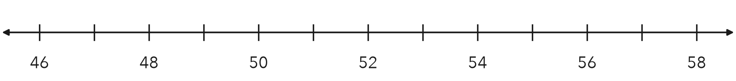
a. Write the inequality.
Step 1 “At least”: is 52 allowed?
Step 2 Symbol:
Step 3 h
b. Graph it on the number line.
Step 4 Dot at 52:
Step 5 Arrow points:
c. Name one value that works and one that does not.
Step 6 A value that works:
Step 7 A value that does not:

3. Bike Rack. A bike rack outside the gym holds at most 36 bikes. Write an inequality using b. Then graph it.
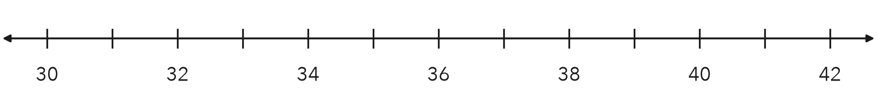
Step 1 “At most”: is 36 allowed?
Step 2 Symbol:
Step 3 b
Step 4 Dot at 36:
Step 5 Arrow points:
Inequality

4. Pool Closed. A pool closes when the air temperature drops to 65 degrees or lower. Write an inequality using t and describe its graph.
Step 1 “Or lower”: does 65 count?
Step 2 Symbol:
Step 3 t
Step 4 Dot at 65:
Step 5 Arrow points:
Inequality

ON YOUR OWN use the open space · show your work · label units
5. Lap Lane. Swimmers must be at least 12 years old to use the lap lane. Write an inequality using a and describe its graph.
Show your work.

Inequality Graph dot, arrow

6. Read a Graph. Use the graph below.
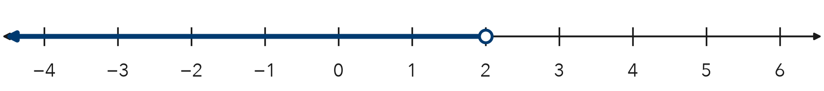
a. Write the inequality, using x.

b. Is 2 a solution? Explain.

Show your work.

7. Canned Food Drive. A homeroom wins a breakfast when it collects at least 180 cans. Let c be the number of cans.  a. Write the inequality.  b. Name two totals under your arrow. | 8. Two Signs. A ride sign says riders must be at least 48 inches tall. A bridge sign says trucks must weigh under 10 tons.  a. Write an inequality for the first sign, using h.  b. Write an inequality for the second sign, using w.  c. Explain why one graph uses a closed dot and the other an open dot.  Show your work.

FIND THE ERROR explain the mistake, then fix it
9. Omar’s Work. Omar graphed x ≤ 7. He drew a closed dot at 7 and then drew his arrow pointing to the right. Explain his mistake and describe the correct graph.
Show your work.

Correct graph

TEST PRACTICE choose the best answer
10. The graph of x < 8 has —
A a closed dot at 8, arrow left B an open dot at 8, arrow right C an open dot at 8, arrow left D a closed dot at 8, arrow right

11. A closed dot at the boundary means the boundary value is —
A a solution B not a solution C negative D zero

CHECK YOURSELF
□ I can do this on my own □ I need a little help □ I have a question about #

