Name Date Period
Lesson 8-5 · Session 2 · Guided Steps · Form A
Testing Solutions to Inequalities
Learning target — I can test values against an inequality and graph the solution set. · 6.EE.B.8
REMEMBER
• To test a value, substitute it for the variable. A true statement means it is a solution.
• Test the boundary: true means a closed dot (≤, ≥); false means an open dot (<, >).
• More than means >. Fewer than and below mean <. At most means ≤.
GUIDED PRACTICE fill in each blank — problems 1–4
1. Is the value a solution? Write yes or no.
a. n ≥ 14; n = 14  Step 1 Substitute: ≥ 14  Step 2 True or false?  Step 3 Solution (yes/no)? | b. n ≥ 14; n = 13  Step 1 Substitute: ≥ 14  Step 2 True or false?  Step 3 Solution (yes/no)? | c. x < 9; x = 9  Step 1 Substitute: < 9  Step 2 True or false?  Step 3 Solution (yes/no)?

d. p > 8; p = 3: | e. k ≥ 7; k = 7: | f. w < 12; w = 9.5:

2. Go-Kart Track. A go-kart track lets a driver race only when the driver weighs more than 80 pounds. Let w be the weight in pounds.
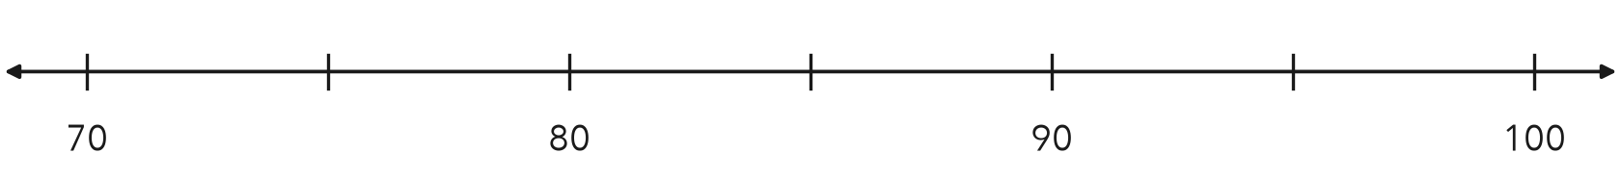
a. Write the inequality.
Step 1 Symbol for “more than”:
Step 2 w
b. Substitute 95. Is it a solution?
Step 3 Substitute: 80
Step 4 True or false?
Step 5 Solution (yes/no)?
c. Substitute 80. Is it a solution?
Step 6 Substitute: 80
Step 7 True or false?
Step 8 Solution (yes/no)?
d. Graph the inequality.
Step 9 Dot at 80:
Step 10 Arrow points:

3. Ride Line. A park closes a ride’s line when more than 45 people are waiting. Write an inequality using n. Test 45 and 52.
Step 1 Symbol for “more than”:
Step 2 Inequality: n
Step 3 Test 45: 45 45 is
Step 4 Test 52: 52 45 is
Step 5 Which are solutions?

4. Lab Liquid. An experiment works only while a liquid stays below 25 °C. Write an inequality using c. Test 25 and 19.
Step 1 Symbol for “below”:
Step 2 Inequality: c
Step 3 Test 25: 25 25 is
Step 4 Test 19: 19 25 is
Inequality

ON YOUR OWN use the open space · show your work · label units
5. Advanced Ramp. A skate park opens its advanced ramp only to riders older than 15. Write an inequality using a. Is 15 a solution?
Show your work.

Inequality Is 15 a solution?

6. Test and Graph. For x ≤ 5, test x = 5 and x = 6. Then graph the inequality.
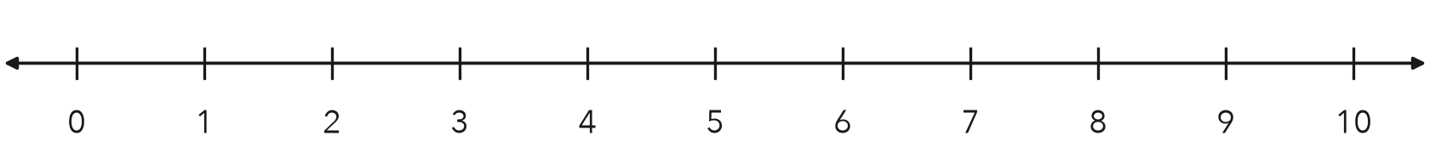
Show your work.

Solutions

7. Wind Speed. A rocket club launches only when the wind speed is less than 12 miles per hour. Write an inequality using w. Test 12, 9 and 15.  Show your work.  Inequality | 8. Baggage Rule. An airline allows a bag that weighs at most 50 pounds. Three bags weigh 50, 51 and 38 pounds.  a. Write the inequality, using w.  b. Which bags are allowed?  c. Describe the graph. What does the dot tell you about a 50-pound bag?  Show your work.

FIND THE ERROR explain the mistake, then fix it
9. Ravi’s Work. Ravi graphed x > 26 with a closed dot at 26. He told his group that 26 is one of the solutions. Explain his mistake and fix the graph.
Show your work.

Correct graph

TEST PRACTICE choose the best answer
10. Which value is a solution of p > 8?
A 3 B 8 C 7.9 D 8.5

11. Testing the boundary value tells you —
A the arrow direction B whether the dot is open or closed C which letter to use D the units

CHECK YOURSELF
□ I can do this on my own □ I need a little help □ I have a question about #

