Name Date Period
Lesson 8-5 · Session 2 · Guided Steps · Form B
Testing Solutions to Inequalities
Learning target — I can test values against an inequality and graph the solution set. · 6.EE.B.8
REMEMBER
• To test a value, substitute it for the variable. A true statement means it is a solution.
• Test the boundary: true means a closed dot (≤, ≥); false means an open dot (<, >).
• More than means >. Fewer than and below mean <. At most means ≤.
GUIDED PRACTICE fill in each blank — problems 1–4
1. Is the value a solution? Write yes or no.
a. n ≥ 15; n = 18  Step 1 Substitute: ≥ 15  Step 2 True or false?  Step 3 Solution (yes/no)? | b. y < 4; y = 4  Step 1 Substitute: < 4  Step 2 True or false?  Step 3 Solution (yes/no)? | c. t > 9; t = 9.5  Step 1 Substitute: > 9  Step 2 True or false?  Step 3 Solution (yes/no)?

d. k ≤ −1; k = 0: | e. m ≥ 6; m = 6: | f. x > 2; x = −3:

2. Zip Line. A zip line lets a rider go only when the rider weighs more than 70 pounds. Let w be the weight in pounds.
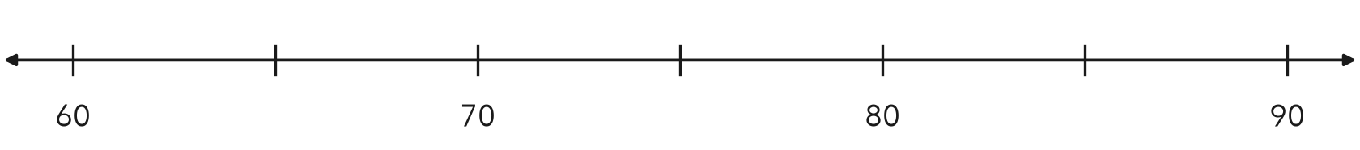
a. Write the inequality.
Step 1 Symbol for “more than”:
Step 2 w
b. Substitute 85. Is it a solution?
Step 3 Substitute: 70
Step 4 True or false?
Step 5 Solution (yes/no)?
c. Substitute 70. Is it a solution?
Step 6 Substitute: 70
Step 7 True or false?
Step 8 Solution (yes/no)?
d. Graph the inequality.
Step 9 Dot at 70:
Step 10 Arrow points:

3. Snack Bar. A snack bar opens a second window when more than 30 people are waiting. Write an inequality using n. Test 30 and 41.
Step 1 Symbol for “more than”:
Step 2 Inequality: n
Step 3 Test 30: 30 30 is
Step 4 Test 41: 41 30 is
Step 5 Which are solutions?

4. Fish Tank. Fish stay healthy only while the water stays below 28 °C. Write an inequality using c. Test 28 and 24.
Step 1 Symbol for “below”:
Step 2 Inequality: c
Step 3 Test 28: 28 28 is
Step 4 Test 24: 24 28 is
Inequality

ON YOUR OWN use the open space · show your work · label units
5. Teen Center. A teen center is open to people older than 12. Write an inequality using a. Is 12 a solution?
Show your work.

Inequality Is 12 a solution?

6. Test and Graph. For x ≥ 4, test x = 4 and x = 3. Then graph the inequality.
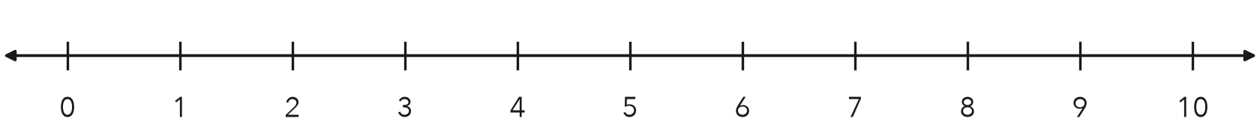
Show your work.

Solutions

7. Drone Range. A drone keeps its signal while it is less than 400 meters from the pilot. Write an inequality using d. Test 400, 350 and 410.  Show your work.  Inequality | 8. Backpack Rule. A hiking club allows a backpack that weighs at most 30 pounds. Three packs weigh 30, 32 and 24 pounds.  a. Write the inequality, using w.  b. Which packs are allowed?  c. Describe the graph. What does the dot tell you about a 30-pound pack?  Show your work.

FIND THE ERROR explain the mistake, then fix it
9. Kiara’s Work. Kiara graphed y < 15 with a closed dot at 15. She told her group that 15 is one of the solutions. Explain her mistake and fix the graph.
Show your work.

Correct graph

TEST PRACTICE choose the best answer
10. Which value is a solution of k ≥ 7?
A 6 B 6.9 C 7 D −7

11. To decide whether to use an open or a closed dot, test —
A the boundary value B a value far from the boundary C zero D a negative value

CHECK YOURSELF
□ I can do this on my own □ I need a little help □ I have a question about #

