Lesson 9.1 Guided Notes

Session 1 · Independent and Dependent Variables
I can name the independent and dependent variables in a relationship. · 6.EE.C.9
Word / Spanish | Meaning — complete the blank | Example
independent variable / variable independiente | The _______: the quantity you choose or that comes first. | hours studied
dependent variable / variable dependiente | The ________: it changes because of the input. | quiz score
depends on / depende de | The output _________ when the input changes. | Score depends on study time.

Key idea
Sentence test: the dependent variable ____________ the independent variable.
On a graph, the independent variable goes on the ________ and the dependent variable goes on the ________.

Worked example
A bike rental costs $5 for each hour. Name the variables.
The two quantities are hours rented and ____________.
The cost changes when the hours change, so cost ____________ hours.
Answer: Independent: _______ · Dependent: ______

You try
1. Name the dependent variable in each pair.
a. minutes jogged, calories burned ______
b. total bill, pizzas ordered ______
________________________________________________________________
2. The longer Rosa plays a video game, the more levels she completes. Write a sentence with “depends on.”
________________________________________________________________
Sum it up: I can tell which variable is independent by ___ because ___.
________________________________________________________________

Session 2 · Tables of Values
I can build a table of values for a relationship between two variables. · 6.EE.C.9
Word / Spanish | Meaning — complete the blank | Example
table of values / tabla de valores | A list of ________ matched with their outputs. | x: 1, 2 y: 9, 18
input / entrada | The number you start with. It goes in the _______ column. | hours worked
output / salida | The number you get _______ you use the rule. | boxes packed

Key idea
Use the ______ rule on every input.
With a fee, __________ first, then add the fee.

Worked example
A worker packs 9 boxes each hour, so b = 9h. Find b for h = 1, 2, and 3.
h = 1: 9 × 1 = _____
h = 2: 9 × 2 = _____
h = 3: 9 × 3 = _____
Answer: Pairs: (1, 9), (2, 18), (3, _____)

You try
1. Use the rule y = 5x + 1 to complete the table.
________________________________________________________________
2. A copier prints 35 pages each minute. How many pages?
a. 2 minutes: ______
b. 4 minutes: ______
________________________________________________________________
Sum it up: To build a table of values, I ___ and then ___.
________________________________________________________________

Session 1 · Model, reason, and explain
Independent and Dependent Variables · 6.EE.C.9
Success: represent the quantities, justify the relationship, and check the result with the correct units.
A shop sells ribbons at $3 per meter with no fixed charge. Define the independent and dependent quantities, explain the dependence, and give the cost for 0,2,5 m.
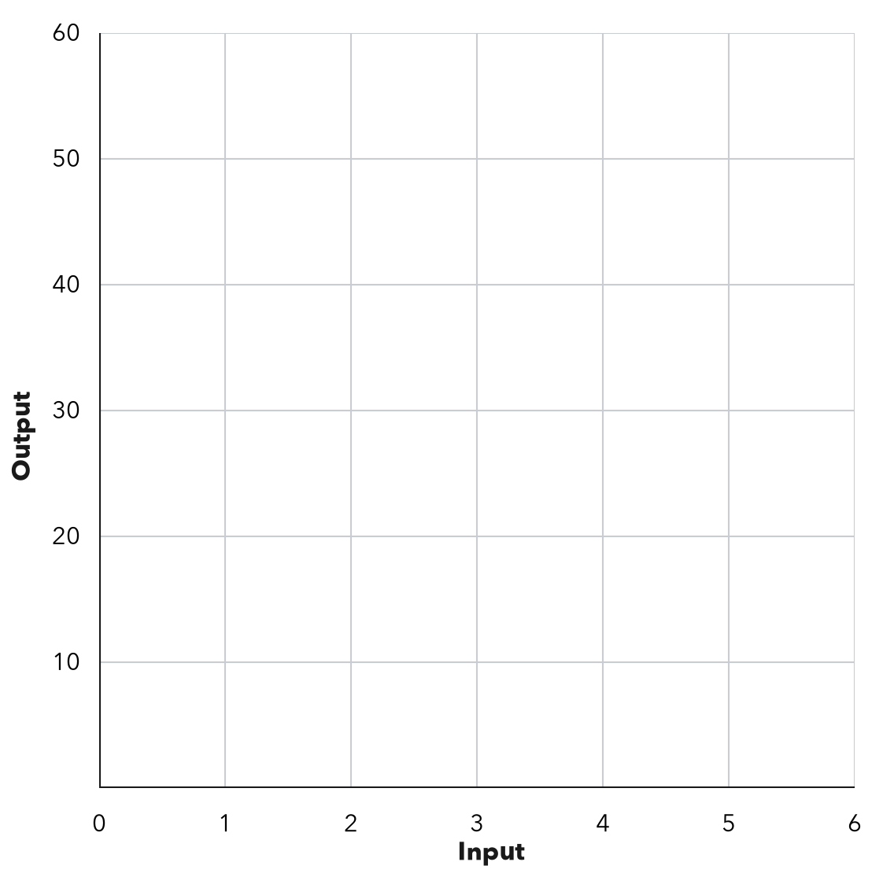
________________________________________________________________
________________________________________________________________
________________________________________________________________

Extend your reasoning
Create a contrasting example that exposes the misconception: answers only which axis a variable conventionally uses.. Explain what changes and what stays true.
________________________________________________________________
________________________________________________________________
Self-check: Did my model, calculation, explanation, and units agree?

Session 2 · Model, reason, and explain
Tables of Values · 6.EE.C.9
Success: represent the quantities, justify the relationship, and check the result with the correct units.
A delivery costs c=2n+5 dollars for n boxes. Complete n=0,2,5. Explain why adding 2 to each successive output fails for nonconsecutive inputs.
________________________________________________________________
________________________________________________________________
________________________________________________________________

Extend your reasoning
Create a contrasting example that exposes the misconception: adds one rate unit between table rows regardless of input jumps.. Explain what changes and what stays true.
________________________________________________________________
________________________________________________________________
Self-check: Did my model, calculation, explanation, and units agree?

