Name Date Period
Lesson 9-2 · Session 1 · Guided Steps · Form A
From Table to Graph
Learning target — I can turn a table of values into points and plot them on a graph. · 6.EE.C.9
REMEMBER
• Each row of a table gives an ordered pair (x, y): the input first, then the output.
• To plot (x, y), start at (0, 0). Go right x, then up y.
GUIDED PRACTICE fill in each blank — problems 1–4
1. Write each table row as an ordered pair (x, y).
a. x = 3, y = 6  Step 1 Input x =  Step 2 Output y =  Step 3 Pair: ( , ) | b. x = 5, y = 45  Step 1 Input x =  Step 2 Output y =  Step 3 Pair: ( , )

c. x = 0, y = 7  Step 1 Input x =  Step 2 Output y =  Step 3 Pair: ( , ) | d. x = 8, y = 1  Step 1 Input x =  Step 2 Output y =  Step 3 Pair: ( , )

2. Dog-Walking Pay. Priya earns $9 for every dog she walks. Complete the table. Then plot the points on the grid.  Step 1 Multiply each x by the rate.  Step 2 Plot: right x, then up y. | 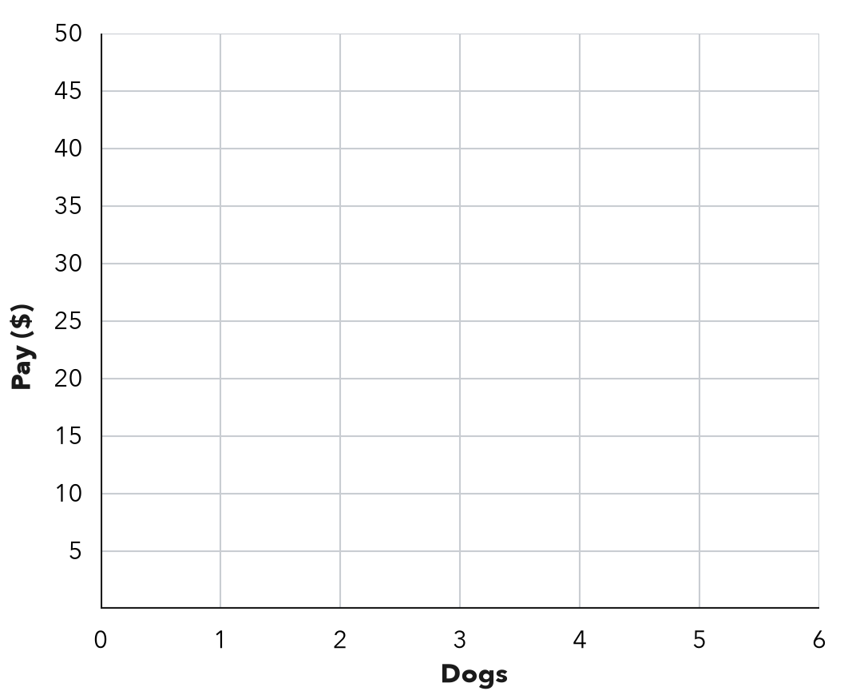
  Dogs (x) | 1 | 2 | 3 | 5
  9 × x | 9 × 1 = | 9 × 2 = | 9 × 3 = | 9 × 5 =
  Pay in $ (y) | $ | $ | $ | $
  (x, y) | ( 1 , ) | ( 2 , ) | ( 3 , ) | ( 5 , )

3. Ski Lift. A ski lift rises 50 feet every second. Write the ordered pair for 6 seconds. What does it mean?  Step 1 Seconds come first: x =  Step 2 Feet: 50 × =  Step 3 Pair: ( , )  Step 4 After seconds, the lift  has risen feet.  Pair ( , ) | 4. Reading Log. Sofia’s table shows x: 1, 2, 3, 4 nights and y: 25, 50, 75, 100 minutes read. For the third night she plotted (75, 3). What did she do wrong? Give the correct point.  Step 1 Third night: x =  Step 2 Minutes that night: y =  Step 3 She put the first.  Step 4 Correct: ( , )  Point ( , )

ON YOUR OWN use the open space · show your work · label units
5. Craft Ribbon. Ribbon costs $3 for every yard. Complete the table. Then plot the points on the grid. | 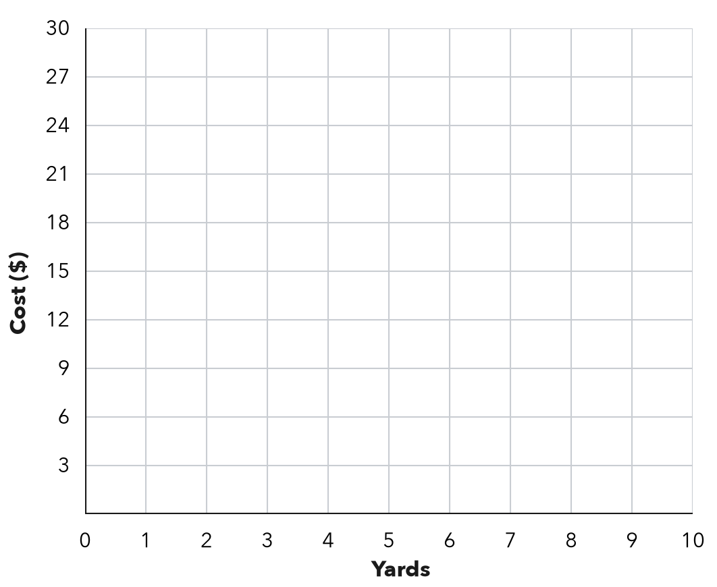
  Yards (x) | 2 | 5 | 8
  Cost ($) (y) | $ | $ | $

6. Corn Rows. A garden plants 18 corn seeds in every row. Write the ordered pair for 5 rows. Then tell what it means.  Show your work.  Pair ( , )  Meaning | 7. From Pairs to a Pattern. A table gives the pairs (1, 5), (2, 10), (3, 15).  a. Describe the rule.  b. What shape do the points make?  c. Write the pair for x = 7.  ( , )

8. With a Fee. A service charges $4 plus $2 for each item. List the pairs for 1, 2 and 3 items. Plot them. Where does the line meet the y-axis?  y-axis point ( , ) | 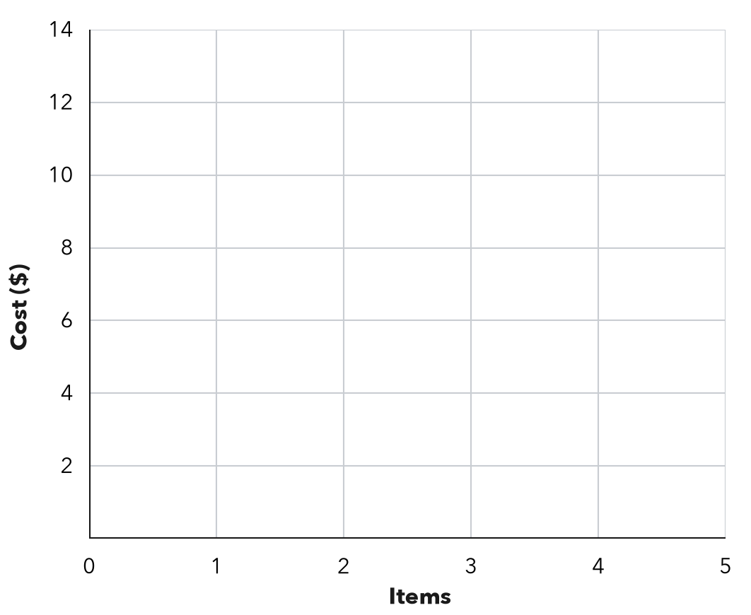
  Items (x) | 1 | 2 | 3
  Cost ($) (y) | $ | $ | $

FIND THE ERROR explain the mistake, then fix it
9. Jonah’s Work. A parking garage charges $5 per hour. Jonah plotted the points (15, 3) and (25, 5). Explain his mistake and give the correct points.
Show your work.

TEST PRACTICE choose the best answer
10. A table row with x = 4 and y = 20 becomes the ordered pair —
A (20, 4) B (4, 20) C (4, 24) D (24, 4)

11. At $9 per ticket, 3 tickets give the ordered pair —
A (9, 3) B (3, 12) C (3, 27) D (27, 3)

CHECK YOURSELF
□ I can do this on my own □ I need a little help □ I have a question about #

