Name Date Period
Lesson 9-2 · Session 1 · Guided Steps · Form B
From Table to Graph
Learning target — I can turn a table of values into points and plot them on a graph. · 6.EE.C.9
REMEMBER
• Each row of a table gives an ordered pair (x, y): the input first, then the output.
• To plot (x, y), start at (0, 0). Go right x, then up y.
GUIDED PRACTICE fill in each blank — problems 1–4
1. Write each table row as an ordered pair (x, y).
a. x = 4, y = 28  Step 1 Input x =  Step 2 Output y =  Step 3 Pair: ( , ) | b. x = 7, y = 2  Step 1 Input x =  Step 2 Output y =  Step 3 Pair: ( , )

c. x = 0, y = 5  Step 1 Input x =  Step 2 Output y =  Step 3 Pair: ( , ) | d. x = 6, y = 54  Step 1 Input x =  Step 2 Output y =  Step 3 Pair: ( , )

2. Babysitting Pay. Lina earns $8 for every hour she babysits. Complete the table. Then plot the points on the grid.  Step 1 Multiply each x by the rate.  Step 2 Plot: right x, then up y. | 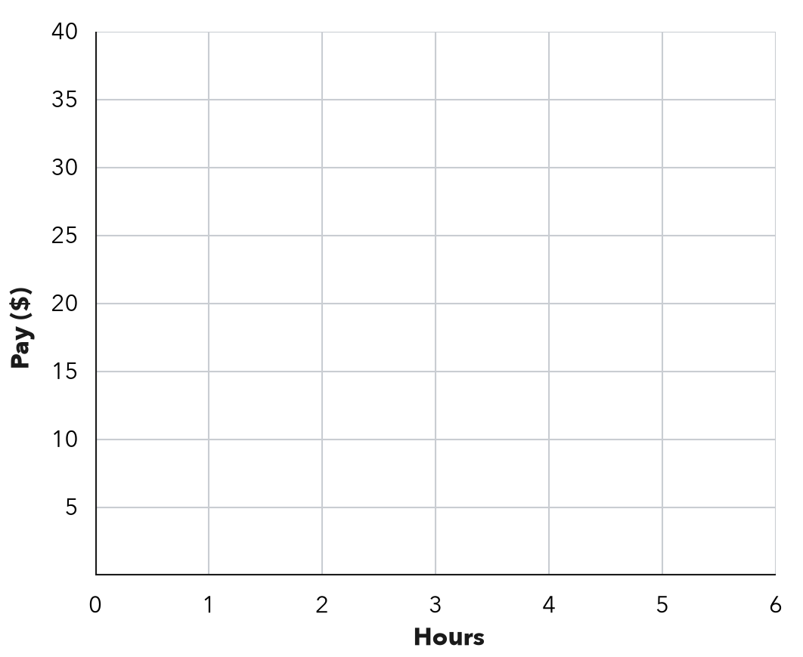
  Hours (x) | 1 | 2 | 3 | 5
  8 × x | 8 × 1 = | 8 × 2 = | 8 × 3 = | 8 × 5 =
  Pay in $ (y) | $ | $ | $ | $
  (x, y) | ( 1 , ) | ( 2 , ) | ( 3 , ) | ( 5 , )

3. Elevator. A glass elevator rises 12 feet every second. Write the ordered pair for 8 seconds. What does it mean?  Step 1 Seconds come first: x =  Step 2 Feet: 12 × =  Step 3 Pair: ( , )  Step 4 After seconds, the elevator  has risen feet.  Pair ( , ) | 4. Reading Log. Marco’s table shows x: 1, 2, 3, 4 days and y: 15, 30, 45, 60 pages read. For the third day he plotted (45, 3). What did he do wrong? Give the correct point.  Step 1 Third day: x =  Step 2 Pages that day: y =  Step 3 He put the first.  Step 4 Correct: ( , )  Point ( , )

ON YOUR OWN use the open space · show your work · label units
5. Party Balloons. A party store ties 16 balloons in every bunch. Complete the table. Then plot the points on the grid. | 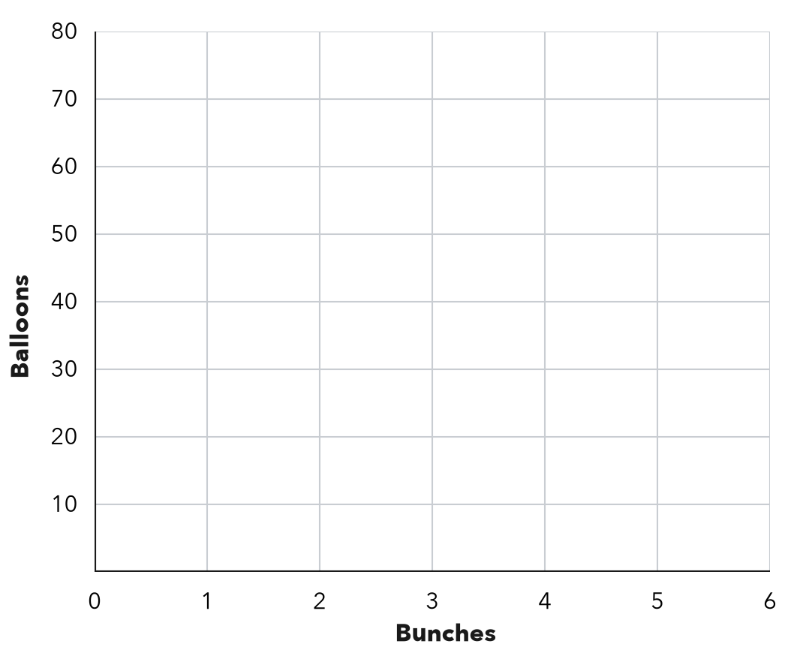
  Bunches (x) | 1 | 3 | 5
  Balloons (y)

6. Tile Rows. A floor has 14 tiles in every row. Write the ordered pair for 6 rows. Then tell what it means.  Show your work.  Pair ( , )  Meaning | 7. From Pairs to a Pattern. A table gives the pairs (1, 4), (2, 8), (3, 12).  a. Describe the rule.  b. What shape do the points make?  c. Write the pair for x = 9.  ( , )

8. With a Fee. A service charges $3 plus $5 for each item. List the pairs for 1, 2 and 3 items. Plot them. Where does the line meet the y-axis?  y-axis point ( , ) | 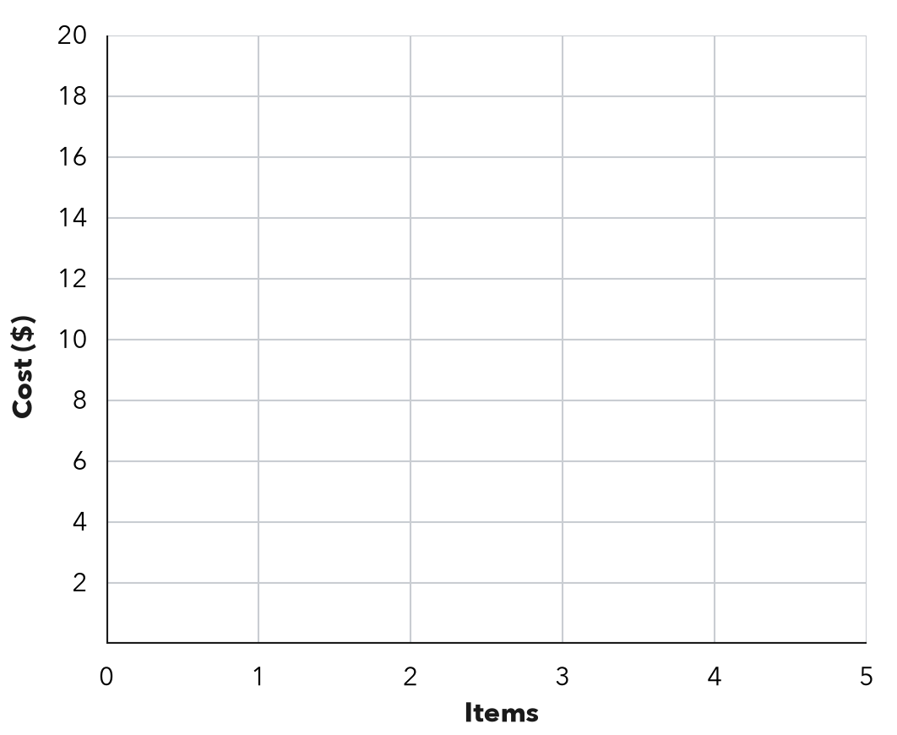
  Items (x) | 1 | 2 | 3
  Cost ($) (y) | $ | $ | $

FIND THE ERROR explain the mistake, then fix it
9. Zuri’s Work. A car wash charges $6 per car. Zuri plotted the points (12, 2) and (30, 5). Explain her mistake and give the correct points.
Show your work.

TEST PRACTICE choose the best answer
10. A table row with x = 6 and y = 42 becomes the ordered pair —
A (42, 6) B (6, 48) C (6, 42) D (7, 42)

11. At $8 per ticket, 5 tickets give the ordered pair —
A (8, 5) B (5, 40) C (40, 5) D (5, 13)

CHECK YOURSELF
□ I can do this on my own □ I need a little help □ I have a question about #

