Name Date Period
Lesson 9-2 · Session 2 · Guided Steps · Form A
Analyzing a Graph
Learning target — I can read a relationship off a graph and describe the rate it shows. · 6.EE.C.9
REMEMBER
• The rate of change is how much y goes up when x goes up by 1: change in y ÷ change in x.
• With the same scales, a steeper line has a greater rate.
GUIDED PRACTICE fill in each blank — problems 1–4
1. Find the rate of change of a line through the two points.
a. (1, 7) and (3, 21)  Step 1 y change: − =  Step 2 x change: − =  Step 3 Rate: ÷ = | b. (2, 10) and (6, 30)  Step 1 y change: − =  Step 2 x change: − =  Step 3 Rate: ÷ =

c. (4, 12) and (5, 15)  Step 1 y change: − =  Step 2 x change: − =  Step 3 Rate: ÷ = | d. (2, 18) and (5, 45)  Step 1 y change: − =  Step 2 x change: − =  Step 3 Rate: ÷ =

2. Scooter Rental. The graph shows the cost of renting a scooter.  a. What does (4, 28) mean?  Step 1 x = 4 means minutes  Step 2 y = 28 means $  Meaning:  b. Cost for 1 minute:  Step 3 Read the graph at x = 1: y = $  b. $  c. Cost for 3 minutes:  Step 4 3 × = $  c. $ | 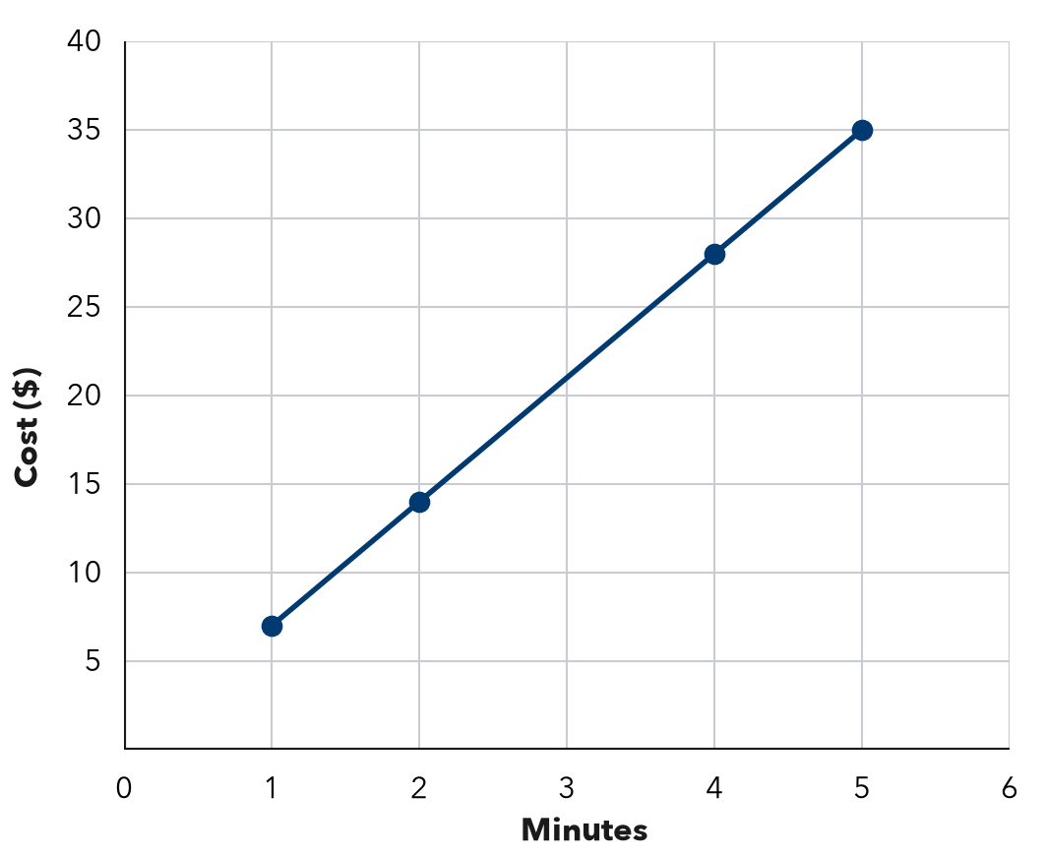

3. Hiking Trail. A graph of hours (x) and miles (y) passes through (1, 2), (3, 6), (5, 10).  Step 1 Pick (3, 6): y ÷ x  Step 2 ÷ = miles  Step 3 8 hours: × 8 =  a. Miles each hour:  b. Miles after 8 hours: | 4. Phone Storage. A graph of songs (x) and megabytes (y) passes through (2, 8), (5, 20), (10, 40).  Step 1 Pick (5, 20): y ÷ x  Step 2 ÷ = MB  Step 3 x = 5 means songs  Step 4 y = 20 means MB  a. MB for one song:  b. (5, 20) means:

ON YOUR OWN use the open space · show your work · label units
5. Sunflower Growth. A graph of weeks (x) and height in inches (y) passes through (2, 14), (4, 28), (6, 42).  Show your work.  a. Rate of change: in. per week  b. Height at 9 weeks: in. | 6. Two Pay Graphs. Job A’s pay graph passes through (1, 6) and (3, 18). Job B’s passes through (1, 9) and (3, 27). Which line is steeper? What does that mean?  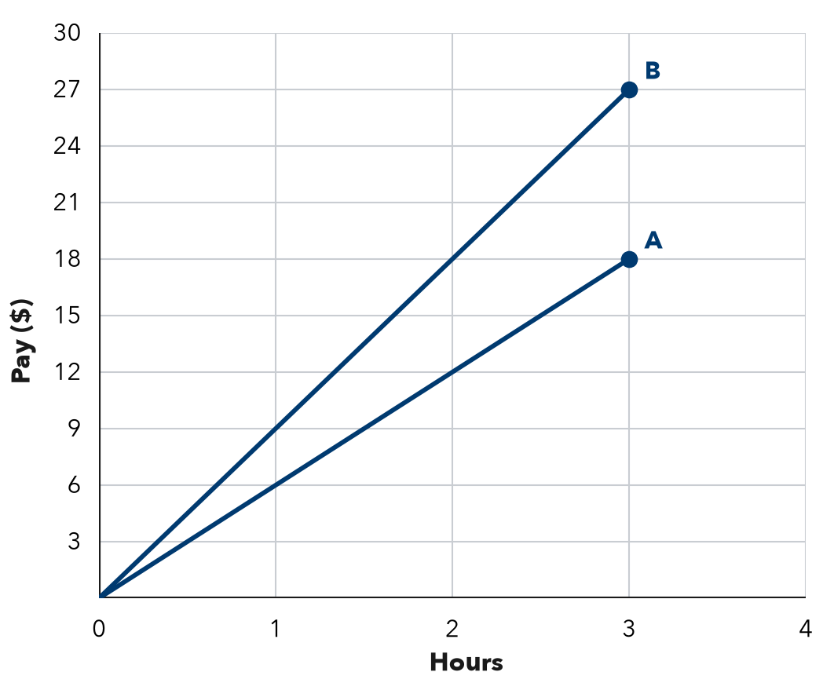  Show your work.  Steeper Job  It means

7. Water Tank. A graph of hours (x) and gallons (y) passes through (2, 50), (4, 100), (7, 175).  Show your work.  a. Unit rate: gallons per hour  b. Pair for 10 hours: ( , ) | 8. Lawn Signs. A fundraiser graph shows lawn signs sold (x) and dollars raised (y). It passes through (3, 45) and (7, 105). Yusuf says (3, 45) means the group raises $45 each hour. Explain the mistake. How much is raised for each sign?  Show your work.  $ _______ per sign

FIND THE ERROR explain the mistake, then fix it
9. Bianca’s Work. A walking graph shows minutes (x) and steps (y). It passes through (2, 100) and (4, 200). Bianca said the walker takes 100 steps each minute. Explain her mistake and find the rate.
Show your work.

TEST PRACTICE choose the best answer
10. A graph through (1, 8) and (2, 16) shows a rate of —
A 8 per unit B 16 per unit C 2 per unit D 24 per unit

11. With the same scales, a steeper line shows —
A a smaller rate B a greater rate C a starting fee D a rate of 0

CHECK YOURSELF
□ I can do this on my own □ I need a little help □ I have a question about #

