Name Date Period
Lesson 9-2 · Session 2 · Guided Steps · Form B
Analyzing a Graph
Learning target — I can read a relationship off a graph and describe the rate it shows. · 6.EE.C.9
REMEMBER
• The rate of change is how much y goes up when x goes up by 1: change in y ÷ change in x.
• With the same scales, a steeper line has a greater rate.
GUIDED PRACTICE fill in each blank — problems 1–4
1. Find the rate of change of a line through the two points.
a. (1, 6) and (4, 24)  Step 1 y change: − =  Step 2 x change: − =  Step 3 Rate: ÷ = | b. (3, 12) and (5, 20)  Step 1 y change: − =  Step 2 x change: − =  Step 3 Rate: ÷ =

c. (2, 16) and (3, 24)  Step 1 y change: − =  Step 2 x change: − =  Step 3 Rate: ÷ = | d. (1, 11) and (3, 33)  Step 1 y change: − =  Step 2 x change: − =  Step 3 Rate: ÷ =

2. Kayak Rental. The graph shows the cost of renting a kayak.  a. What does (4, 24) mean?  Step 1 x = 4 means hours  Step 2 y = 24 means $  Meaning:  b. Cost for 1 hour:  Step 3 Read the graph at x = 1: y = $  b. $  c. Cost for 3 hours:  Step 4 3 × = $  c. $ | 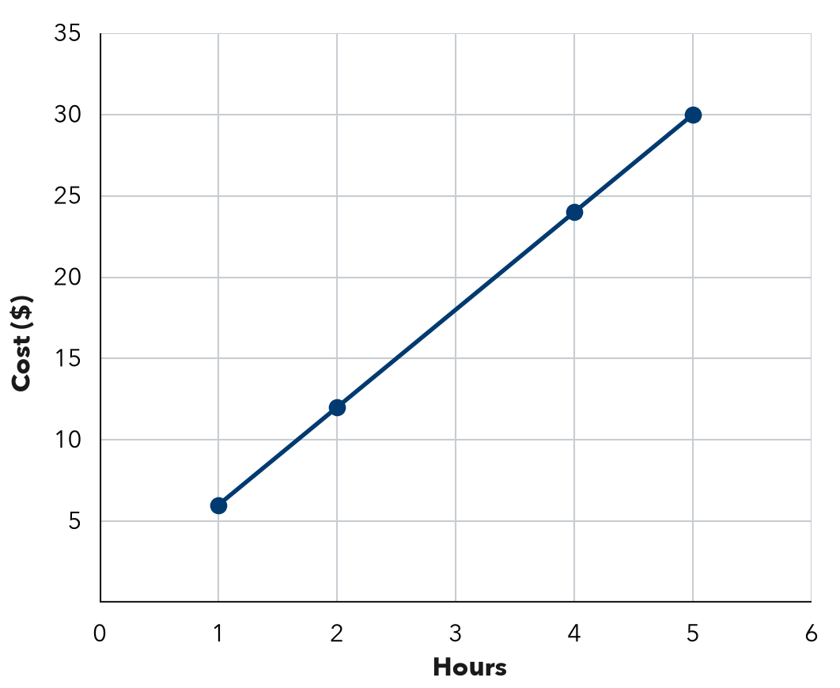

3. Bike Trail. A graph of hours (x) and miles (y) passes through (1, 3), (2, 6), (4, 12).  Step 1 Pick (2, 6): y ÷ x  Step 2 ÷ = miles  Step 3 7 hours: × 7 =  a. Miles each hour:  b. Miles after 7 hours: | 4. Photo Storage. A graph of photos (x) and megabytes (y) passes through (3, 15), (6, 30), (10, 50).  Step 1 Pick (6, 30): y ÷ x  Step 2 ÷ = MB  Step 3 x = 6 means photos  Step 4 y = 30 means MB  a. MB for one photo:  b. (6, 30) means:

ON YOUR OWN use the open space · show your work · label units
5. Bean Plant. A graph of weeks (x) and height in centimeters (y) passes through (2, 6), (4, 12), (6, 18).  Show your work.  a. Rate of change: cm per week  b. Height at 11 weeks: cm | 6. Two Pay Graphs. Job A’s pay graph passes through (1, 8) and (3, 24). Job B’s passes through (1, 5) and (3, 15). Which line is steeper? What does that mean?  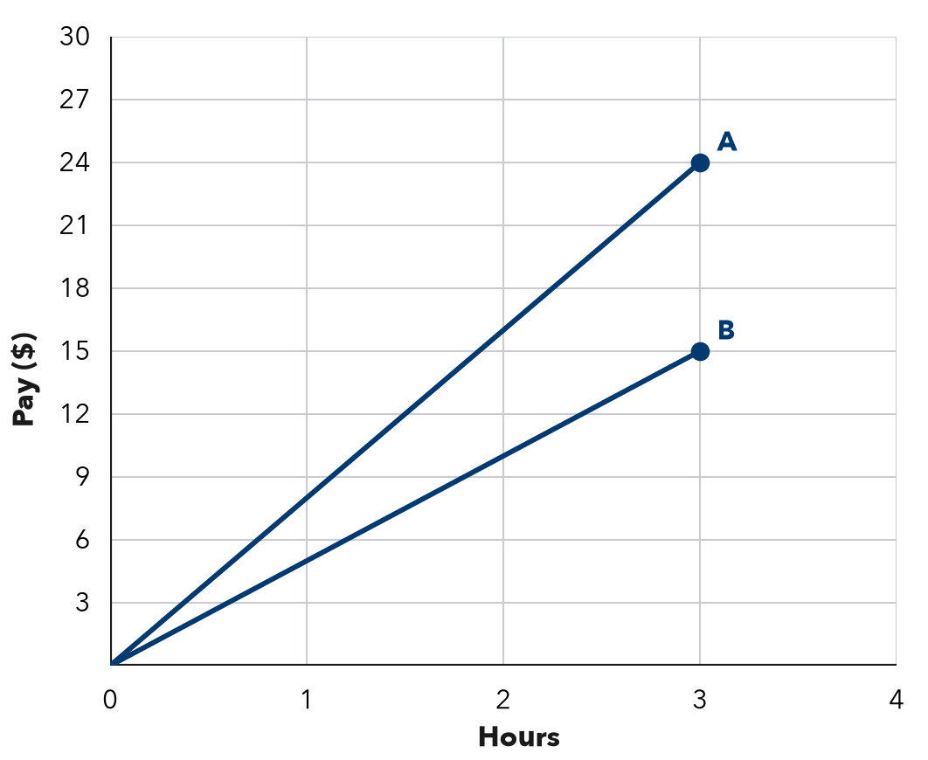  Show your work.  Steeper Job  It means

7. Rain Barrel. A graph of hours (x) and liters (y) passes through (3, 60), (5, 100), (8, 160).  Show your work.  a. Unit rate: liters per hour  b. Pair for 12 hours: ( , ) | 8. Cookie Boxes. A bake-sale graph shows boxes sold (x) and dollars raised (y). It passes through (4, 36) and (6, 54). Lena says (4, 36) means the club raises $36 for each box. Explain the mistake. How much is raised for each box?  Show your work.  $ _______ per box

FIND THE ERROR explain the mistake, then fix it
9. Amir’s Work. A jogging graph shows minutes (x) and meters (y). It passes through (3, 120) and (6, 240). Amir said the jogger runs 120 meters each minute. Explain his mistake and find the rate.
Show your work.

TEST PRACTICE choose the best answer
10. A graph through (1, 7) and (2, 14) shows a rate of —
A 14 per unit B 2 per unit C 7 per unit D 21 per unit

11. With the same scales, Line P is steeper than Line Q. This means —
A P has a smaller rate B P has a greater rate C P starts higher D the rates are equal

CHECK YOURSELF
□ I can do this on my own □ I need a little help □ I have a question about #

