9.2 Connect a Table, Graph and Equation
Student activity · each notebook costs $4; there is no other charge

Complete the table, then plot the ordered pairs.
Notebooks x | 0 | 1 | 2 | 3 | 4 | 5
Cost y ($) | 0 | 4 | _____ | _____ | _____ | _____
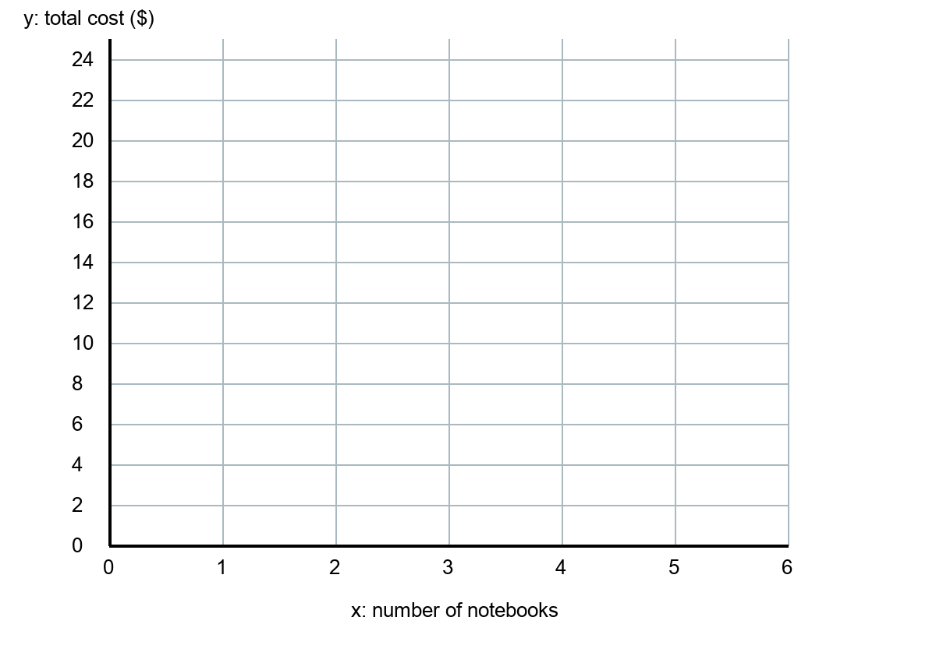
Write an equation: ____________. Explain how the rule appears in the table and graph. Is (2.5, 10) a possible purchase in this situation? Why?
________________________________________________________________________
________________________________________________________________________

