Lesson 9.3 Guided Notes

Session 1 · Equations from Tables
I can write an equation that matches a table of values. · 6.EE.C.9
Word / Spanish | Meaning — complete the blank | Example
equation / ecuación | A math sentence with an _______ sign. | y = 5x
constant / constante | A number that _______ changes. | the 5 in y = 5x
rate / tasa | The amount for ______ one unit. | $3 for each pound

Key idea
If y ÷ x is the ______ in every row, the equation is y = (that number) × x.
If y − x is the same in every row, the equation is y = x _____ (that number).
Check the equation with _____ rows.

Worked example
Write an equation for the pairs (1, 6), (2, 12) and (5, 30).
6 ÷ 1 = _____, 12 ÷ 2 = 6, 30 ÷ 5 = 6
The rate is _____ in every row.
Answer: y = _____. Check: 6 × 5 = 30.

You try
1. Write an equation for each table.
a. x: 2, 4, 6 y: 10, 20, 30 y = ______
b. x: 1, 2, 3 y: 9, 10, 11 y = ______
________________________________________________________________
2. A table shows x: 3, 5, 8 and y: 24, 40, 64. Write the equation. Then find y when x = 12.
________________________________________________________________
Sum it up: To write an equation from a table, I ___, and I check it by ___.
________________________________________________________________

Session 2 · Equations from Situations
I can write an equation from a described situation and identify its variables. · 6.EE.C.9
Word / Spanish | Meaning — complete the blank | Example
unit rate / tasa unitaria | The amount for exactly _____ unit. | $4 for each hour
multiplicative rule / regla multiplicativa | __________ the input by the same number. | y = 6x
additive rule / regla aditiva | _____ the same number to the input. | y = x + 6
per / por | Means “for ______ one.” | 25 miles per gallon

Key idea
A rate (“each,” “per”) ____________ the variable.
A one-time fee or a starting amount is _______ once.

Worked example
A pet sitter earns $9 each day. Write an equation for the dollars e earned in d days.
Define the letters: d = days, e = ________________.
The rate is $9 for each _____, so e = _____.
Answer: Test d = 5: e = 9 × 5 = _____ dollars.

You try
1. Write an equation for each situation.
a. Each box holds 8 pens. Pens p in b boxes: p = ______
b. A gym costs $10 to join plus $20 a month. Cost c for m months: c = ______
________________________________________________________________
2. Devin earns $13 for each lawn he mows. Write an equation for his pay p for n lawns. Find his pay for 6 lawns.
________________________________________________________________
Sum it up: In my equation, the rate goes ___, and a one-time fee goes ___.
________________________________________________________________

Session 1 · Model, reason, and explain
Equations from Tables · 6.EE.C.9
Success: represent the quantities, justify the relationship, and check the result with the correct units.
Compare tables A: (0,0),(2,10),(5,25) and B: (0,5),(2,7),(5,10). Write a multiplicative rule for A and an additive rule for B. Check all rows.
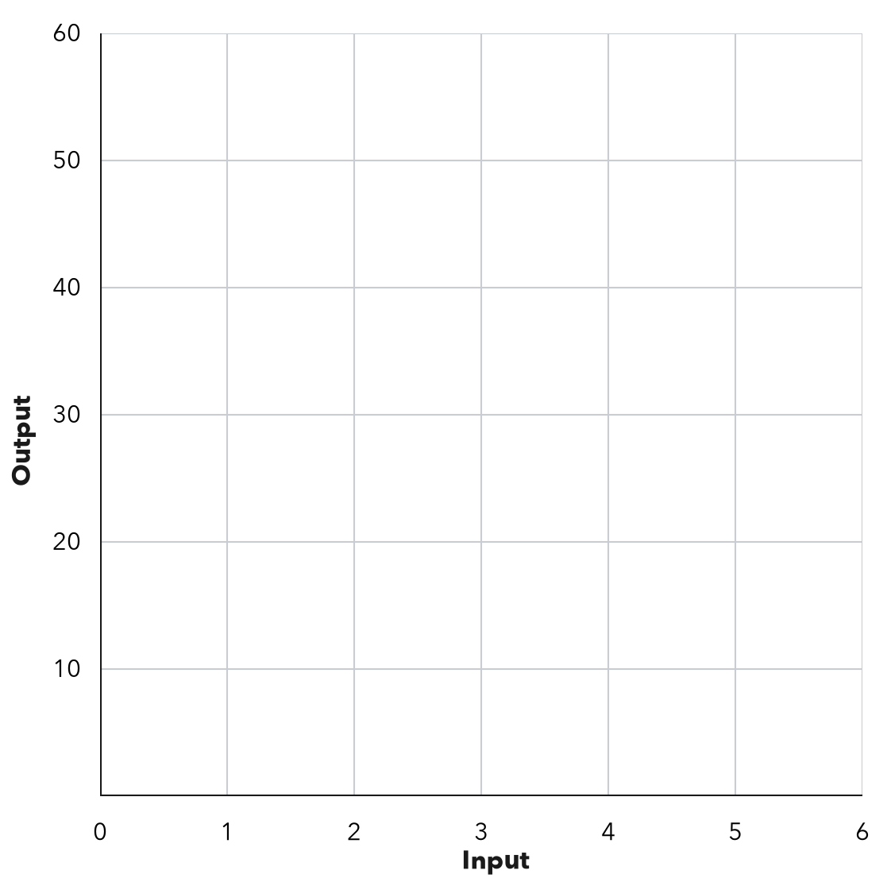
________________________________________________________________
________________________________________________________________
________________________________________________________________

Extend your reasoning
Create a contrasting example that exposes the misconception: confuses constant difference with constant ratio or divides by zero.. Explain what changes and what stays true.
________________________________________________________________
________________________________________________________________
Self-check: Did my model, calculation, explanation, and units agree?

Session 2 · Model, reason, and explain
Equations from Situations · 6.EE.C.9
Success: represent the quantities, justify the relationship, and check the result with the correct units.
A sitter earns $8 per visit plus a one-time $5 travel payment. Define variables, write an equation, and connect each term to the story.
________________________________________________________________
________________________________________________________________
________________________________________________________________

Extend your reasoning
Create a contrasting example that exposes the misconception: multiplies the fixed fee by the number of items or leaves variables undefined.. Explain what changes and what stays true.
________________________________________________________________
________________________________________________________________
Self-check: Did my model, calculation, explanation, and units agree?

