Lesson 9.4 Guided Notes

Session 1 · Substitute and Solve
I can substitute a value into an equation to find the matching output. · 6.EE.C.9
Word / Spanish | Meaning — complete the blank | Example
substitute / sustituir | Put a known number in _______ of a letter. | put 8 in for x
order of operations / orden de las operaciones | __________ first, then add or subtract. | 3 × 4 + 10 = 22
reasonable / razonable | Makes _______ for the story. | 17 days, not 17 years

Key idea
To find an output, ____________ the input for the variable.
With a fee, __________ first, then add the fee.

Worked example
A bakery makes 24 rolls each hour, so r = 24h. Is 5 hours enough for an order of 150 rolls?
Substitute h = 5: r = 24 × _____.
Multiply: r = _____ rolls.
Compare: 120 _____ 150.
Answer: _____, 5 hours makes only 120 rolls.

You try
1. Substitute to find y.
a. y = 4x + 7; x = 6 ______
b. y = 12x; x = 9 ______
________________________________________________________________
2. A rental costs c = 8h + 15 dollars for h hours. Find the cost for 5 hours.
________________________________________________________________
Sum it up: When I substitute into an equation with a fee, I ___ before I ___.
________________________________________________________________

Session 2 · Working Backward to a Goal
I can work backward from a goal to find the input an equation needs. · 6.EE.C.9
Word / Spanish | Meaning — complete the blank | Example
work backward / trabajar hacia atrás | Start with the ______ and undo the steps. | goal first, then divide
inverse operation / operación inversa | An action that ________ another action. | ÷ undoes ×
at least / al menos | That number _________. | at least 42 cars

Key idea
Put the goal in place of the ________, then solve for the input.
With a fee, __________ the fee first, then divide by the rate.
If only whole items make sense, round _____ to reach the goal.

Worked example
Tickets cost $6. A club needs at least $100. How many tickets must it sell?
Put in the goal: 100 = _____n.
Divide: 100 ÷ 6 ≈ ______.
16 tickets make $96 (too low); _____ tickets make $102.
Answer: The club must sell _____ tickets.

You try
1. Solve for x.
a. 11x = 528 ______
b. 4x + 10 = 50 ______
________________________________________________________________
2. A van holds 8 students. 60 students are going on a trip. How many vans are needed?
________________________________________________________________
Sum it up: When I work backward with a fee, I ___ first because ___.
________________________________________________________________

Session 1 · Model, reason, and explain
Substitute and Solve · 6.EE.C.9
Success: represent the quantities, justify the relationship, and check the result with the correct units.
A rental costs c=7h+12. Is $40 enough for 4 hours? Show substitution and a contextual decision.
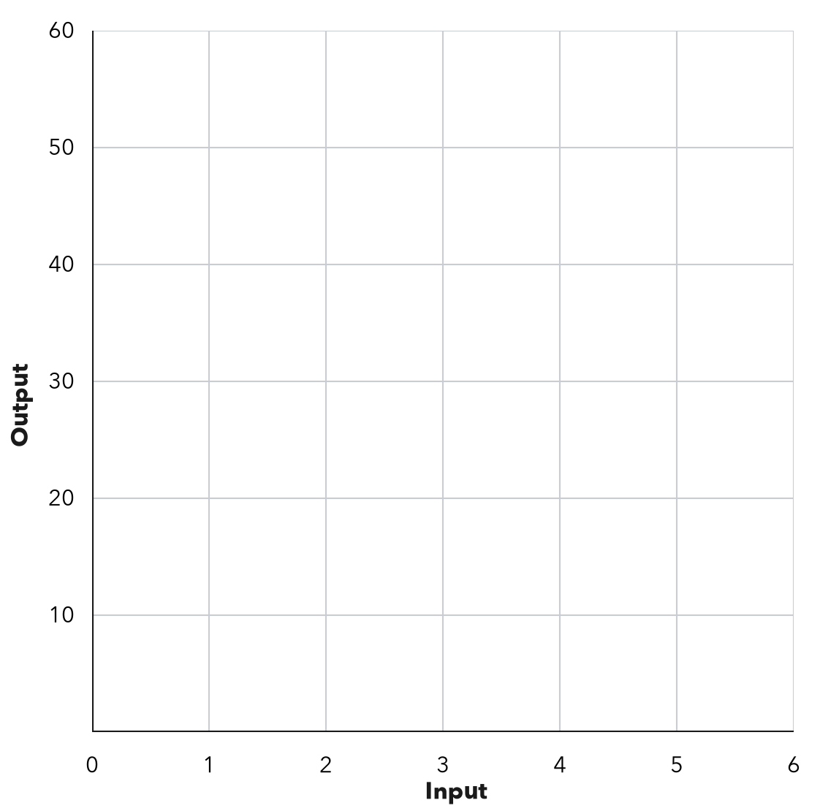
________________________________________________________________
________________________________________________________________
________________________________________________________________

Extend your reasoning
Create a contrasting example that exposes the misconception: adds the fee before multiplying or gives a value without answering the decision.. Explain what changes and what stays true.
________________________________________________________________
________________________________________________________________
Self-check: Did my model, calculation, explanation, and units agree?

Session 2 · Model, reason, and explain
Working Backward to a Goal · 6.EE.C.9
Success: represent the quantities, justify the relationship, and check the result with the correct units.
Tickets sell for $6. Find the fewest whole tickets needed to raise at least $100. Separately, find the most tickets that can be bought with at most $100. Test neighboring integers.
________________________________________________________________
________________________________________________________________
________________________________________________________________

Extend your reasoning
Create a contrasting example that exposes the misconception: always rounds up, including a maximum-budget problem.. Explain what changes and what stays true.
________________________________________________________________
________________________________________________________________
Self-check: Did my model, calculation, explanation, and units agree?

