Featured Lesson: Speak, Write, Improve

Safer Hallways
Name
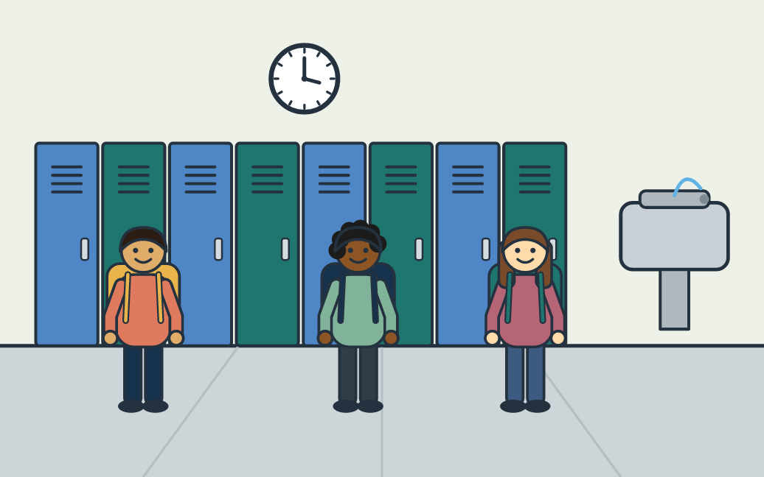
Your task: The hallway gets crowded between classes. Explain one change the school could make so students get to class safely, and give a reason.
Sentence frame: One change the school could make is ___. This would help because ___. For example, ___.

What to do
- Open the link. Look at the hallway picture.
- Name two things you see and one problem.
- Say your answer to a partner: One change the school could make is ___. This would help because ___. For example, ___.
- Write what you said in two or three sentences.
- Add one example that starts with “For example.”
- Read your new response to your partner.

My first response

My improved response

You need: A device with the student link, or the printed backup page; Paper or a document to write in; A partner (a microphone is not needed).
Time: About 10 minutes. Online activity: thelanguagepage.com/access-practice-lab/voice/ladder/school-hallway

Teacher page: Safer Hallways
Use this page if the live activity will not load. Hand out page 1 and teach the same 10 minutes.
Objective: Students will explain one change and support it with a reason and an example, first aloud and then in writing.

Five steps
- Notice 1 minute. Show the picture. Ask: “What do you see? What problem could happen here?” Take two quick answers.
- Speak 2 minutes. Read the prompt. Partners take turns answering with the frame. The listener holds up one finger for the change and two for the reason.
- Write 3 minutes. Students turn what they said into two or three written sentences. Allow home-language notes first.
- Improve 2 minutes. Give one cue only: “Add an example that starts with For example.” Students add it and read the new version once.
- Share 2 minutes. Two or three students read the revised response and say what they added.

Example learner work
Example first response: The school should make the hallway bigger. It is too crowded.
Example improved response: One change the school could make is to put arrows on the floor so everyone walks the same way. This would help because students would not run into each other. For example, a student with a heavy backpack could get to class without being pushed.
The improved response adds a clear change, a reason and an example.
One feedback cue: Add an example that starts with “For example.”
Quick check: Ask students to point to their change, their “because,” and their “For example.” Count how many have all three.
Follow-up: Students write one change for another school place (the lunch line or bus loading) with the same three parts, then try the Language Upgrade Lab.

Three support choices
More support
- Vocabulary: crowded, hallway, rule, safely, bump into, walk on the right, arrows.
- Visual reference: the hallway picture stays on screen.
- Oral rehearsal: say it twice with a partner before writing.
- Sentence frame: One change the school could make is ___. This would help because ___.
Some support
- Optional connectors: because, so, also, for example.
- Reason prompt: “Why would this help?”
Greater independence
- Write a fuller explanation with two reasons.
- Choose a more exact word for “crowded” or “rule.”
- Answer a classmate who disagrees: “Some students think … However, …”
Students may plan in their home language before they say or write in English. Supports fade; the task stays the same. These are practical supports, not WIDA levels or alignments. If students will not record, use live partner talk. The activity needs no microphone.
All activities and handouts: thelanguagepage.com/access-practice-lab/start

