Prime Factorization — Homework
Lesson 1-1-flagship • Standard 6.NS.4
Name: ______________________ Period: ______ Date: ____________

Today's Goals
Content: I can write a number as a product of its prime factors using a factor tree.
Language: I can explain how I broke a number down using the words prime number, composite number, factor, and exponent.

Key Words
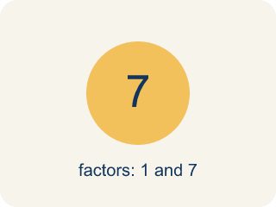
Prime number (Número primo) — A number bigger than 1 that you can only divide by 1 and itself.
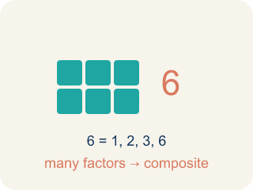
Composite number (Número compuesto) — A number bigger than 1 that you can divide by more than just 1 and itself.
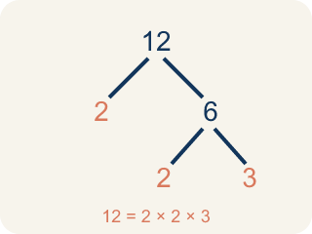
Prime factorization (Factorización prima) — Writing a number as prime numbers multiplied together.

Factor tree (Árbol de factores) — A picture that splits a number into its prime numbers, step by step.
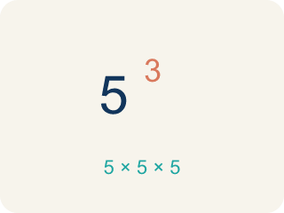
Exponent (Exponente) — A small number that tells how many times to multiply a number by itself.

Practice
Show your work. Use the blank space under each problem.
1. Which of the following is a prime number?
A. 17
B. 15
C. 21
D. 9
______________________________________________________________________
2. What is the prime factorization of 30?
A. 2 × 3 × 5
B. 5 × 6
C. 2 × 15
D. 3 × 10
______________________________________________________________________
3. Match each number to its prime factorization.
Item | Answer choices
____ 12 | F. 2 × 5 × 5
____ 18 | E. 3 × 3 × 5
____ 20 | D. 2 × 2 × 7
____ 28 | C. 2 × 2 × 5
____ 45 | B. 2 × 3 × 3
____ 50 | A. 2 × 2 × 3
______________________________________________________________________
4. Build the factor tree. Write each number as a product of primes.
Number | First Split | Prime Factorization
24 | 4 × 6
36 | 4 × 9
40 | 5 × 8
56 | 7 × 8
______________________________________________________________________
5. Sort each number: can it be expressed as a product of exactly TWO prime factors, or does it need THREE or more?
Groups: Product of Exactly Two Primes | Product of Three or More Primes
• 6 (= 2 × 3) → __________________
• 10 (= 2 × 5) → __________________
• 15 (= 3 × 5) → __________________
• 35 (= 5 × 7) → __________________
• 12 (= 2 × 2 × 3) → __________________
• 30 (= 2 × 3 × 5) → __________________
• 24 (= 2 × 2 × 2 × 3) → __________________
• 60 (= 2 × 2 × 3 × 5) → __________________
______________________________________________________________________
6. Two students found different factor trees for 60. Student A started with 2 × 30. Student B started with 6 × 10. Which statement is true?
A. Both get the same prime factorization: 2 × 2 × 3 × 5
B. Only Student A gets the correct prime factorization
C. Only Student B gets the correct prime factorization
D. They will get different prime factorizations
______________________________________________________________________

Answer Key (Teacher)
1. A. 17
17 has exactly two factors: 1 and 17. 15 = 3 × 5, 21 = 3 × 7, and 9 = 3 × 3, so they are all composite.
2. A. 2 × 3 × 5
30 = 2 × 15 = 2 × 3 × 5. All three factors (2, 3, 5) are prime, so 2 × 3 × 5 is the prime factorization.
3. Matches:
12 → 2 × 2 × 3
18 → 2 × 3 × 3
20 → 2 × 2 × 5
28 → 2 × 2 × 7
45 → 3 × 3 × 5
50 → 2 × 5 × 5

4. Build the factor tree. Write each number as a product of primes.
24 → 2 × 2 × 2 × 3
36 → 2 × 2 × 3 × 3
40 → 2 × 2 × 2 × 5
56 → 2 × 2 × 2 × 7

5. Correct groups:
6 (= 2 × 3) → Product of Exactly Two Primes
10 (= 2 × 5) → Product of Exactly Two Primes
15 (= 3 × 5) → Product of Exactly Two Primes
35 (= 5 × 7) → Product of Exactly Two Primes
12 (= 2 × 2 × 3) → Product of Three or More Primes
30 (= 2 × 3 × 5) → Product of Three or More Primes
24 (= 2 × 2 × 2 × 3) → Product of Three or More Primes
60 (= 2 × 2 × 3 × 5) → Product of Three or More Primes

6. A. Both get the same prime factorization: 2 × 2 × 3 × 5
The Fundamental Theorem of Arithmetic says every composite number has exactly one prime factorization. No matter how you start the factor tree, you always end with 2 × 2 × 3 × 5.

