UNIT 1 · LESSON 7 STANDARD 6.NS.3

Divide Decimals
Student Notes Packet
Name: ______________________ Date: ____________ Period: ________

Today's Goals
Content: I can divide with decimals by making the divisor a whole number first.
Language: I can explain my work using the words dividend, divisor, quotient, and equivalent division.

Key Vocabulary
Look at the picture, read the word, then read what it means.
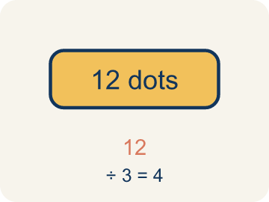 | Dividend Dividendo  The number you are splitting up in a division problem.  Example: In 8.4 ÷ 2.1 = 4, the dividend is 8.4 — it is the total being split
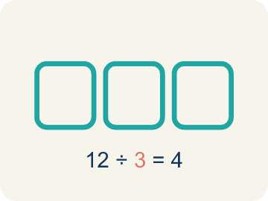 | Divisor Divisor  The number you split by in a division problem.  Example: In 8.4 ÷ 2.1 = 4, the divisor is 2.1 — it is the size of each group
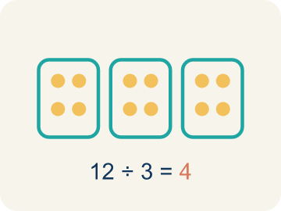 | Quotient Cociente  The answer when you divide.  Example: In 8.4 ÷ 2.1 = 4, the quotient is 4 — there are 4 groups
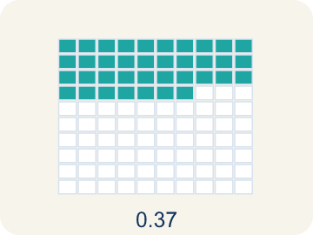 | Decimal division División decimal  Dividing with decimals. First make the number you divide by a whole number.  Example: 8.4 ÷ 2.1 → multiply both by 10 → 84 ÷ 21 = 4
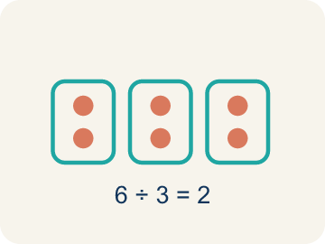 | Equivalent division División equivalente  Multiplying both numbers by 10 or 100 gives the same answer.  Example: 7.56 ÷ 0.12 = 756 ÷ 12 = 63 (both multiplied by 100)

Worked Example

Watch & Read I Do — follow along with your teacher
Space Station Pod Splitter
The space station has 18.9 kilograms of a rare mineral sample that must be divided equally among 6.3-kilogram storage pods. How many pods can be completely filled?

Think about:
• What total amount is being divided?
• What is the size of each pod?
• How do you divide when the divisor is a decimal?
• Can you turn this into a whole number division problem?

Solved Example I Do — watch each step
Problem: What is 14.4 ÷ 1.2?
A) 12
B) 1.2
C) 120
D) 0.12
Step 1: Multiply both by 10: 144 ÷ 12 = 12.
Answer: A. 12

Guided Practice

Solve Together We Do — work with your class
Problem: What is 3.78 ÷ 0.6?
A) 6.3
B) 63
C) 0.63
D) 0.063
Step 1:

Step 2:

Answer:

A ribbon is 16.8 feet long. You need to cut it into pieces that are each 2.4 feet long for a craft project.
How does decimal division help you figure out how many pieces you can cut?

Sentence frame: I can cut ___ pieces because 16.8 ÷ 2.4 = ___.

Turn & Talk discuss with a partner
1. [Launch] The station has 18.9 kilograms of mineral to divide into 6.3-kilogram pods. Why can't you divide by the decimal 6.3 directly the same way you divide by a whole number?
Start with: I make the divisor 6.3 into a ___ before dividing.
Convierto el divisor 6.3 en un ___ antes de dividir.
Word bank: dividend, divisor, quotient, decimal division, equivalent division
2. [Explore] When you divided 18.9 by 6.3, how did you use equivalent division to make the divisor a whole number?
Start with: I moved both decimal points ___ place, changing it to ___ ÷ ___.
Moví ambos puntos decimales ___ lugar, cambiándolo a ___ ÷ ___.
Word bank: dividend, divisor, quotient, decimal division, equivalent division
3. [Connect] A ribbon is 16.8 feet long and you cut pieces that are each 2.4 feet. How does decimal division tell you how many pieces you can cut?
Start with: I can cut ___ pieces because I divided 16.8 by ___.
Puedo cortar ___ piezas porque dividí 16.8 entre ___.
Word bank: dividend, divisor, quotient, decimal division, equivalent division
4. [Reflect] Why does making the divisor a whole number first make dividing by a decimal so much easier?
Start with: Making the divisor a whole number helps because ___.
Convertir el divisor en un número entero ayuda porque ___.
Word bank: dividend, divisor, quotient, decimal division, equivalent division

Independent Practice

On Your Own You Do — show your work
Solve each problem. Show your thinking in the work box.
1. What is 8.4 ÷ 0.7?
A) 12
B) 1.2
C) 120
D) 0.12

2. What is 15.6 ÷ 1.3?
A) 12
B) 1.2
C) 120
D) 13

3. A ribbon is 16.8 feet long. You cut it into pieces that are each 2.4 feet long. How many pieces do you get?
A) 7 pieces
B) 8 pieces
C) 6 pieces
D) 14.4 pieces

4. What is 4.8 ÷ 0.6?
A) 8
B) 0.8
C) 80
D) 4.2

Write About the Math

Build Strong Sentences The Writing Revolution
I can explain my work using the words dividend, divisor, quotient, and equivalent division.

1. Kernel Sentence subject + verb
Model: Decimal division is dividing with decimals. First make the number you divide by a whole number.

Write a kernel sentence about decimal division. Use a subject and a verb.
Escribe una oración base sobre división decimal. Usa un sujeto y un verbo.

2. Sentence Expansion because · but · so
Kernel: Decimal division matters in math
because Decimal division matters in math because ___.
División decimal importa en matemáticas porque ___.

but Decimal division matters in math, but ___.
División decimal importa en matemáticas, pero ___.

so Decimal division matters in math, so ___.
División decimal importa en matemáticas, entonces ___.

3. Explain Your Reasoning use a sentence starter
I make the divisor 6.3 into a ___ before dividing.
Convierto el divisor 6.3 en un ___ antes de dividir.
Dividing by a decimal directly is hard because ___.
Dividir entre un decimal directamente es difícil porque ___.
I moved both decimal points ___ place, changing it to ___ ÷ ___.
Moví ambos puntos decimales ___ lugar, cambiándolo a ___ ÷ ___.

Exit Ticket
Answer on your own. This shows what you learned today.
★ What is 19.2 ÷ 0.8?
A) 24
B) 2.4
C) 240
D) 0.24

Answer Key & Teacher Guide
Teacher reference — remove or fold back before distributing to students.

Worked Notes (I Do / We Do)
I Do: A. 12
We Do: A. 6.3

Independent Practice
1. A) 12 — 8.4 ÷ 0.7 = 84 ÷ 7 = 12.
2. A) 12 — Multiply both by 10: 156 ÷ 13 = 12.
3. A) 7 pieces — 16.8 ÷ 2.4: multiply both by 10 → 168 ÷ 24 = 7 pieces.
4. A) 8 — Multiply both by 10: 48 ÷ 6 = 8.

Exit Ticket
A) 24 — Multiply both by 10: 192 ÷ 8 = 24.

Writing (TWR) — what to look for
Kernel sentence: a complete sentence needs a subject and a verb. Example: Decimal division is dividing with decimals. First make the number you divide by a whole number.
Expansion: because = reason, but = contrast/exception, so = result. Answers vary; each must keep the kernel idea.

Turn & Talk — listen for
1. Students explain you move the decimal in the divisor to make it whole (6.3 to 63) and move the dividend the same way, naming 18.9 as the dividend and 6.3 as the divisor.
2. Students rewrite 18.9 ÷ 6.3 as 189 ÷ 63 = 3, explaining moving both points one place keeps the division equivalent, so 3 pods are filled.
3. Students rewrite 16.8 ÷ 2.4 as 168 ÷ 24 = 7, so 7 pieces can be cut with none left over.
4. Students explain that a whole-number divisor lets them divide normally, and equivalent division keeps the quotient the same while removing the decimal from the divisor.

