Divide Decimals — Homework
Lesson 1-7 • Standard 6.NS.3
Name: ______________________ Period: ______ Date: ____________

Today's Goals
Content: I can divide with decimals by making the divisor a whole number first.
Language: I can explain my work using the words dividend, divisor, quotient, and equivalent division.

Key Words
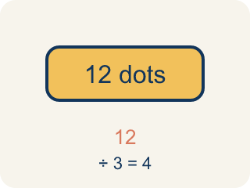
Dividend (Dividendo) — The number you are splitting up in a division problem.
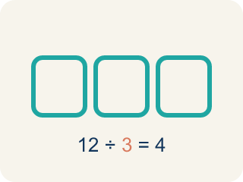
Divisor (Divisor) — The number you split by in a division problem.
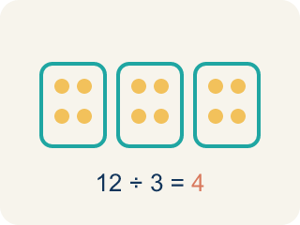
Quotient (Cociente) — The answer when you divide.
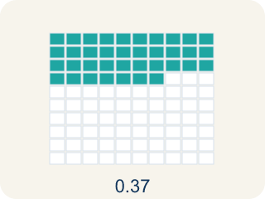
Decimal division (División decimal) — Dividing with decimals. First make the number you divide by a whole number.
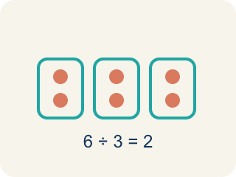
Equivalent division (División equivalente) — Multiplying both numbers by 10 or 100 gives the same answer.

Practice
Show your work. Use the blank space under each problem.
1. What is 14.4 ÷ 1.2?
A. 12
B. 1.2
C. 120
D. 0.12
______________________________________________________________________
2. What is 3.78 ÷ 0.6?
A. 6.3
B. 63
C. 0.63
D. 0.063
______________________________________________________________________
3. Solve each decimal division problem.
Division Problem | Quotient
9.6 ÷ 0.8
15.6 ÷ 1.3
24.5 ÷ 3.5
5.76 ÷ 0.24
11.34 ÷ 0.9
______________________________________________________________________
4. Match each decimal division to its quotient.
Item | Answer choices
____ 7.2 ÷ 0.8 | F. 1.2
____ 4.56 ÷ 0.6 | E. 7
____ 16.8 ÷ 2.4 | D. 30
____ 3.6 ÷ 0.12 | C. 7
____ 10.5 ÷ 1.5 | B. 7.6
____ 0.96 ÷ 0.8 | A. 9
______________________________________________________________________
5. A ribbon is 16.8 feet long. You cut it into pieces that are each 2.4 feet long. How many pieces do you get?
A. 7 pieces
B. 8 pieces
C. 6 pieces
D. 14.4 pieces
______________________________________________________________________
6. Sort: should you multiply both numbers by 10 or by 100 to make the divisor a whole number?
Groups: Multiply Both by 10 | Multiply Both by 100
• 6.3 ÷ 0.7 → multiply by 10 → __________________
• 8.4 ÷ 2.1 → multiply by 10 → __________________
• 15.6 ÷ 1.3 → multiply by 10 → __________________
• 7.56 ÷ 0.12 → multiply by 100 → __________________
• 5.76 ÷ 0.24 → multiply by 100 → __________________
• 9.45 ÷ 0.15 → multiply by 100 → __________________
______________________________________________________________________
7. What is 4.8 ÷ 0.6?
A. 8
B. 0.8
C. 80
D. 4.2
______________________________________________________________________
8. What is 9.45 ÷ 0.9?
A. 10.5
B. 1.05
C. 105
D. 9.5
______________________________________________________________________
9. A ribbon is 7.2 meters long and is cut into 0.8-meter pieces. How many pieces are there?
A. 9
B. 8
C. 7
D. 10
______________________________________________________________________
10. What is 15 ÷ 0.25?
A. 60
B. 6
C. 1.5
D. 0.6
______________________________________________________________________

Answer Key (Teacher)
1. A. 12
Multiply both by 10: 144 ÷ 12 = 12.
2. A. 6.3
Multiply both by 10: 37.8 ÷ 6 = 6.3.
3. Solve each decimal division problem.
9.6 ÷ 0.8 → 12
15.6 ÷ 1.3 → 12
24.5 ÷ 3.5 → 7
5.76 ÷ 0.24 → 24
11.34 ÷ 0.9 → 12.6

4. Matches:
7.2 ÷ 0.8 → 9
4.56 ÷ 0.6 → 7.6
16.8 ÷ 2.4 → 7
3.6 ÷ 0.12 → 30
10.5 ÷ 1.5 → 7
0.96 ÷ 0.8 → 1.2

5. A. 7 pieces
16.8 ÷ 2.4: multiply both by 10 → 168 ÷ 24 = 7 pieces.
6. Correct groups:
6.3 ÷ 0.7 → multiply by 10 → Multiply Both by 10
8.4 ÷ 2.1 → multiply by 10 → Multiply Both by 10
15.6 ÷ 1.3 → multiply by 10 → Multiply Both by 10
7.56 ÷ 0.12 → multiply by 100 → Multiply Both by 100
5.76 ÷ 0.24 → multiply by 100 → Multiply Both by 100
9.45 ÷ 0.15 → multiply by 100 → Multiply Both by 100

7. A. 8
Multiply both by 10: 48 ÷ 6 = 8.
8. A. 10.5
Multiply both by 10: 94.5 ÷ 9 = 10.5.
9. A. 9
7.2 ÷ 0.8 = 72 ÷ 8 = 9 pieces.
10. A. 60
Dividing by 0.25 is like multiplying by 4: 15 × 4 = 60.

