UNIT 10 · LESSON 1 STANDARD 6.G.2

Volume with Whole Number Edges (Flagship)
Student Notes Packet
Name: ______________________ Date: ____________ Period: ________

Today's Goals
Content: I can find the volume of a rectangular prism with whole-number edges using length × width × height.
Language: I can explain my work using the words volume, rectangular prism, cubic units, and edge.

Key Vocabulary
Look at the picture, read the word, then read what it means.
 | Volume Volumen  How much space is inside a solid shape.  Example: A box 3 × 2 × 4 holds 24 unit cubes, so V = 24 cubic units
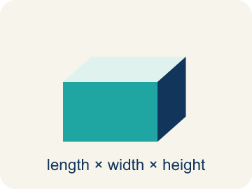 | Rectangular prism Prisma rectangular  A solid box shape with six flat rectangle sides.  Example: A cereal box or shoe box — it has length, width, and height
 | Cubic units Unidades cúbicas  The units used to measure space inside, like cubic inches.  Example: A tiny cube that is 1 in × 1 in × 1 in = 1 in³ (one cubic inch)
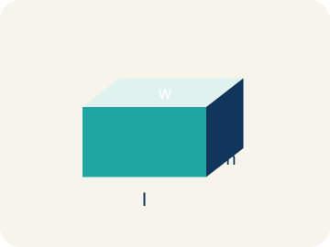 | Length, width, height Largo, ancho, altura  How long, how wide, and how tall a box is.  Example: V = l × w × h: for a box 5 × 3 × 2, volume = 30 cubic units
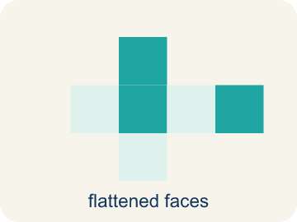 | Net Plantilla (desarrollo plano)  A flat shape that folds up into a solid.  Example: A cross-shaped pattern of 6 rectangles folds into a rectangular box
 | Edge Arista  The line where two flat sides of a solid meet.  Example: A cube has 12 edges — 4 along the top, 4 along the bottom, 4 vertical

Worked Example

Watch & Read I Do — follow along with your teacher
Time Capsule Project
Your team is building time capsule containers to store class memories. Each container is a rectangular prism, and you need to figure out how much each one can hold. That means calculating the volume using whole number dimensions!

Think about:
• What three measurements do you need to find the volume of a box?
• What does volume tell us about a container?
• How is volume different from the area of one face?
• If two containers have the same volume, must they have the same shape?
• What happens to the volume if you double just one dimension?

Solved Example I Do — watch each step
Problem: What is the volume of a rectangular prism with l = 7 in, w = 3 in, h = 4 in?
A) 84 in³
B) 14 in³
C) 84 in²
D) 42 in³
Step 1: V = l × w × h = 7 × 3 × 4 = 84 cubic inches.
Answer: A. 84 in³

Guided Practice

Solve Together We Do — work with your class
Problem: A time capsule box has a volume of 120 cm³. Its length is 10 cm and width is 4 cm. What is its height?
A) 3 cm
B) 6 cm
C) 4 cm
D) 12 cm
Step 1:

Step 2:

Answer:

A moving company uses rectangular boxes. A large box is 24 inches long, 18 inches wide, and 18 inches tall. A medium box is 18 inches long, 14 inches wide, and 12 inches tall.
How many more cubic inches does the large box hold than the medium box?

Sentence frame: The large box volume is ___ in³ because V = ___ × ___ × ___. The medium box volume is ___ in³. The large box holds ___ more cubic inches.

Turn & Talk discuss with a partner
1. [Launch] You are sealing time capsule containers and must know exactly how much each holds. Why do you need three edge measurements (length, width, and height) to find the volume of a container?
Start with: I need three measurements because volume fills space in ___ directions.
Necesito tres medidas porque el volumen llena el espacio en ___ direcciones.
Word bank: volume, length, width, height, rectangular prism, edge
2. [Explore] In the Fold Shop you fold a flat net into a closed box. How does folding the net help you understand what the volume V = l × w × h actually measures?
Start with: When the net folds up, the ___ faces enclose a ___ that I can fill with unit cubes.
Cuando la red se dobla, las ___ caras encierran un ___ que puedo llenar con cubos unitarios.
Word bank: volume, cubic units, rectangular prism, net, edge
3. [Connect] At the Loading Dock, a large moving box is 24 × 18 × 18 in and a medium box is 18 × 14 × 12 in. Talk through how to find how many more cubic inches the large box holds.
Start with: The large box volume is ___ in³ because 24 × 18 × 18 = ___.
El volumen de la caja grande es ___ in³ porque 24 × 18 × 18 = ___.
Word bank: volume, cubic units, rectangular prism, length, width, height
4. [Reflect] As you seal the capsule, a teammate writes a box's volume as 220 in². How would you fix the units and explain why volume must use cubic units?
Start with: The units should be ___ instead of in² because volume measures ___.
Las unidades deben ser ___ en lugar de in² porque el volumen mide ___.
Word bank: volume, cubic units, rectangular prism, edge, net

Independent Practice

On Your Own You Do — show your work
Solve each problem. Show your thinking in the work box.
1. Which unit is used for volume?
A) Cubic inches (in³)
B) Square inches (in²)
C) Inches (in)
D) Degrees (°)

2. Two storage bins: Bin A is 8 × 6 × 5 inches. Bin B is 9 × 4 × 7 inches. Which holds more and by how much?
A) Bin B by 12 in³
B) Bin A by 12 in³
C) Bin B by 24 in³
D) They hold the same

Write About the Math

Build Strong Sentences The Writing Revolution
I can explain my work using the words volume, rectangular prism, cubic units, and edge.

1. Kernel Sentence subject + verb
Model: Volume is how much space is inside a solid shape.

Write a kernel sentence about volume. Use a subject and a verb.
Escribe una oración base sobre volumen. Usa un sujeto y un verbo.

2. Sentence Expansion because · but · so
Kernel: Volume matters in math
because Volume matters in math because ___.
Volumen importa en matemáticas porque ___.

but Volume matters in math, but ___.
Volumen importa en matemáticas, pero ___.

so Volume matters in math, so ___.
Volumen importa en matemáticas, entonces ___.

3. Explain Your Reasoning use a sentence starter
I need three measurements because volume fills space in ___ directions.
Necesito tres medidas porque el volumen llena el espacio en ___ direcciones.
Length and width alone only give one ___, not the whole volume.
El largo y el ancho solos solo dan una ___, no todo el volumen.
When the net folds up, the ___ faces enclose a ___ that I can fill with unit cubes.
Cuando la red se dobla, las ___ caras encierran un ___ que puedo llenar con cubos unitarios.

Exit Ticket
Answer on your own. This shows what you learned today.
★ A rectangular prism has l = 11 in, w = 5 in, h = 4 in. What is the volume?
A) 220 in³
B) 55 in³
C) 220 in²
D) 200 in³

Answer Key & Teacher Guide
Teacher reference — remove or fold back before distributing to students.

Worked Notes (I Do / We Do)
I Do: A. 84 in³
We Do: A. 3 cm

Independent Practice
1. A) Cubic inches (in³) — Volume measures 3D space, so it uses cubic units like in³. Square units (in²) are for area, and inches are for length.
2. A) Bin B by 12 in³ — Bin A: 8 × 6 × 5 = 240 in³. Bin B: 9 × 4 × 7 = 252 in³. Bin B holds 12 in³ more.

Exit Ticket
A) 220 in³ — V = 11 × 5 × 4 = 220 cubic inches. Remember: volume uses cubic units (in³).

Writing (TWR) — what to look for
Kernel sentence: a complete sentence needs a subject and a verb. Example: Volume is how much space is inside a solid shape.
Expansion: because = reason, but = contrast/exception, so = result. Answers vary; each must keep the kernel idea.

Turn & Talk — listen for
1. Students explain volume is three-dimensional, so all three edges (length, width, height) are needed; two measurements only describe one flat face.
2. Students connect the folded net to the 3D space inside, and explain volume counts the unit cubes that fill it, computed as l × w × h.
3. Students compute large = 7776 in³, medium = 3024 in³, then subtract to get 4752 in³ more, and reason that you must find each volume before comparing.
4. Students change in² to in³ and explain that volume fills 3D space (three edges multiplied), while square units describe the flat area of one face.

